The complete React full stack – Coding Revolution Fernando 01/16/21

# (buy - The Complete 2021 Web Development Bootcamp

Npm start, test test. Npm start will initiate a development server to test the code.

Npm run build, npm run eject. When running eject, all the hiding configuration files become visible.

Bundle.js is provided to index.html by React. It includes all the JS code we write.

React.createElement(‘element’,{className},”content”) // React.createElement(‘h1’,{className:”title”},”Hello World”)

From a component, always rturn only a single element. If multiple, wrap it with <div> or <React.Fragment> or just <> </>

Javascript inside jsx can return only a single statement.

Npm install –g create-react-app

Create-react-app <app-name>

If something is sourced into components outside of src folder in React, will not work.



Git code

React events are called synthetic events.

String interpolation is always done using backticks and $

There is no 2 way binding in React. If needed, use ‘state’.

# React.Component

This page contains a detailed API reference for the React component class definition. It assumes you’re familiar with fundamental React concepts, such as [Components and Props](https://reactjs.org/docs/components-and-props.html), as well as [State and Lifecycle](https://reactjs.org/docs/state-and-lifecycle.html). If you’re not, read them first.

### https://reactjs.org/docs/react-component.html

### The Component Lifecycle

Each component has several “lifecycle methods” that you can override to run code at particular times in the process. **You can use**[**this lifecycle diagram**](https://projects.wojtekmaj.pl/react-lifecycle-methods-diagram/)**as a cheat sheet.** In the list below, commonly used lifecycle methods are marked as **bold**. The rest of them exist for relatively rare use cases.

#### **Mounting**

These methods are called in the following order when an instance of a component is being created and inserted into the DOM:

* [**constructor()**](https://reactjs.org/docs/react-component.html#constructor)
* [static getDerivedStateFromProps()](https://reactjs.org/docs/react-component.html#static-getderivedstatefromprops) // static methods are class methods. They prevent user from updating the state. Can’t use ‘this’ by the user to update state.
* [**render()**](https://reactjs.org/docs/react-component.html#render)
* [**componentDidMount()**](https://reactjs.org/docs/react-component.html#componentdidmount)

**Note:**

These methods are considered legacy and you should [avoid them](https://reactjs.org/blog/2018/03/27/update-on-async-rendering.html) in new code:

* [UNSAFE_componentWillMount()](https://reactjs.org/docs/react-component.html#unsafe_componentwillmount)

#### **Updating**

An update can be caused by changes to props or state. These methods are called in the following order when a component is being re-rendered:

* [static getDerivedStateFromProps()](https://reactjs.org/docs/react-component.html#static-getderivedstatefromprops)
* [shouldComponentUpdate()](https://reactjs.org/docs/react-component.html#shouldcomponentupdate)
* [**render()**](https://reactjs.org/docs/react-component.html#render)
* [getSnapshotBeforeUpdate()](https://reactjs.org/docs/react-component.html#getsnapshotbeforeupdate)
* [**componentDidUpdate()**](https://reactjs.org/docs/react-component.html#componentdidupdate)

**Note:**

These methods are considered legacy and you should [avoid them](https://reactjs.org/blog/2018/03/27/update-on-async-rendering.html) in new code:

* [UNSAFE_componentWillUpdate()](https://reactjs.org/docs/react-component.html#unsafe_componentwillupdate)
* [UNSAFE_componentWillReceiveProps()](https://reactjs.org/docs/react-component.html#unsafe_componentwillreceiveprops)

#### **Unmounting**

This method is called when a component is being removed from the DOM:

* [**componentWillUnmount()**](https://reactjs.org/docs/react-component.html#componentwillunmount)

#### **Error Handling**

These methods are called when there is an error during rendering, in a lifecycle method, or in the constructor of any child component.

* [static getDerivedStateFromError()](https://reactjs.org/docs/react-component.html#static-getderivedstatefromerror)
* [componentDidCatch()](https://reactjs.org/docs/react-component.html#componentdidcatch)

### Other APIs

Each component also provides some other APIs:

* [setState()](https://reactjs.org/docs/react-component.html#setstate)
* [forceUpdate()](https://reactjs.org/docs/react-component.html#forceupdate)

### Class Properties

* [defaultProps](https://reactjs.org/docs/react-component.html#defaultprops)
* [displayName](https://reactjs.org/docs/react-component.html#displayname)

### Instance Properties

* [props](https://reactjs.org/docs/react-component.html#props)
* [state](https://reactjs.org/docs/react-component.html#state)

shouldComponentUpdate(nextProps, nextState){

console.log("update- should component update")

console.log("prevstate",this.state.count)

console.log("nextstate",nextState)

if shouldComponentUpdate(nextProps, nextState) return false, no state update will happen and no more rendering. It asks only if the component should be updated. The state will be updated irrespectively.

When the state/prop of a parent component changes, all its child components are ‘updated’.

componentDidUpdate(prevProps, prevState){

console.log("update - component did update")

console.log("prev state",prevState)

console.log("curr state", this.state.count)

}

componentDidUpdate – gives previous props/states

getSnapshotBeforeUpdate(prevProps, prevState) can return any props/state value, which can be used as 3rd argument in componentDidUpdate(,,snapshot).

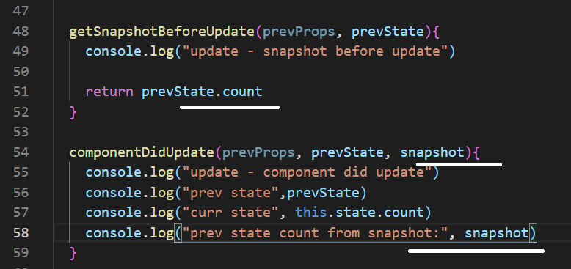

getDerivedStateStateFromProps(props, state) – will provide with the current prop/state before update. This will enable us to modify the state as did below.

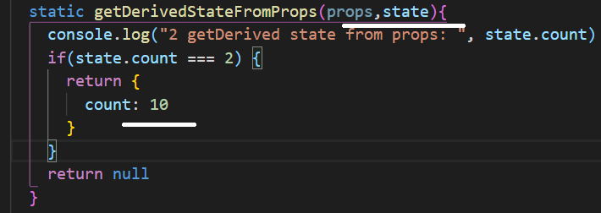

React hooks: <https://reactjs.org/docs/hooks-intro.html>

useState hook:

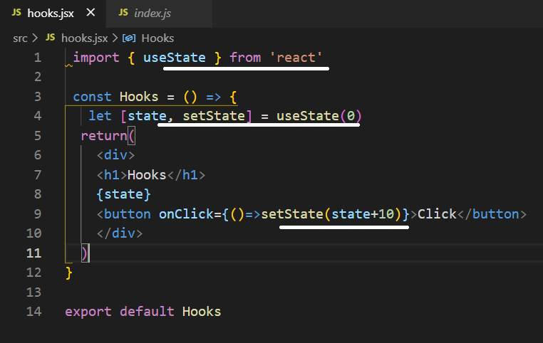

Another form of update:

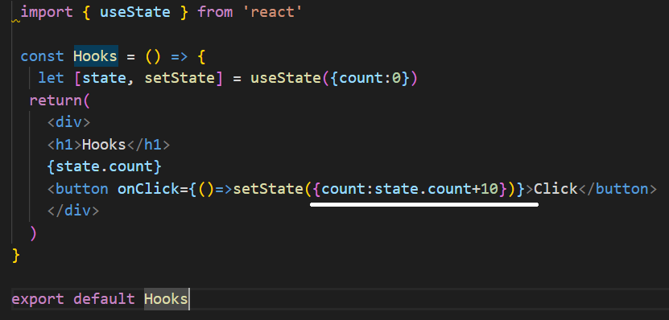

https://reactjs.org/docs/hooks-reference.html

* [Basic Hooks](https://reactjs.org/docs/hooks-reference.html#basic-hooks)
  + [useState](https://reactjs.org/docs/hooks-reference.html#usestate)
  + [useEffect](https://reactjs.org/docs/hooks-reference.html#useeffect)
  + [useContext](https://reactjs.org/docs/hooks-reference.html#usecontext)
* [Additional Hooks](https://reactjs.org/docs/hooks-reference.html#additional-hooks)
  + [useReducer](https://reactjs.org/docs/hooks-reference.html#usereducer)
  + [useCallback](https://reactjs.org/docs/hooks-reference.html#usecallback)
  + [useMemo](https://reactjs.org/docs/hooks-reference.html#usememo)
  + [useRef](https://reactjs.org/docs/hooks-reference.html#useref)
  + [useImperativeHandle](https://reactjs.org/docs/hooks-reference.html#useimperativehandle)
  + [useLayoutEffect](https://reactjs.org/docs/hooks-reference.html#uselayouteffect)
  + [useDebugValue](https://reactjs.org/docs/hooks-reference.html#usedebugvalue)

useState will not merge data like setState. To override this, use the spread operator as below:

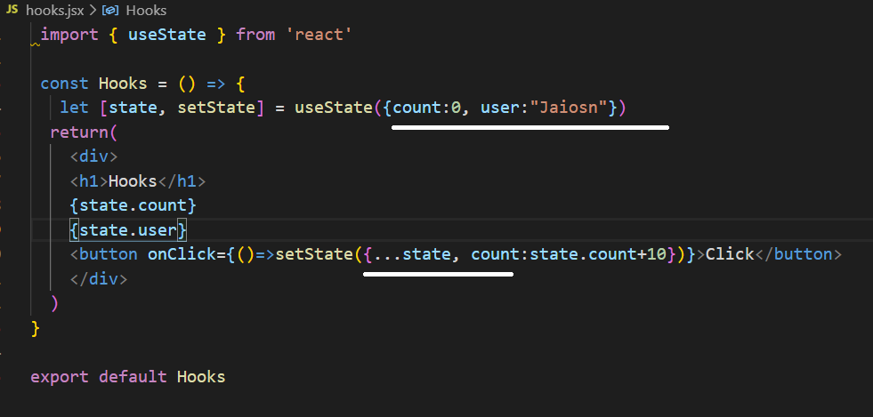

useReducer can be effieciently used when multiple values are entered inside the state object

useEffect executes a call back function. If the 2nd parameter is omitted, the function will be executed during create, update and delete life-cycle. If an empty bracket is given, its run only during the mount and unmount. If any state object is given inside the bracket, its updated whenever that state changes.

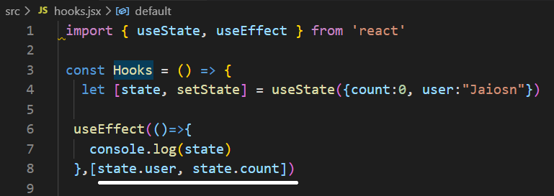

In memory, the functions if a component are different in each re-render.

useCallback is going to cache the function in memory.

Dependency:

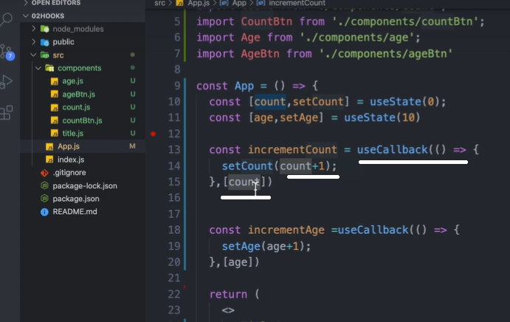

No dependency:

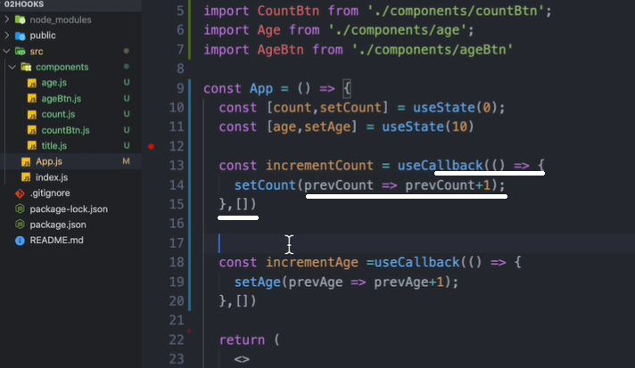

React.memo – if the component doesn’t receive any chained props, the child component will not be re-renderd.

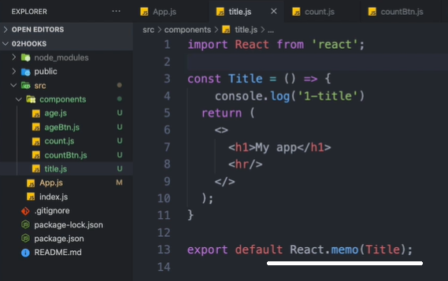

createRef:

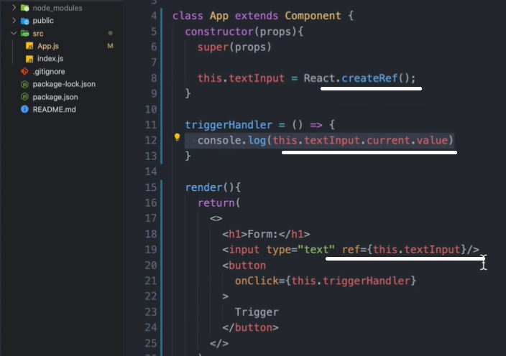

useRef:

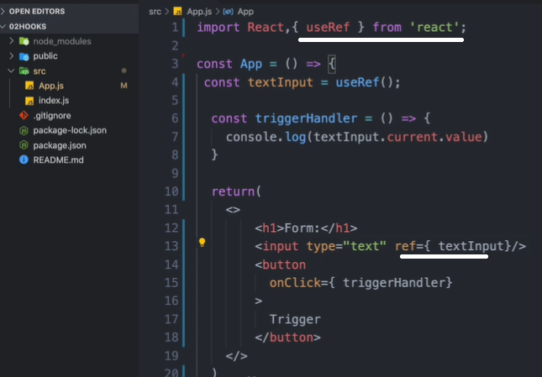

References are not properties, cant send down to child components.

Using React.forwardRef – to use the ‘ref’ as property:

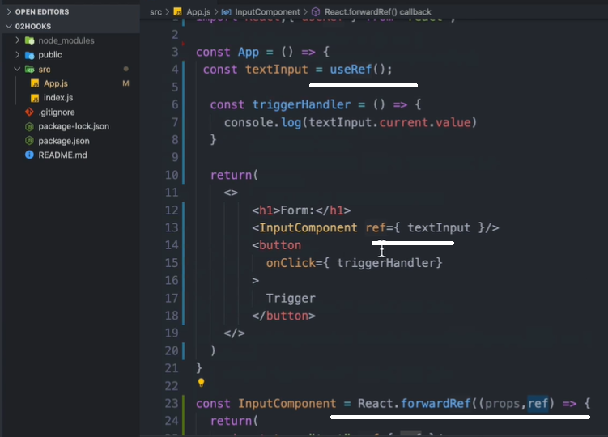

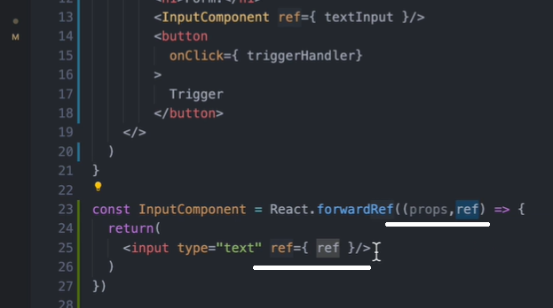

Program:

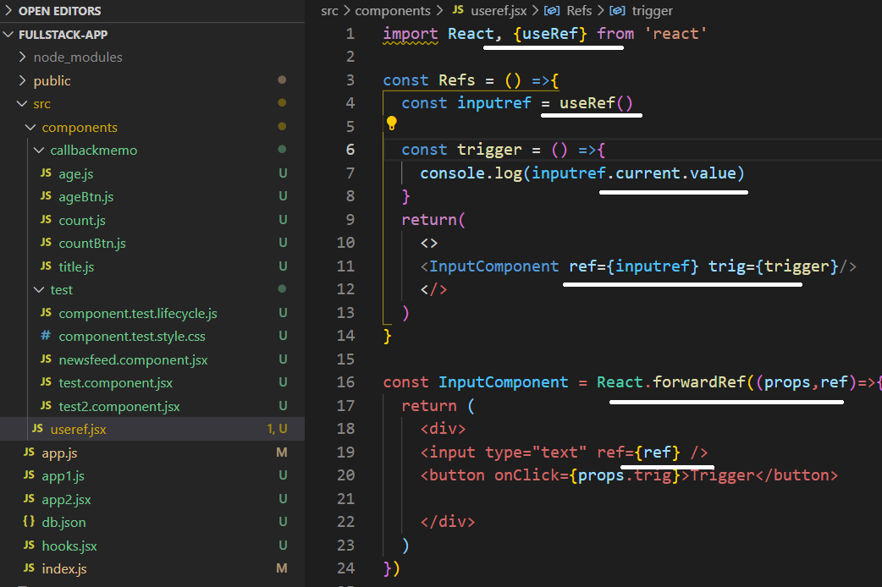

Context allow as to store and retrieve data and functions from a centralised place.

To use context, optionally in a class, declare the context, provider. Create state inside the class and pass it to the provider as value.

In the main app, import the provider and wrap it around the components which need the context.

In the sub component, import the context and use ‘useContext’ to access the state or context.

Class context provider:

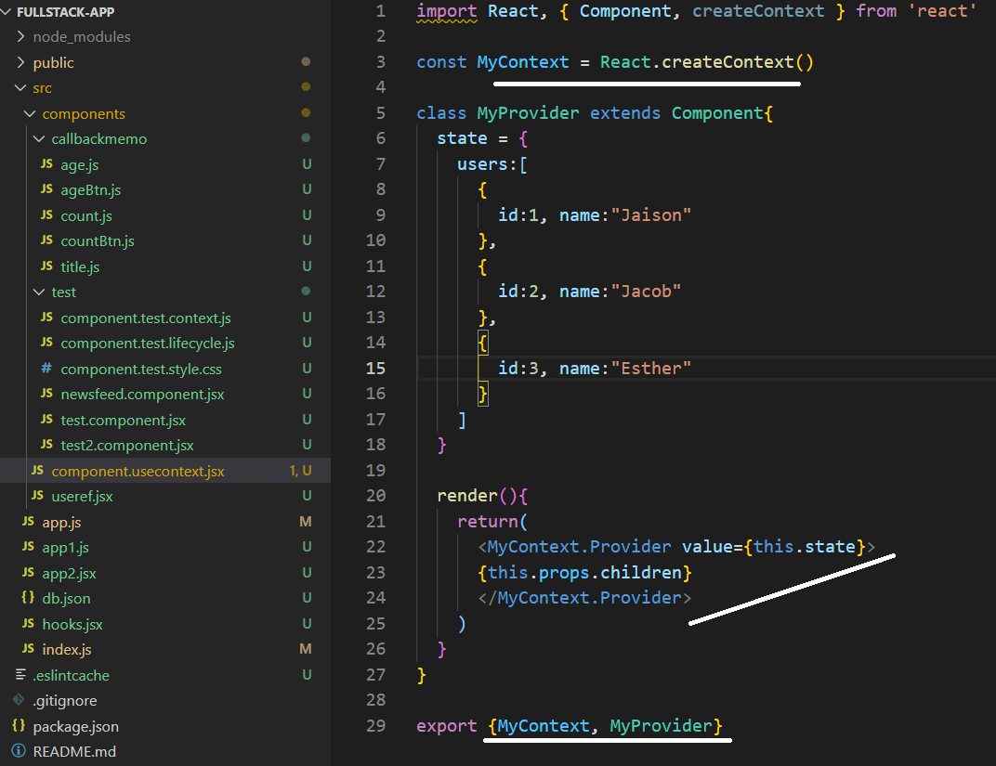

Configuring the provider in the main app:

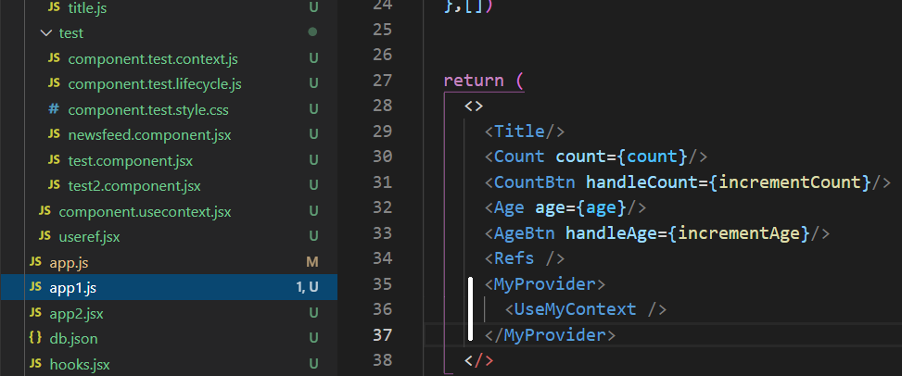

Using the context in the component:

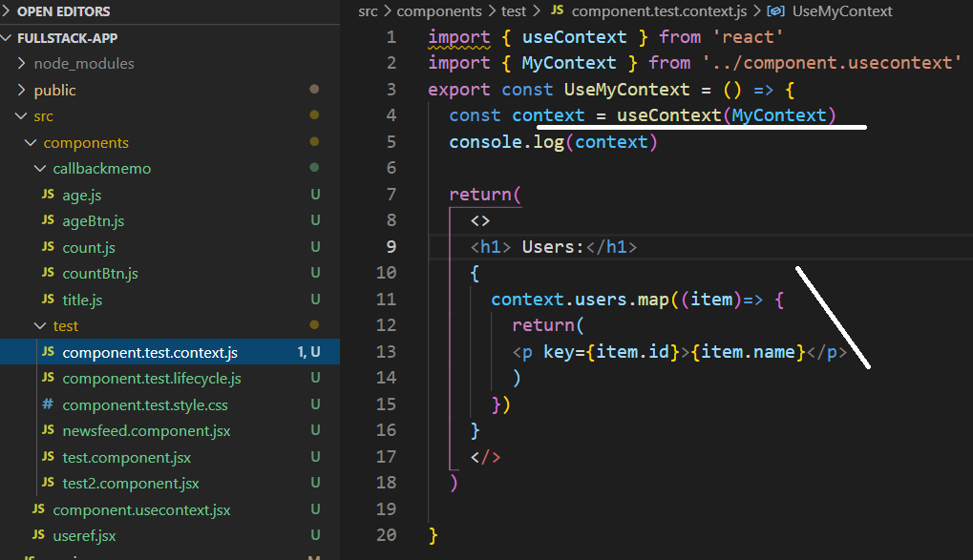

Context consumer – better to use function when using the consumer.

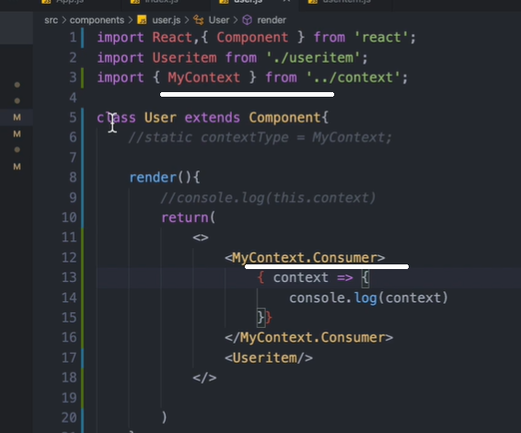

To change the development server port in package.json

    "start": " set PORT=8000 && react-scripts start",

To access the context from a class based component, use the ‘static’ property:

Static contextType = MyContext – staticType is a reserved word. It gives the ‘context’ word.

To install fonts, go to fonts.google.com search for the font, select the font, go to select this style, select the link, paste it in index.html inside the public folder.

Npm install react-bootstrap bootstrap

Directly import ‘bootstrap/dist/css/bootstrap.min.css’ into the app.js

Npm install react-toastify

import { ToastContainer, toast } from 'react-toastify'

in the main app:

import 'bootstrap/dist/css/bootstrap.min.css'

import "react-toastify/dist/ReactToastify.css";

**React Router:**

Npm install react-router-dom

The BrowserRouter class knows the url history.

Import { BrowserRouter, Route, Link } from ‘react-router-dom

Link is for putting the ‘link’ into the url. When the route detets the link, it loads the appropriate component.

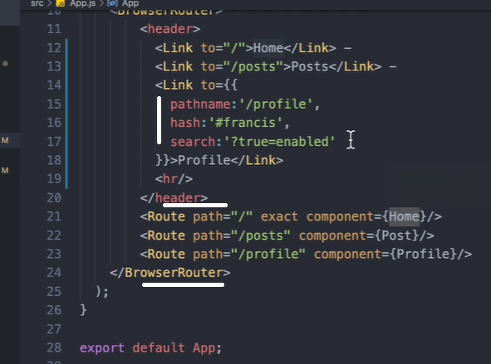

By default, the Route will pass props to the components. It comes from React Router. Location, history, match.

For child links, use <Link to={{ pathname:`${props.match.url}/posts`}}

Dynamic params are accessed via props.match.params.id posts/:id

HashRouter and MemoryRouter - - hashrouter shows # in the url. Memoryrouter shows no links in the url. These are given in the same place as the BrowserRouter.

NavLink:

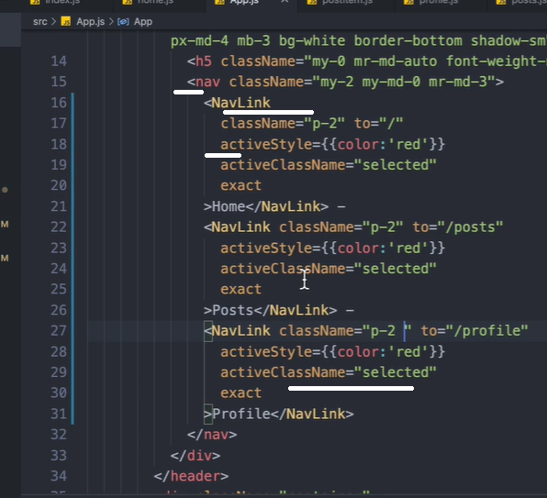

Switch will attempt find specific path for the url. Once it finds, then stops.

Redirect redirects the url from the url to the url:

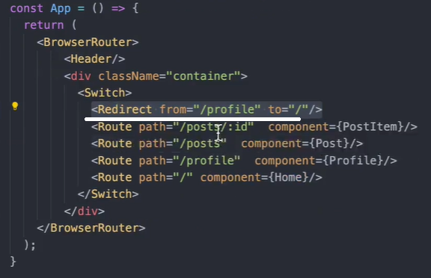

Redirect using function: change the state ‘redir’ using a button click using ‘setRedir’

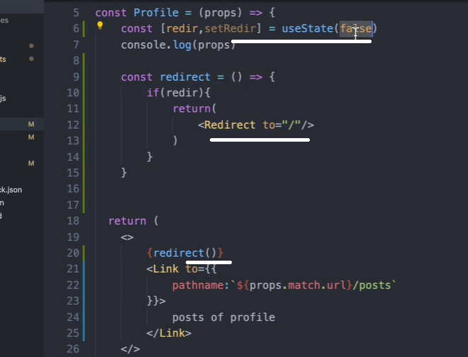

Redirect using props.history.push

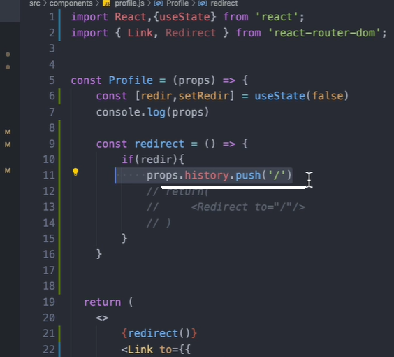

Using default Route for 404 cases where the url is not valid. Route has a render method

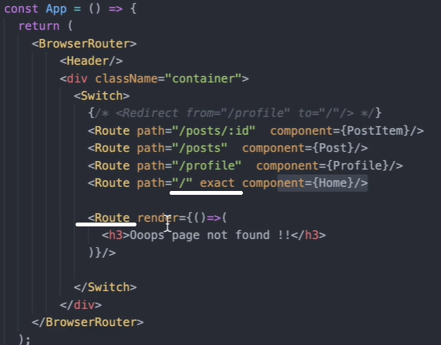

Pure components checks to see if there is any changes to the props and state before rendering the component. If no changes, it ignores the rendering of the component. Like shoudComponentUpdate returns false if not needed.

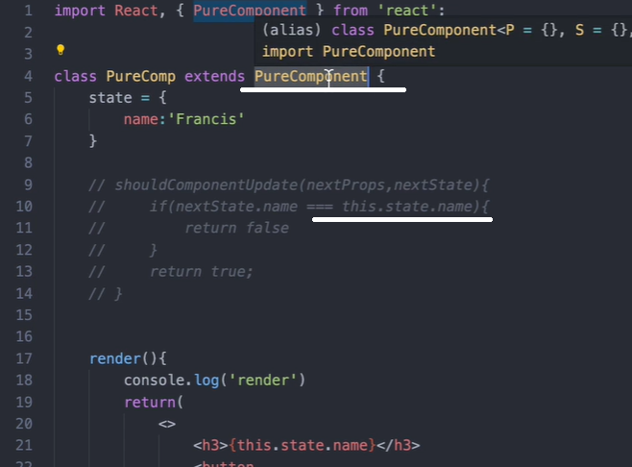

For functional components, if there is no change to the state, automatically will not re-render.

In 3 ways, we can list an array into the component:

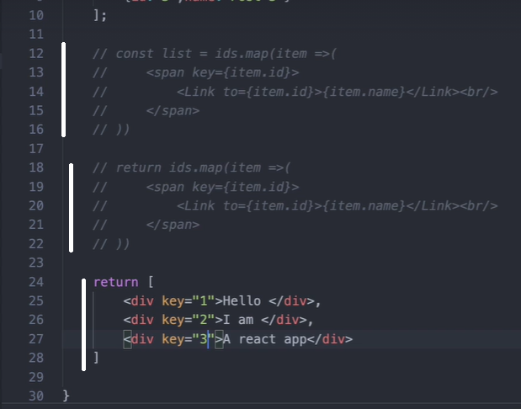

An exporting component object can be an arrow function with a constant declaration or a normal function.

A HOC component declaration:

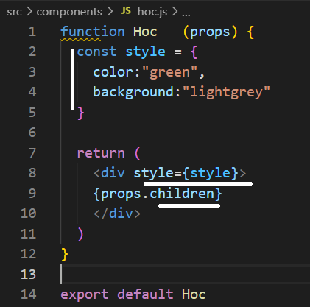

An hoc can be a component for user authentication.

Transition in React is Transition group, motion and spring.

Npm install react-transition-group

Transition has 4 states. Entering, entered, exiting, exited.

Import Transition from ‘react-transition-group’

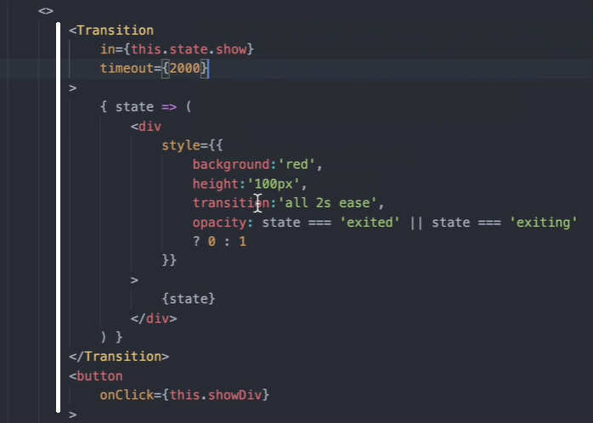

Changing class with state interpolation on css

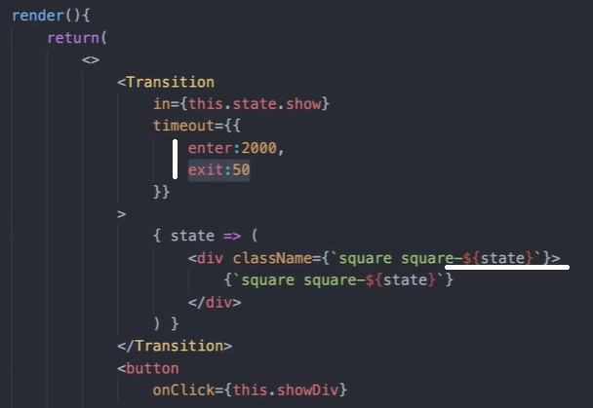

Can make enter={false} like this inside transition.

Css

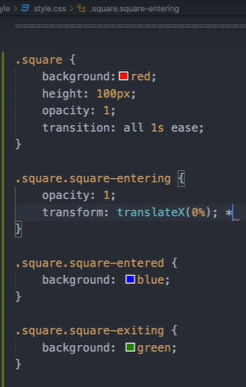

https//:Reactcommunity.org

import CSSTransition from ‘react-transition-group’

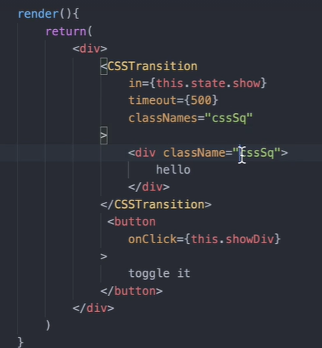

Css

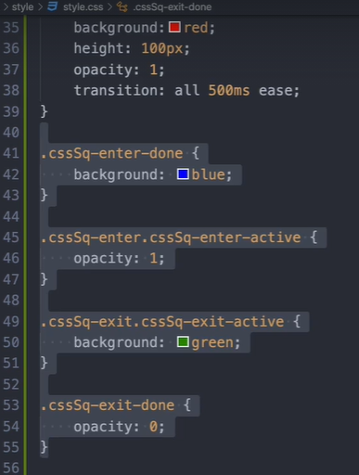

react-awesome-reveal // animatecss // <https://github.com/FormidableLabs/react-animations>

**REDUX** – A predictable state container for JS apps

The provider from ‘redux-react’ should wrap the entire app from the top level. It’s the bridge connecting React to redux

A promise example.

<!DOCTYPE html>

<html>

<body>

<h2>JavaScript Promise</h2>

<p>Wait 3 seconds (3000 milliseconds) for this page to change.</p>

<h1 id="demo"></h1>

<script>

let myPromise = new Promise((rsolv, rjct) =>{

let jj = "Jaison"

if (jj === "Jaison") rsolv("Success, resolved")

else rjct("Error, failed")

})

myPromise.then((value) => {

document.getElementById("demo").innerHTML = value},

(value) => {

document.getElementById("demo").innerHTML = value},)

</script>

</body>

</html>

---

The applyMiddleware function from ‘redux’ is to use 3rd party middleware functions for redux

Const createStoreWithApplyMiddleware = applyMiddleware()(createStore)

<Provider store={ createStoreWithApplyMiddleware())>

Redux works with actions and reducers.

React-redux process flow:

Application dispatch an action to the action creator. Action creator executes the action and return an object with type and payload. Reducer recieves the type and update store with the payload.

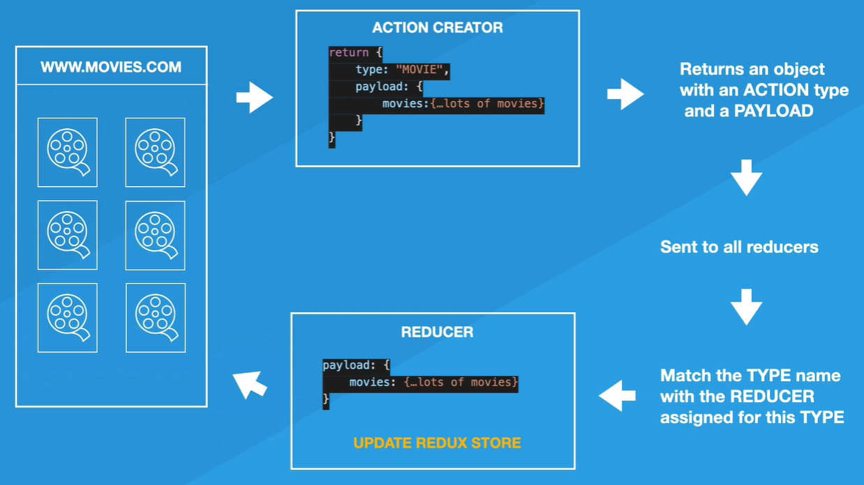

Redux-promise is a middleware. Its like redux-thunk

Import promiseMiddleware from ‘redux-promise’ – in the main component where ‘redux’ is imported

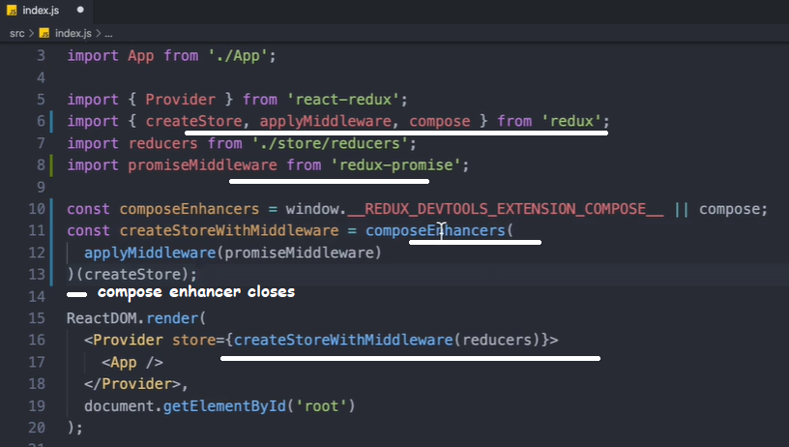

‘compose’ helps the browser extension ‘devtools’ to work efficiently.

An ‘action’ is a function that returns an object with a type and pyload.

The flow: 1) an action function is created and exported that returns an object with type and payload.

2) the reducer is created and exported. 3) the combineReducers imports the reducer function.

4) the combineReducers is imported in the main app. 5) the Home component imports the action function. It imports ‘connect’ from ‘react-redux’. The Home component dispatches the action, which the reducer handles and updates the store. Upon changes to the data, React re-renders the component.

combineReducers is a function itself.

Connect – gives access to state for the component through mapStateToProps.

When using redux hooks in funcitonal components, import { useDispatch, useSelector } from ‘react-redux’. The useSelector behave like mapStateToProps like in class.

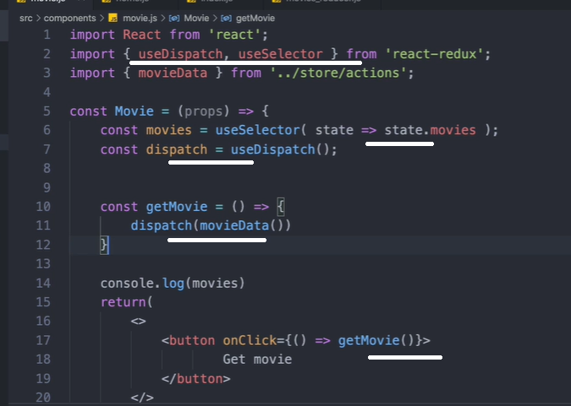

Formik is a library for managing Forms. Formik.org

Schema validation with Yup.

Npm install formik yup

* 1. Create a formik element as wrapper. 2) inside the wrapper, create an arrow function. In that function, take Formik methods as objects. 3) inside the function return, provide the form elements. 4) Inside Formik element, pass fom element names as properties for initalValues. 5) assign/connect form element values with Formik property and form element methods with Formik methods.

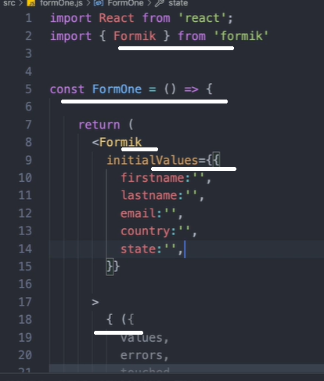

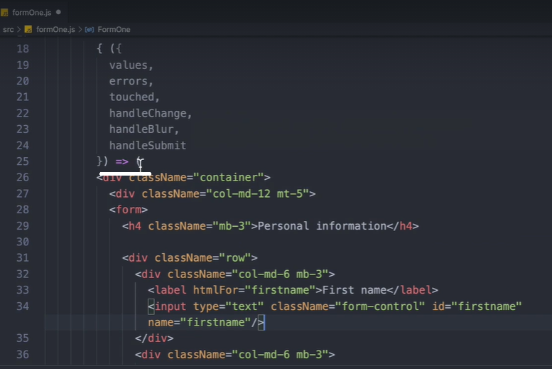

Get email format check from regex github.

Form validation:

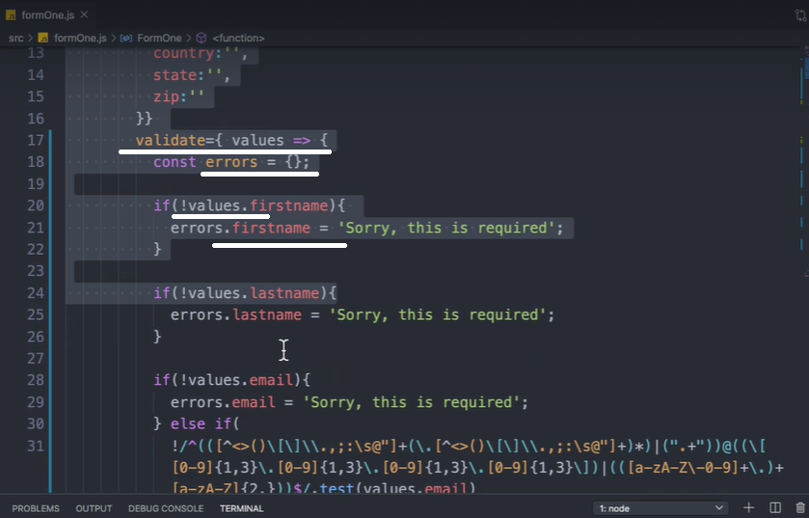

Validation Code:

validate={ values => {

const errors = {};

if(!values.firstname){

errors.firstname = 'Sorry, this is required';

}

if(!values.lastname){

errors.lastname = 'Sorry, this is required';

}

if(!values.email){

errors.email = 'Sorry, this is required';

} else if(

!/^(([^<>()\[\]\\.,;:\s@"]+(\.[^<>()\[\]\\.,;:\s@"]+)*)|(".+"))@((\[[0-9]{1,3}\.[0-9]{1,3}\.[0-9]{1,3}\.[0-9]{1,3}\])|(([a-zA-Z\-0-9]+\.)+[a-zA-Z]{2,}))$/.test(values.email)

){

errors.email = 'Invalid email';

}

return errors;

}}

--------------------------------------

Error input on the form on condition.

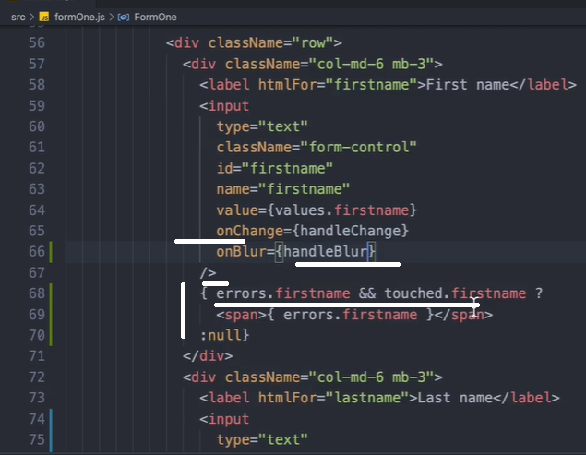

Import * as Yup from ‘yup’

Its only for validation of the elements.

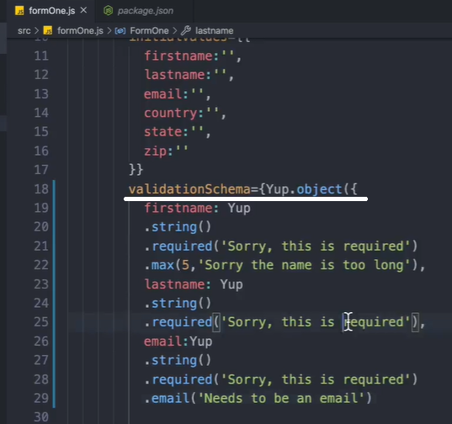

Code (Yup):

import React from 'react';

import { Formik } from 'formik'

import * as Yup from 'yup'

const Play2 = () => {

return (

<Formik

initialValues={{

firstname:'',

lastname:'',

email:'',

country:'',

state:'',

zip:''

}}

**validationSchema={Yup.object({**

**firstname: Yup**

**.string()**

**.required('Sorry, this is required')**

**.max(5,'Sorry the name is too long'),**

**lastname: Yup**

**.string()**

**.required('Sorry, this is required'),**

**email:Yup**

**.string()**

**.required('Sorry, this is required')**

**.email('Needs to be an email')**

**})}**

onSubmit={( values )=>{

console.log(values)

}}

>

{ ({

values,

errors,

touched,

handleChange,

handleBlur,

handleSubmit

}) => (

<div className="container">

<div className="col-md-12 mt-5">

<form onSubmit={handleSubmit}>

<h4 className="mb-3">Personal information - Play2</h4>

<div className="row">

<div className="col-md-6 mb-3">

<label htmlFor="firstname">First name</label>

<input

type="text"

className="form-control"

id="firstname"

name="firstname"

value={values.firstname}

onChange={handleChange}

onBlur={handleBlur}

/>

{ errors.firstname && touched.firstname ?

<span>{ errors.firstname }</span>

:null}

</div>

<div className="col-md-6 mb-3">

<label htmlFor="lastname">Last name</label>

<input

type="text"

className="form-control"

id="lastname"

name="lastname"

value={values.lastname}

onChange={handleChange}

onBlur={handleBlur}

/>

{ errors.lastname && touched.lastname ?

<span>{ errors.lastname }</span>

:null}

</div>

</div>

<div className="mb-3">

<label htmlFor="email">Email</label>

<input

type="email"

className="form-control"

id="email"

name="email"

placeholder="you@example.com"

value={values.email}

onChange={handleChange}

onBlur={handleBlur}

/>

{ errors.email && touched.email ?

<span>{ errors.email }</span>

:null}

</div>

<div className="row">

<div className="col-md-5 mb-3">

<label htmlFor="country">Country</label>

<select

className="custom-select d-block w-100"

id="country"

name="country"

value={values.country}

onChange={handleChange}

>

<option value="">Choose...</option>

<option value="US">United States</option>

<option value="CA">Canada</option>

<option value="NL">Netherlands</option>

</select>

</div>

<div className="col-md-4 mb-3">

<label htmlFor="state">State</label>

<select

className="custom-select d-block w-100"

id="state"

name="state"

value={values.state}

onChange={handleChange}

>

<option value="">Choose...</option>

<option value="california">California</option>

<option value="toronto">Toronto</option>

<option value="utrech">Utrech</option>

</select>

</div>

<div className="col-md-3 mb-3">

<label htmlFor="zip">Zip</label>

<input

type="text"

className="form-control"

id="zip"

name="zip"

value={values.zip}

onChange={handleChange}

/>

</div>

</div>

<hr className="mb-4"/>

<button className="btn btn-primary btn-lg btn-block" type="submit">

Submit

</button>

</form>

</div>

</div>

)}

</Formik>

);

}

export default Play2;

Formik can be used inside class and functional components.

Formik hook. Import { useFormk } from ‘formik’

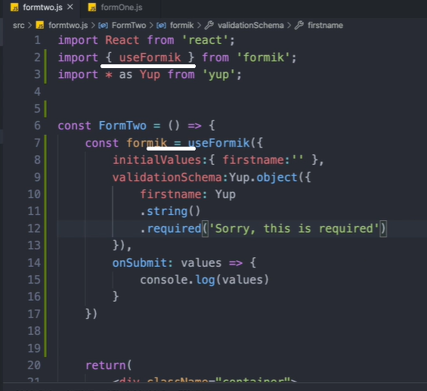

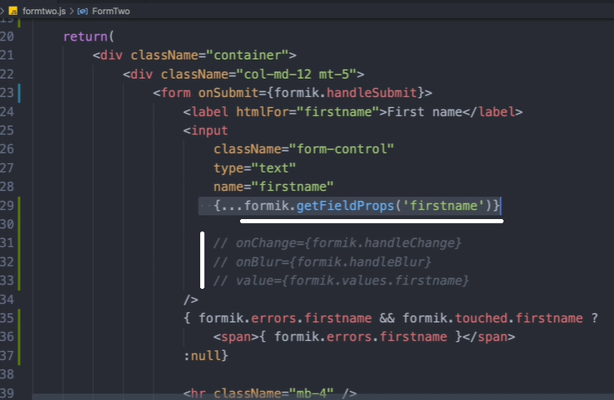

Formik components: import { Formik, Form } from ‘formik’

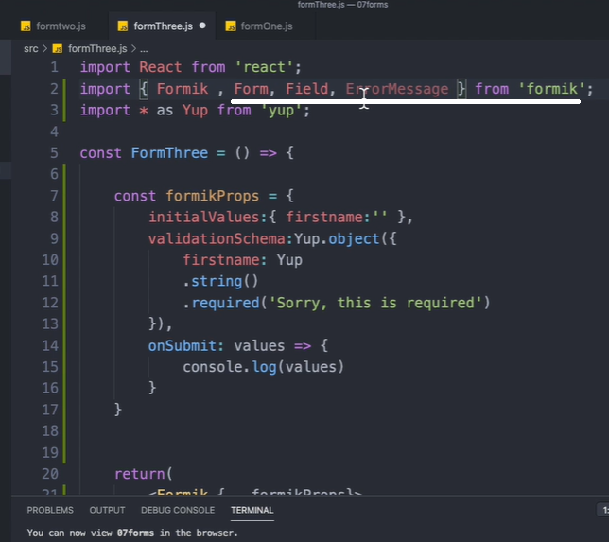

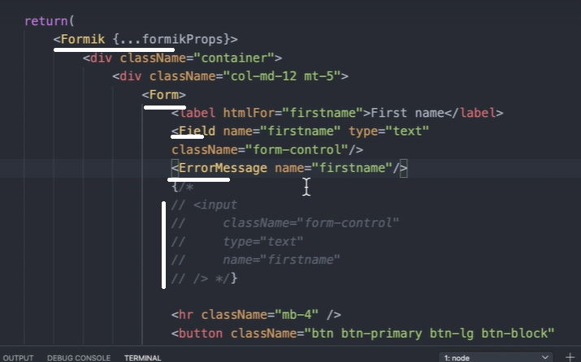

Formik.org

Custom state and form: this is a class component

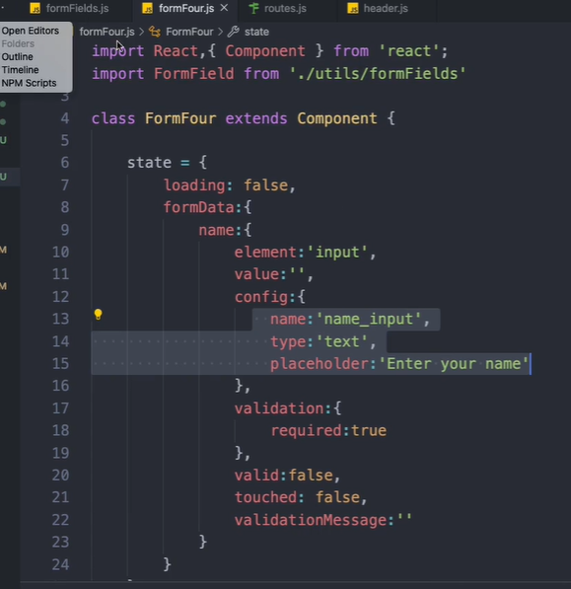

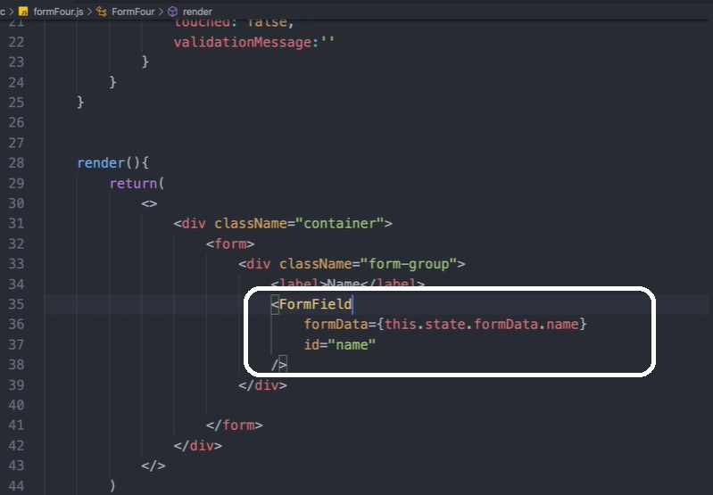

This is a utility component for generating the Form.

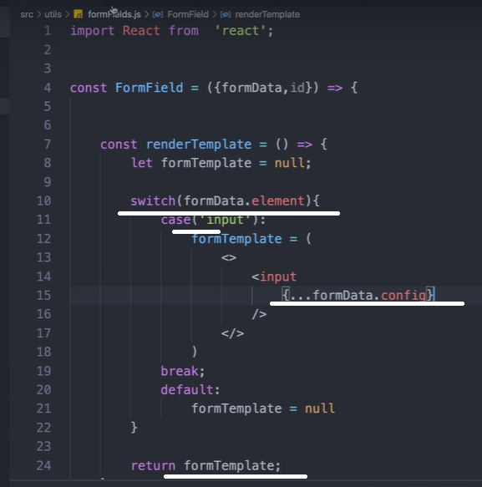

Call the ‘formTemplae’ inside the return as { formTemplate }

useReducer:

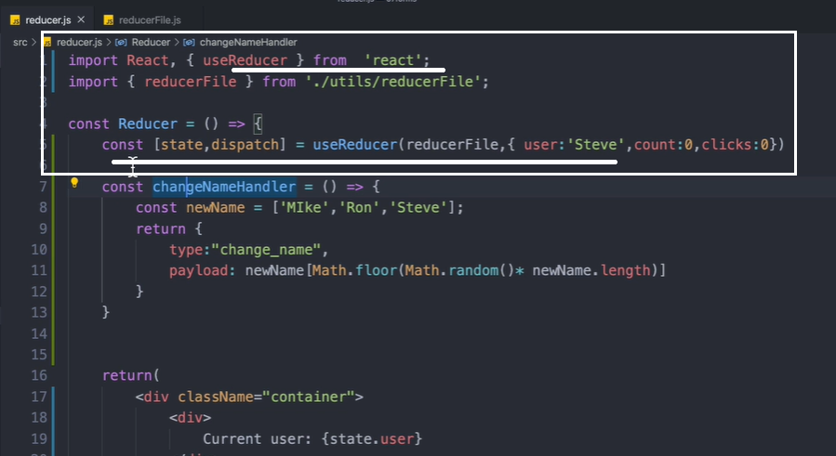

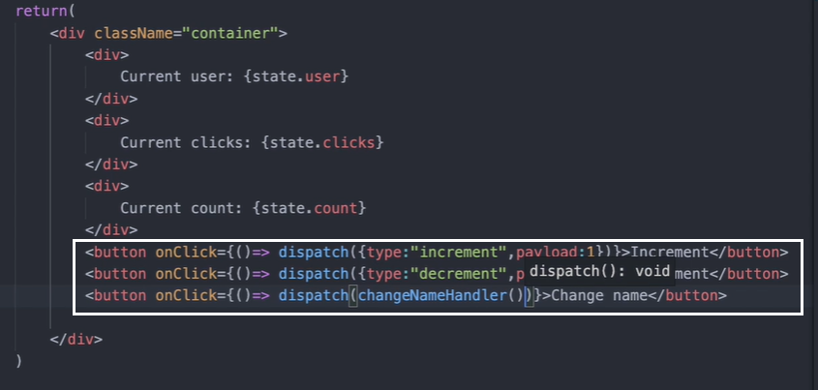

Reducer logic seperated as a function:

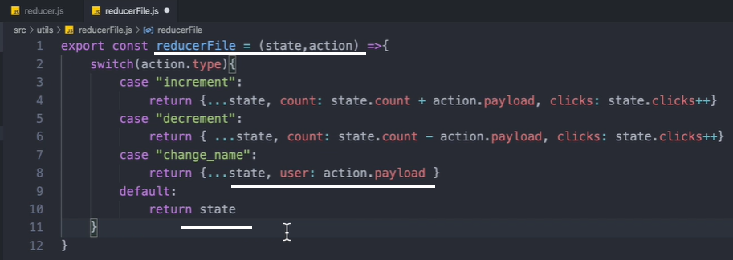

Node:

Read, evaluate, print and loop (REPL)

Node translates javascript into machine code.

No process locks in nodejs. JS is single threaded, like Node.

Asynchronous actions are moved to unicorn by node till it resolves/rejects. Unicorn lives in API

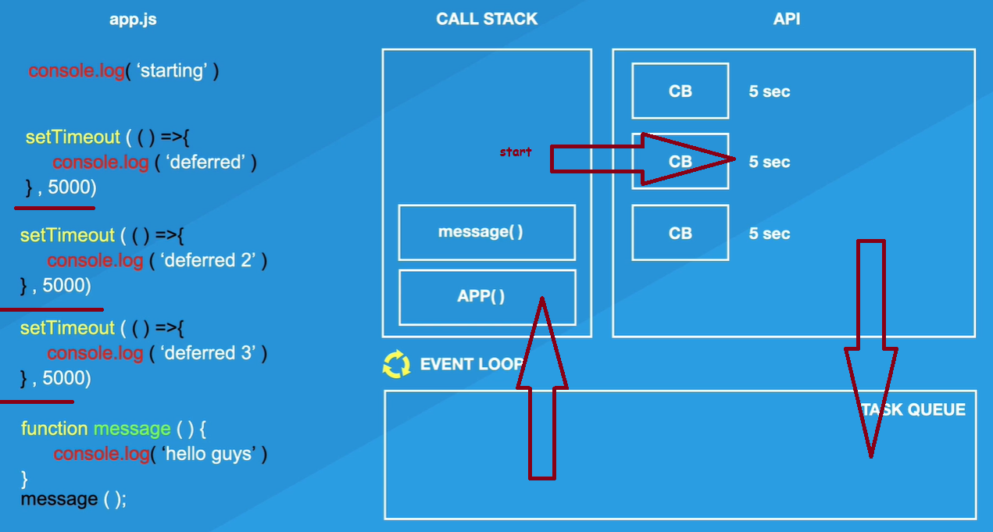

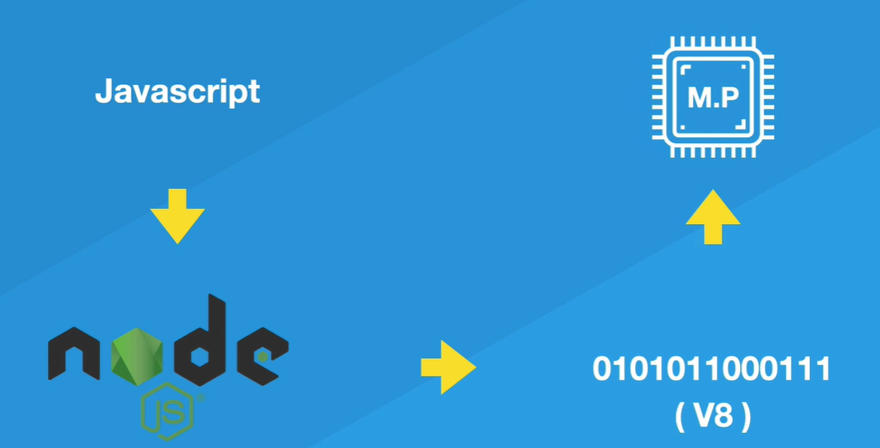

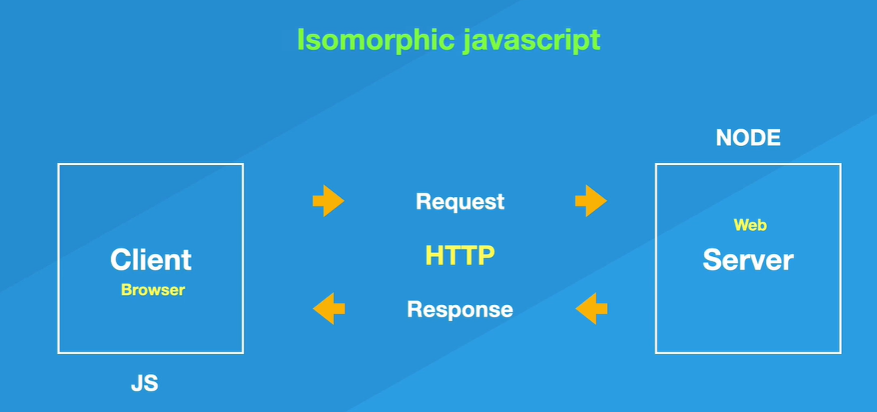

Isomorphic JavaScript, also known as Universal JavaScript, describes JavaScript applications which run both on the client and the server.

Express is a library use to create a server.

Many ways to create a server, NodeJS is just one ex.

Creating a server:

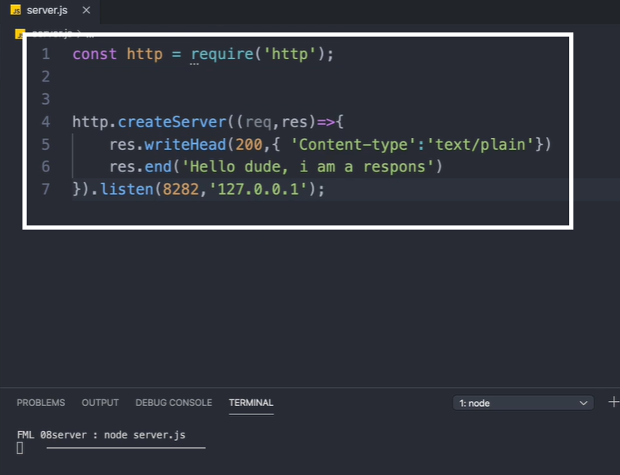

Writing html to server:

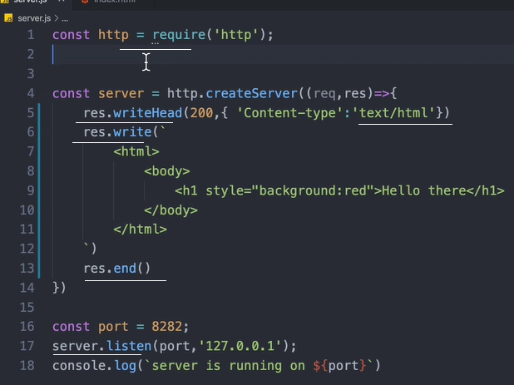

Accessing html file:

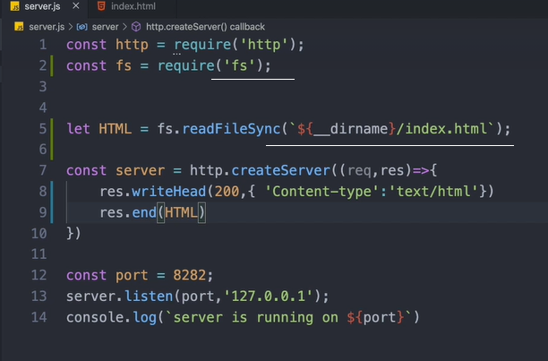

Sending json object as response:

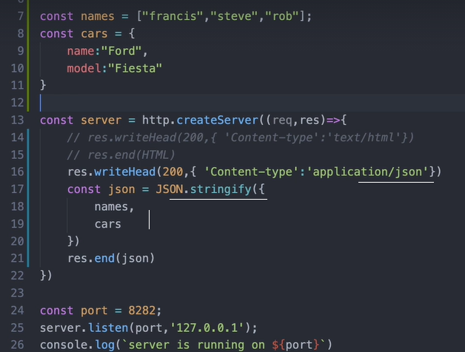

Server is getting ‘request’ from the browser/client and it ‘response’s

Receiving requests and send responses:

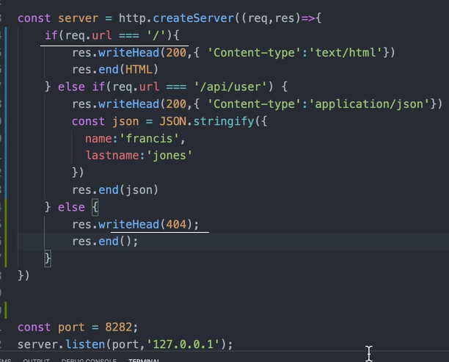

An API is also called an endport.

Code:

const http = require('http')

const fs = require('fs')

const { RSA_NO_PADDING } = require('constants')

const html = fs.readFileSync(`${__dirname}/index.html`)

const myArray = [1,2,3,'jaison','jacob']

const myObj = {Children:{name:"Emil", id:1} }

const server = http.createServer((req,res)=> {

if(req.url === "/") {

res.writeHead(200,{"content-type":"text/html"})

res.end(html)

} else if(req.url === "/children"){

res.writeHead(200,{"content-type":"text/json"})

const json = JSON.stringify({myArray,myObj})

res.end(json)

} else {

res.writeHead(404)

res.end()

}

})

server.listen(8281,'127.0.0.1')

npm init to start a new project, with package.json and node_modules.

For server to auto-monitor for any changes to the server, install nodemon and start server page with nodemon as nodemon server.js

Process.env.port is the port used by the hosting server for this server application.

Express code:

const express = require('express')

const app = express()

app.get('/',(req,res)=>{

res.send('<html><body><h1 style="background:red"> Hellow </h1> </body></html>')

})

app.listen(3000)

params hold dynamic value entered into the url. Query is ?var=value&var=value in the url

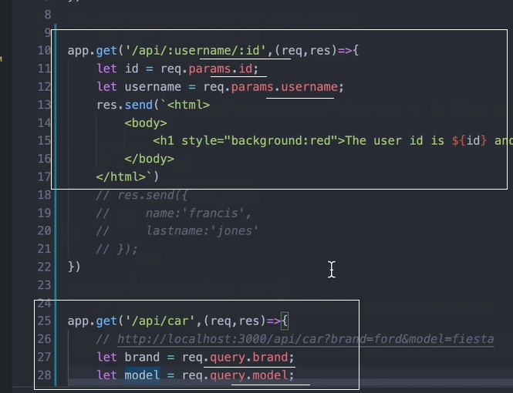

‘next’ has to be used in a middlweare function inorder to pass the action to the next function.

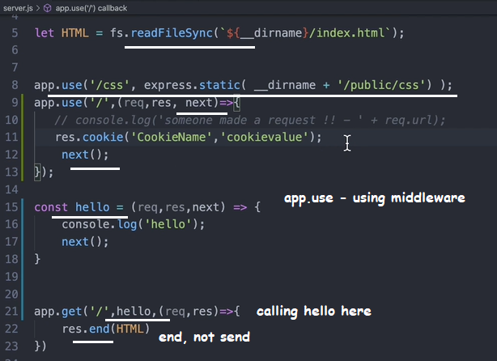

‘body-parser’ is a 3rd party library used in the server to receive ‘POST’ requests; from the body.

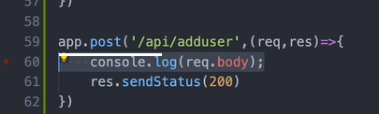

Route is most important in a server listening for requests.

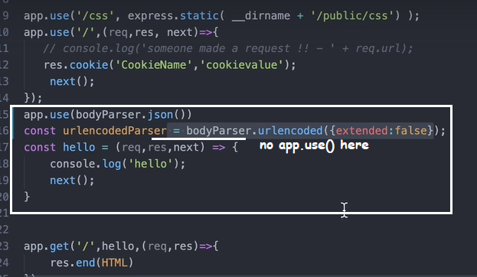

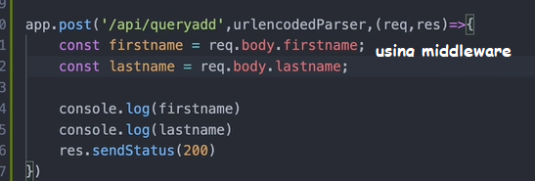

Install ‘concurrently’ to run both the server and client in a single command.

Edit package.json as below: this is written inside server package.json. Note --prefix

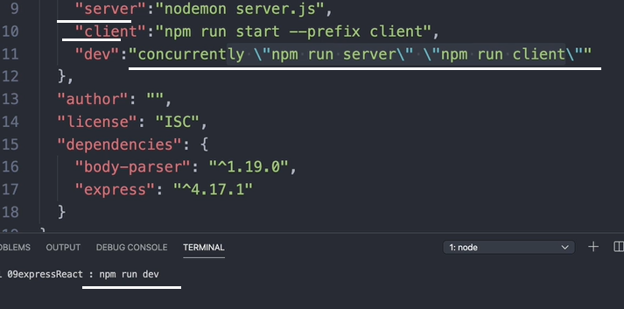

When the client makes a request to the server from a different port, ‘CORS’ policy prevents access.

To overcome this, add a proxy to the client package.json as below: client port is 3000, server port is 3001. axios

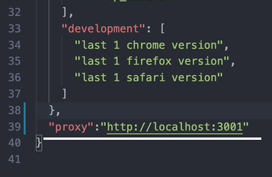

For fetch:

// fetch("http://localhost:3001/first",{

    //   mode: 'no-cors'

    // })

To use mongodb cluster, install mongodb

Import { MongoClient } = require ‘mongodb’

When connecting to the cluster uri, can omit the dbname if we don’t want.

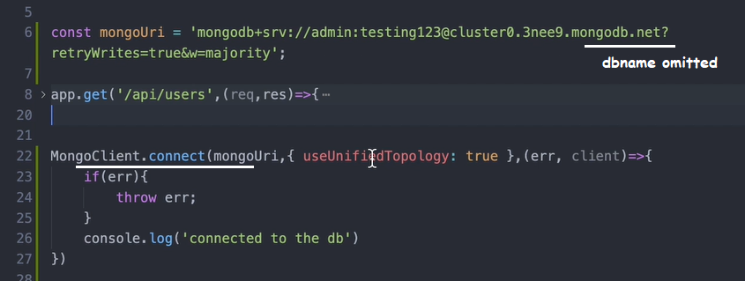

Database structure is: projects - > clusters -> databases -> collections.

In the server :

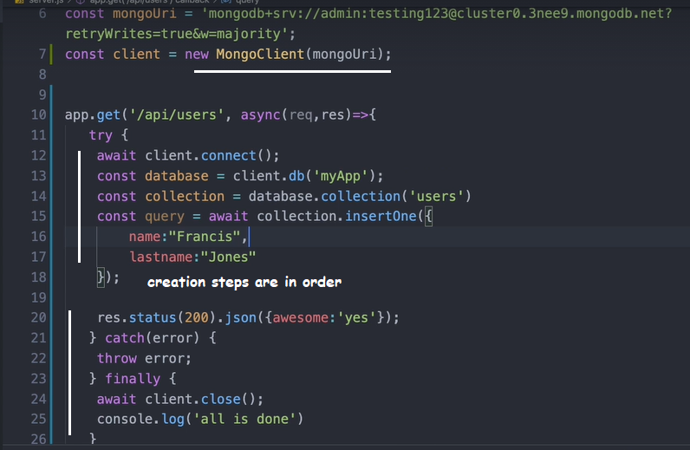

Mongoose works wth model and schemas. It’s a library.

Mongoose validates the input data to the database as per the model and schema.

Mongoose work with models. Schema is part of that model.

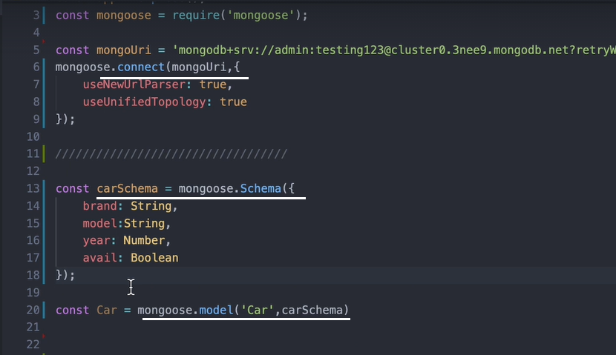

In the frontend:

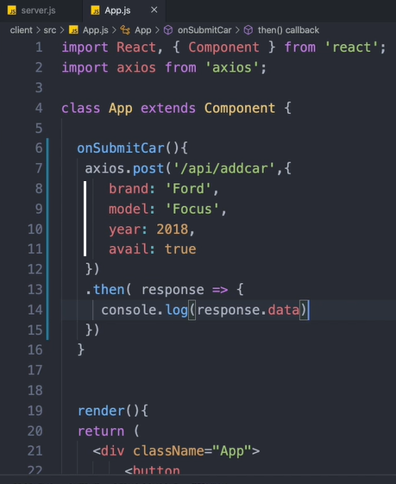

App.use(body.parser.json())

In the server: don’t forget to provide dbname in the uri

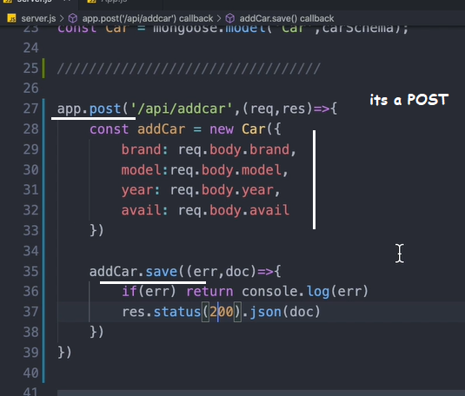

To get data from mongoose, use find, findOne, findById

Finding data from the database:

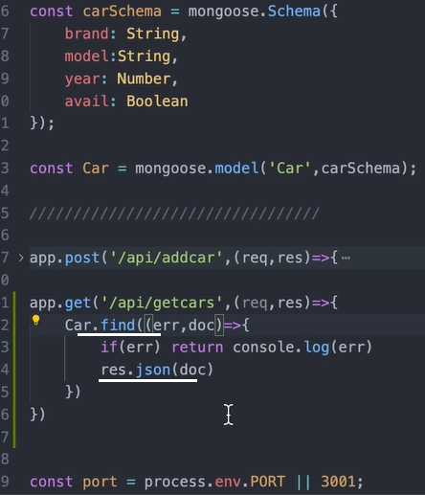

In the fontend: saving data from the backend to the state:

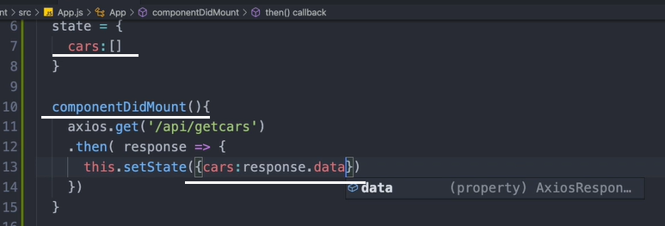

Rendering the result state data:

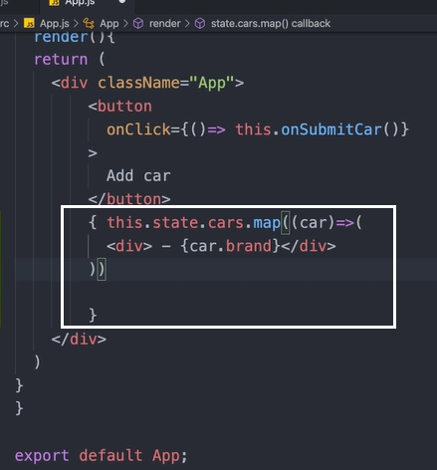

Find filter:

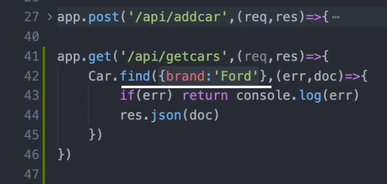

findOne returns only single document.

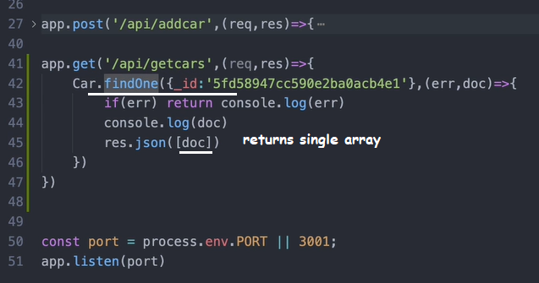

findById requires no key:

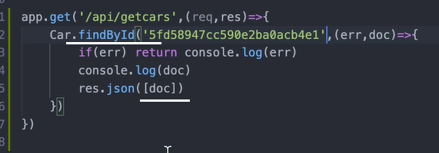

To remove item from the back end. Frontend code:

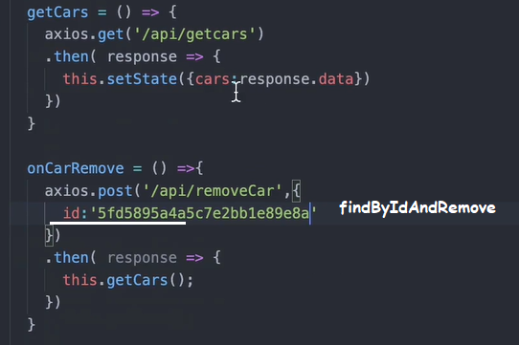

Removing item from collection:

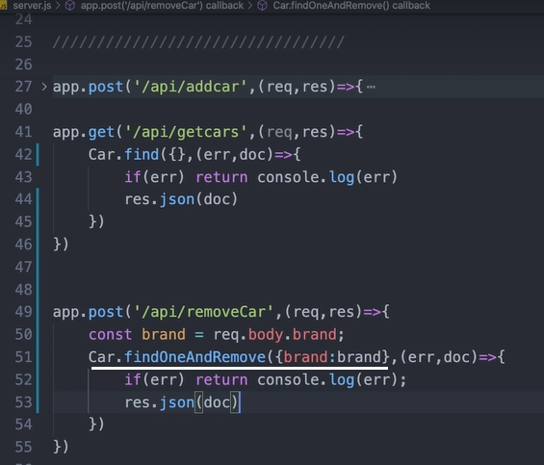

Removing items from collection by ‘remove’:

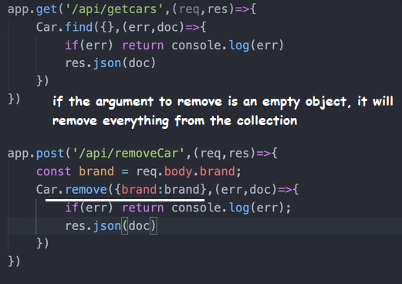

For updates, use ‘update’ and ‘findByIDAndUpdate’

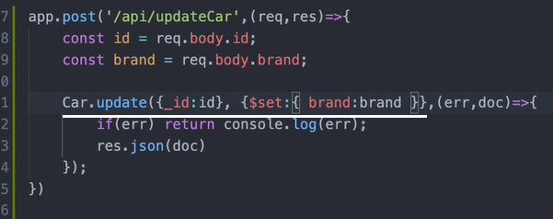

Another kind of update:

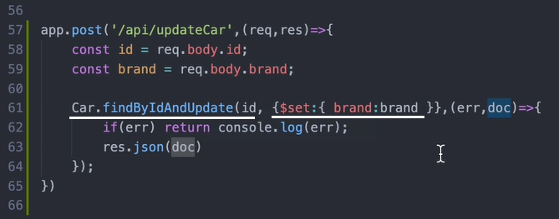

Another update method:

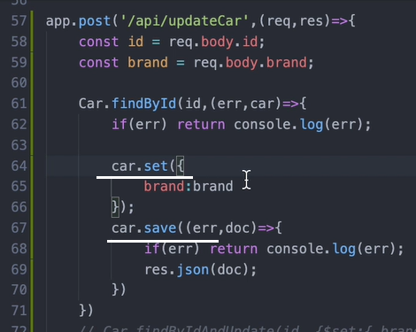

With Postman, we can test all the server routes and responses from the server. (Instead of using a client).

Nodemon is a dev dependency, not a production one.

Server.js is inside /server

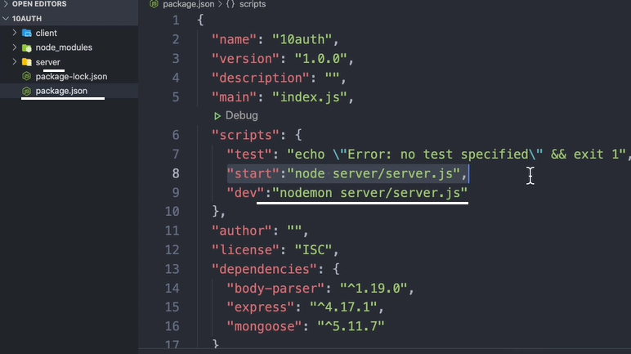

Mongoose.set – to set a property for mongoose

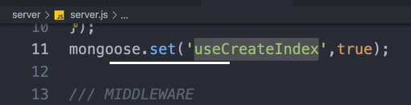

Schema validation:

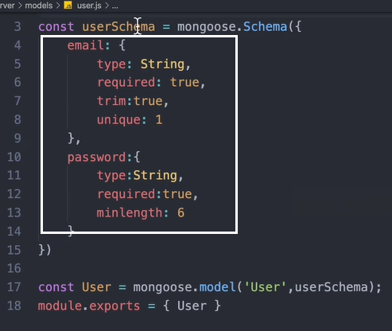

Sending data to database through the server using Postman:

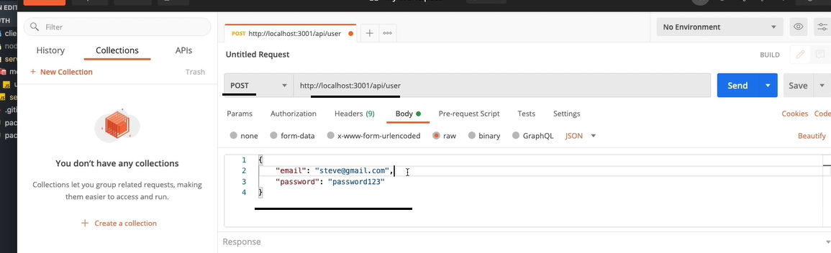

For encryption of password/data, install bcrypt. Npm install bcrypt const bcrypt = require ‘bcrypt’

Generate password by using salted crypting:

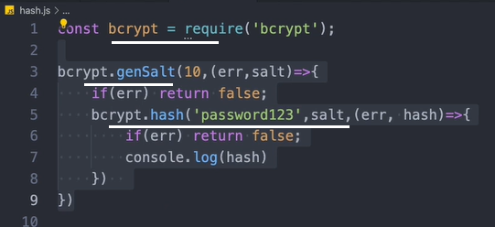

This is a middleware executed when the user collection is created with the password encryption:

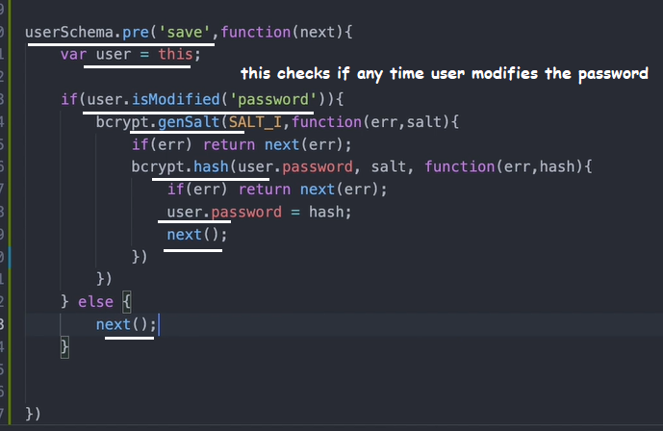

Password matching:

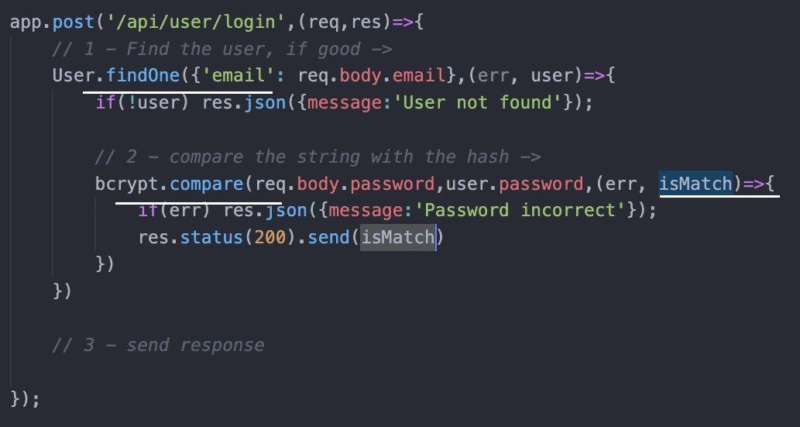

Next() is only in middleware, not in methods.

Gereric password check method:

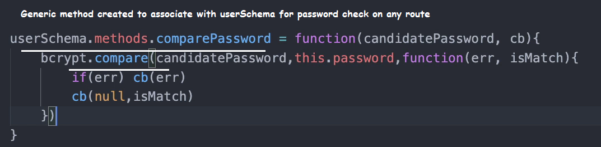

Applying the generic password check method on the router:

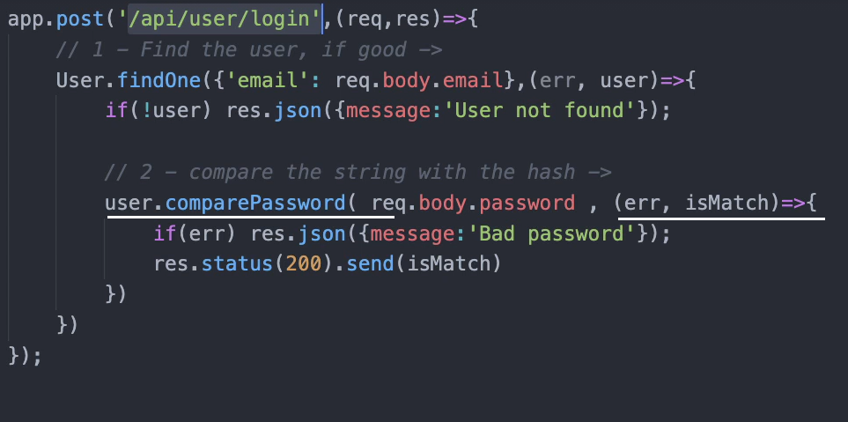

Web tokens are used for authorization of user to move from on page to another or to do certain things in application once the user has the password credentials.

Npm install jsonwebtoken

Generating and verifying a jwt token logic:

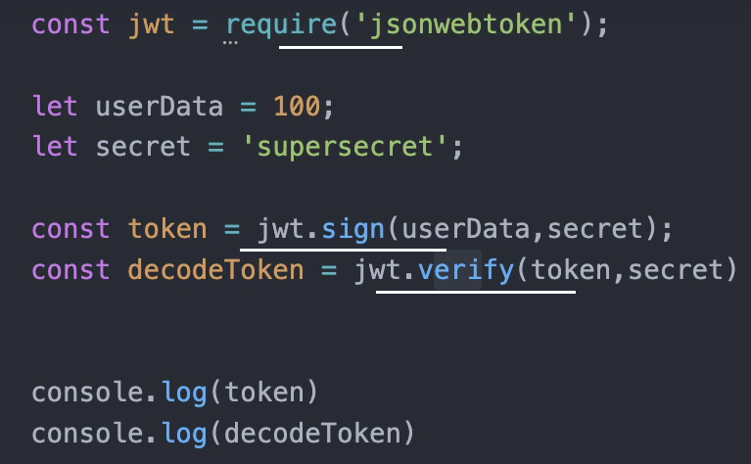

The token will be stored in a broswer local storage or in cookie.

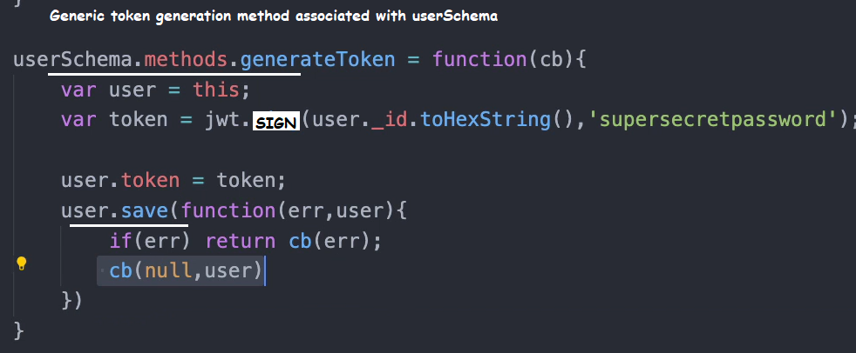

Token is stored in the session:

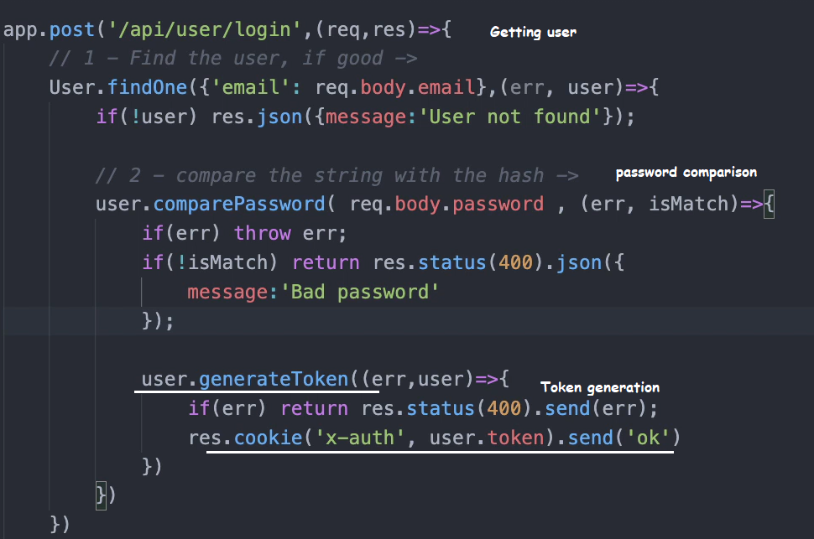

Install cookie-parser

Getting the token back:

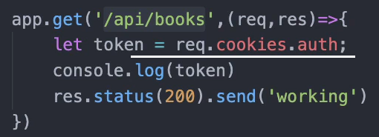

‘Statics’ method is run from the Object. ‘methods’ are run from the Object instance.

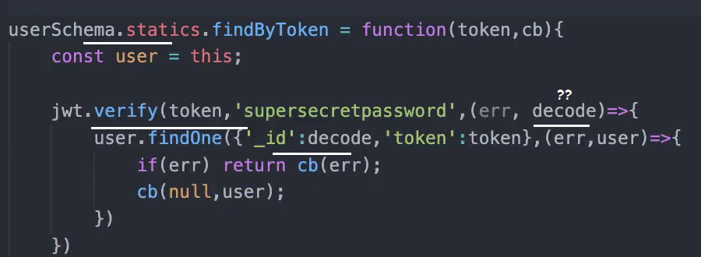

### jwt.verify(token, secretOrPublicKey, [options, callback])

(Asynchronous) If a callback is supplied, function acts asynchronously. The callback is called with the decoded payload if the signature is valid and optional expiration, audience, or issuer are valid. If not, it will be called with the error.

(Synchronous) If a callback is not supplied, function acts synchronously. Returns the payload decoded if the signature is valid and optional expiration, audience, or issuer are valid. If not, it will throw the error.

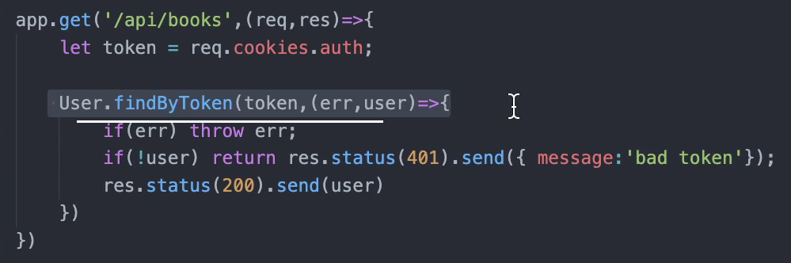

Using middleware:

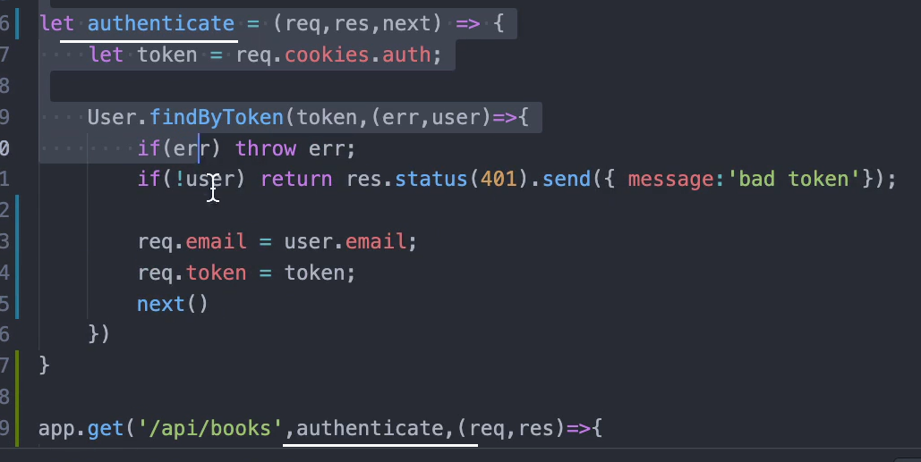

Npm install dotenv

Config file for secrets while deployment.

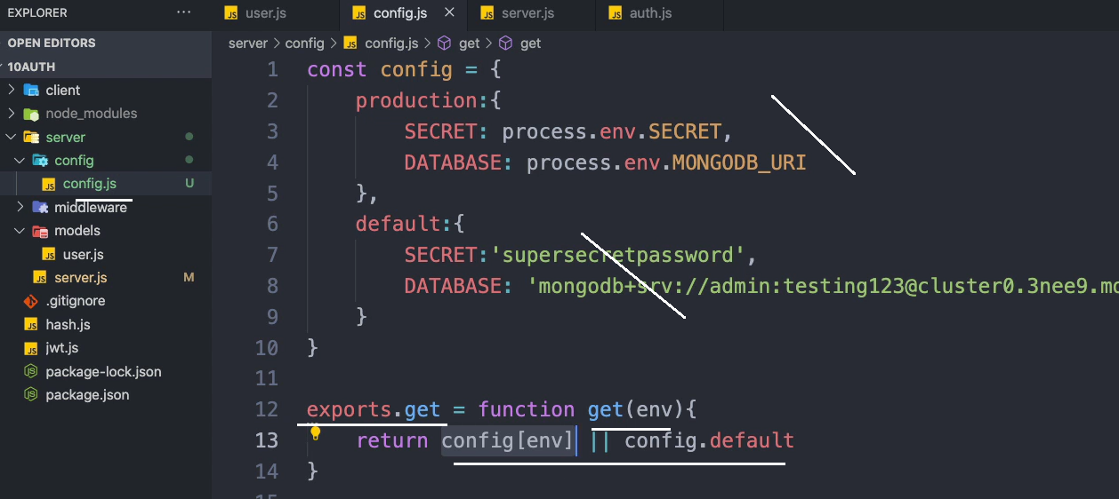

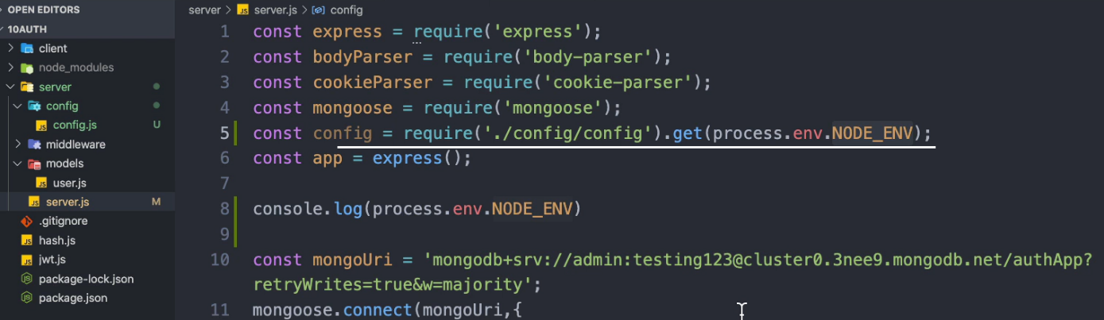

Updating secret fields in Heroku:

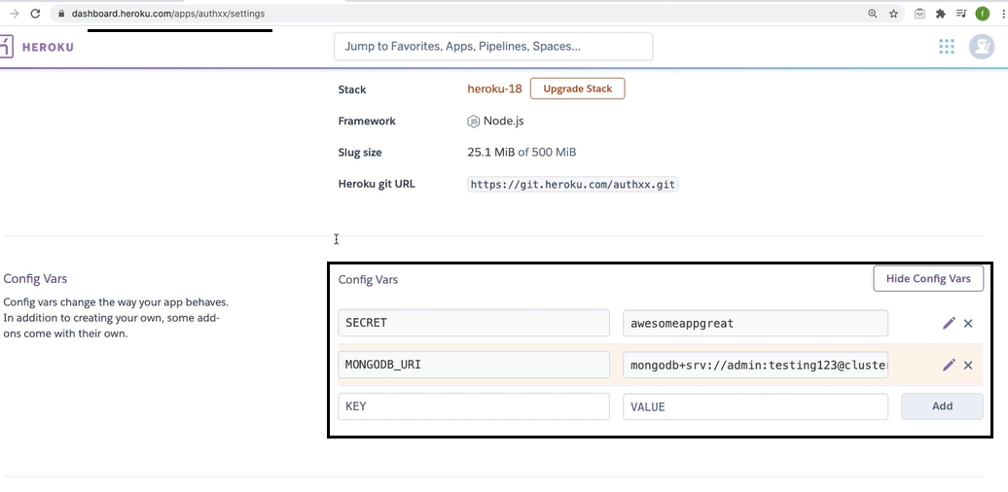

In cli, heroku logs –for server losgs

**Project**

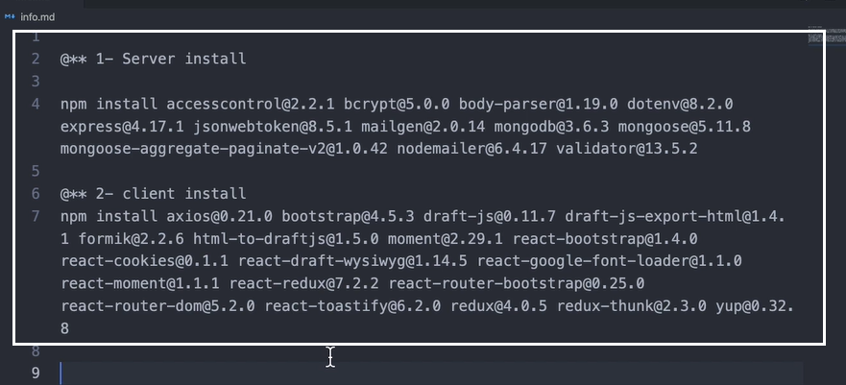

Install all the server libraries from the root FLICKBASE. Then create the server and client folders. Install React and other libraries from the client folder.

First develop the server. Then the client frontend

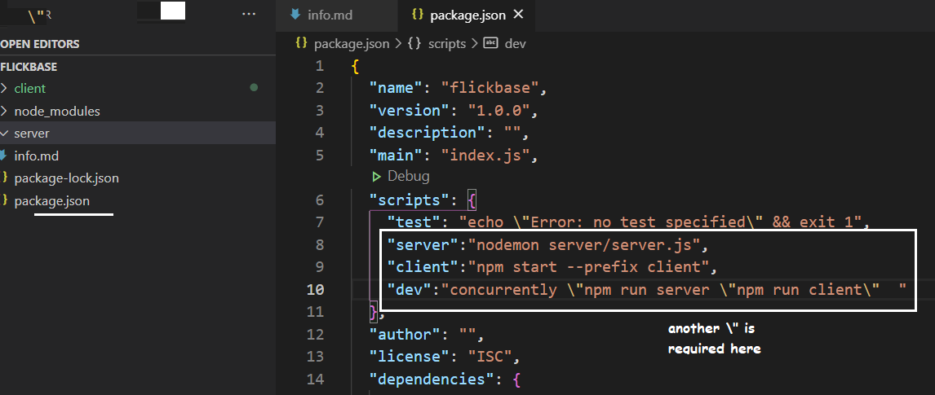

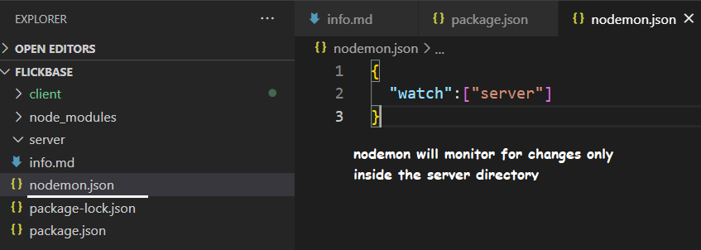

Npm run dev – to open both server and client. This file should be created in the root folder

‘validator’ is for validating mongoose.

Validator usage in schema definition:

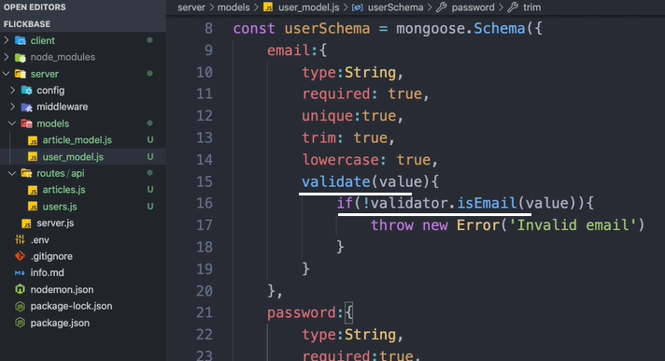

enum=[“admin”,”user”] – can pass only either 1

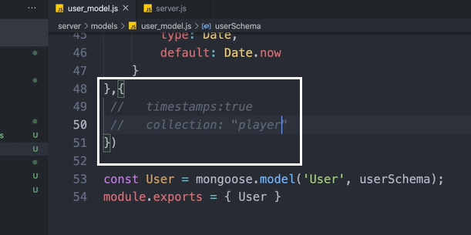

Generating a token is not an async funciton.

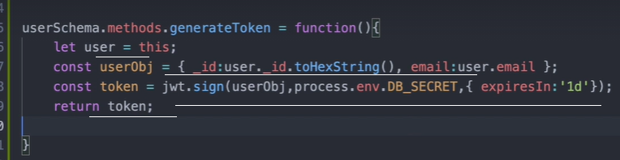tokens can be stored in the database, be compared, blacklisted if needed, manually expire it …

Cookies is server side. Local storage is client/browser side.

Library ‘accesscontrol’ is for role and attributed based access control in Node.js

Role accesscontrol:

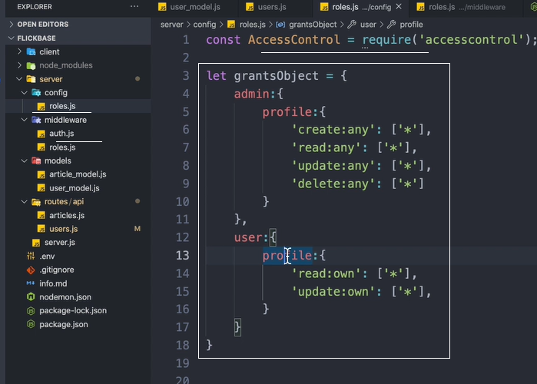

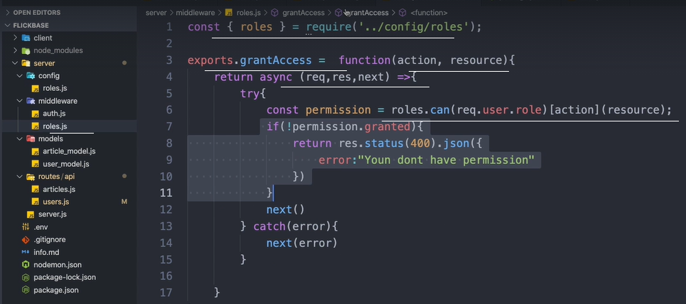

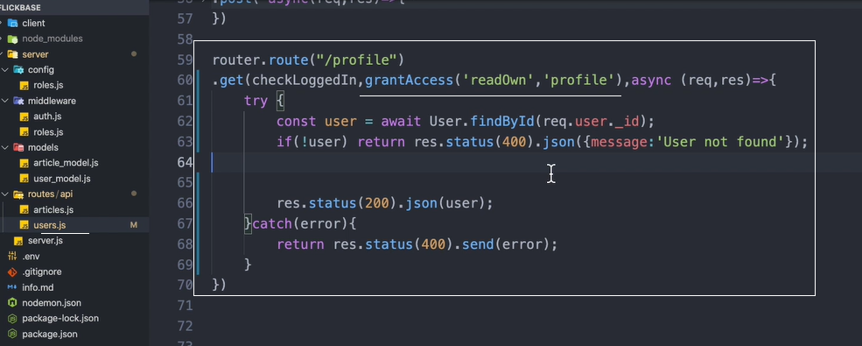

**locals** An object that contains **response local** variables scoped to the request, and therefore available only to the view(s) rendered during that request / **response** cycle (if any). Otherwise, this property is identical to app.

# What is a Callback?

**Simply put:** A callback is a function that is to be executed **after** another function has finished executing — hence the name ‘call back’.

**More complexly put:** In JavaScript, functions are objects. Because of this, functions can take functions as arguments, and can be returned by other functions. Functions that do this are called **higher-order functions**. Any function that is passed as an argument is called a **callback function**.

Callbacks are a way to make sure certain code doesn’t execute until other code has already finished execution.

JavaScript functions are executed in the sequence they are called. Not in the sequence they are defined.

Functions running in parallel with other functions are called asynchronous

Patching/updating database:

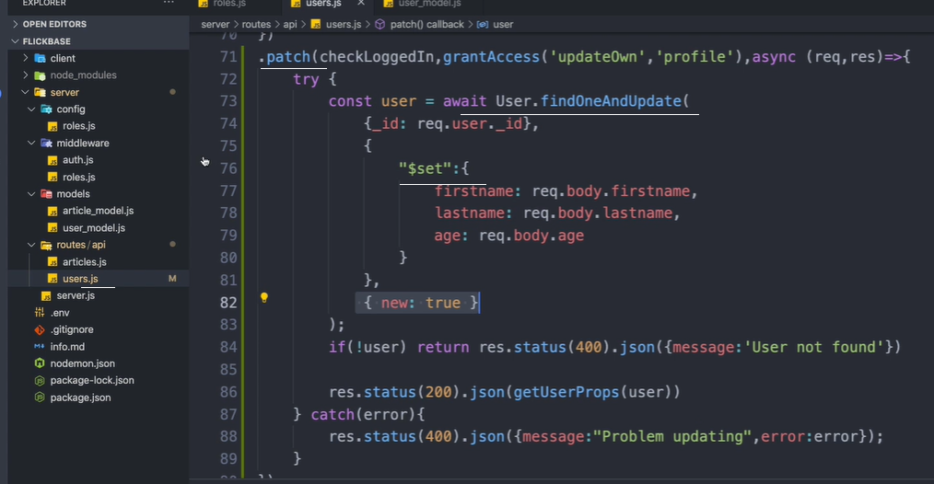

Authorization check router:

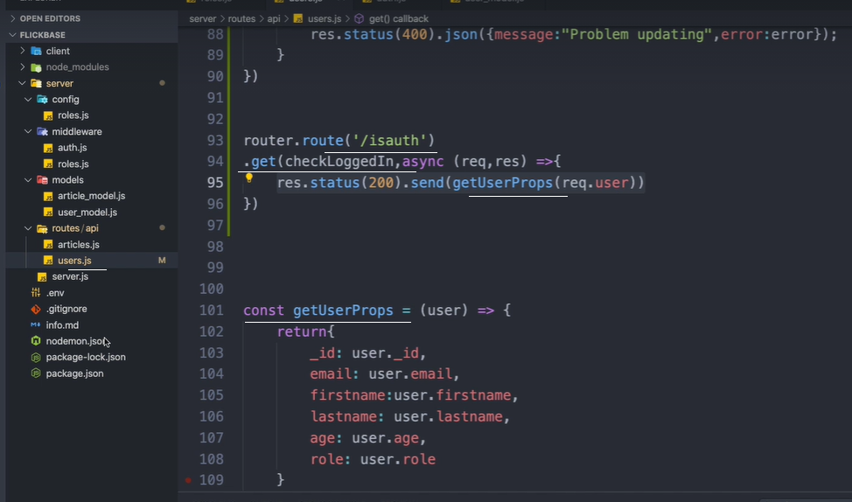

Update email:

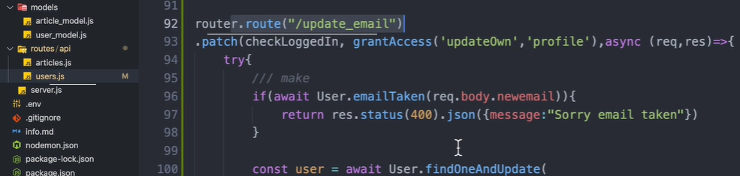

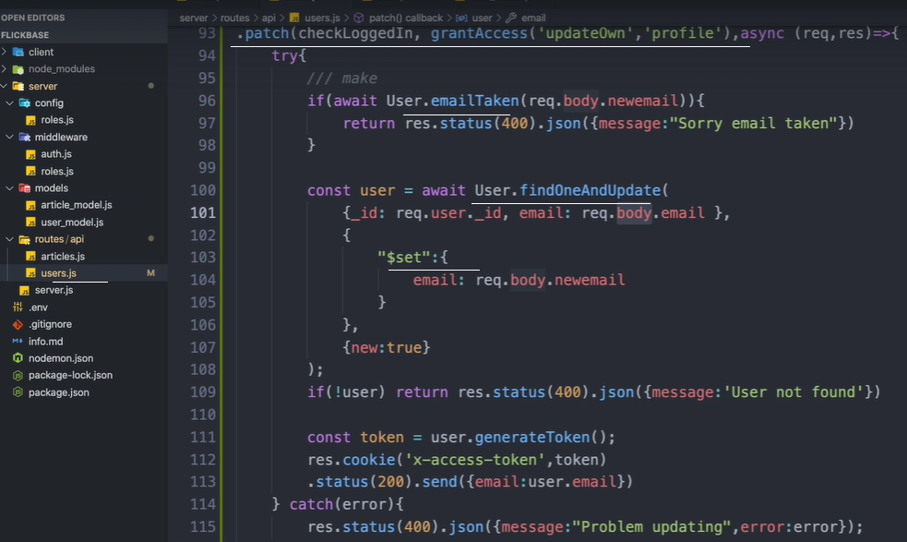

**Async functions** always return a **promise**. If the return value of an **async function** is not explicitly a **promise**, it will be implicitly wrapped in a **promise**.

Types of express middleware

* Application level middleware **app.use**
* Router level middleware **router.use**
* Built-in middleware **express.static,express.json,express.urlencoded**
* Error handling middleware **app.use(err,req,res,next)**
* Thirdparty middleware **bodyparser,cookieparser**

## **Application Level Middleware**

**Example 1 : Auth middleware**

Suppose we are having five routes **getUsers,getDetails,updateDetails,isLoggedIn,isLoggedOut**

every route must be authenticated if the user is not authenticated then he is not able to call the above mentioned routes,so every GET,POST calls required authentication.In this case we build a authtication middleware.

Now once the request comes the auth middleware will do some authentication logic that we have written inside it.Once authentication successful then remaining routed must be called using next()

if auth fails then it wont perform next route exit the middleware with error response logic

## **Router Level Middleware**

Router-level middleware works in the same way as application-level middleware, except it is bound to an instance of express.Router().

const router = express.Router()

Load router-level middleware by using the router.use() and router.METHOD() functions.

## **Error Handing Middleware**

Express JS comes with default error handling params, define error-handling middleware functions in the same way as other middleware functions, except error-handling functions have four arguments instead of three:

**app.use(function (err, req, res, next) {  
 console.error(err.stack)  
 res.status(500).send('Something broke!')  
})**

## **Third-party Middlewares**

In some cases we will be adding some extra features to our backend

Install the Node.js module for the required functionality, then load it in your app at the application level or at the router level.

Example: **body-parser**

All middlewares will populate the req.body property with the parsed body when the Content-Type request header.

**app.use({urlencoded:false})**

Mongoose [models](https://mongoosejs.com/docs/models.html) provide several static helper functions for [CRUD operations](https://en.wikipedia.org/wiki/Create,_read,_update_and_delete). Each of these functions returns a [mongoose Query object](http://mongoosejs.com/docs/api.html#Query).

* [Model.deleteMany()](https://mongoosejs.com/docs/api.html#model_Model.deleteMany)
* [Model.deleteOne()](https://mongoosejs.com/docs/api.html#model_Model.deleteOne)
* [Model.find()](https://mongoosejs.com/docs/api.html#model_Model.find)
* [Model.findById()](https://mongoosejs.com/docs/api.html#model_Model.findById)
* [Model.findByIdAndDelete()](https://mongoosejs.com/docs/api.html#model_Model.findByIdAndDelete)
* [Model.findByIdAndRemove()](https://mongoosejs.com/docs/api.html#model_Model.findByIdAndRemove)
* [Model.findByIdAndUpdate()](https://mongoosejs.com/docs/api.html#model_Model.findByIdAndUpdate)
* [Model.findOne()](https://mongoosejs.com/docs/api.html#model_Model.findOne)
* [Model.findOneAndDelete()](https://mongoosejs.com/docs/api.html#model_Model.findOneAndDelete)
* [Model.findOneAndRemove()](https://mongoosejs.com/docs/api.html#model_Model.findOneAndRemove)
* [Model.findOneAndReplace()](https://mongoosejs.com/docs/api.html#model_Model.findOneAndReplace)
* [Model.findOneAndUpdate()](https://mongoosejs.com/docs/api.html#model_Model.findOneAndUpdate)
* [Model.replaceOne()](https://mongoosejs.com/docs/api.html#model_Model.replaceOne)
* [Model.updateMany()](https://mongoosejs.com/docs/api.html#model_Model.updateMany)
* [Model.updateOne()](https://mongoosejs.com/docs/api.html#model_Model.updateOne)

When need to specify multiple elements into the schema object, declare as below:

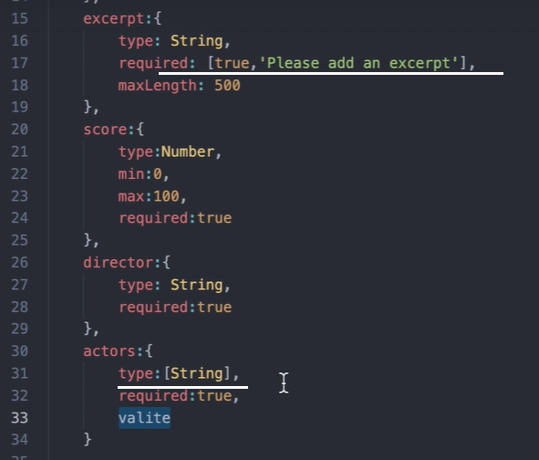

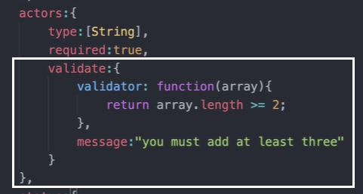

While updating / patching the database through the router, we need to pass 3 things: 1) what to be updated, 2) how to be updated, 3) what to be returned after the update.

Receiving params from the route:

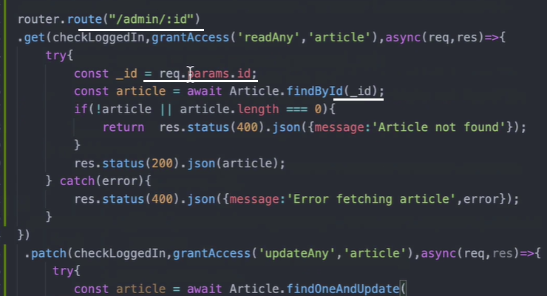

Get all from the req body to update:

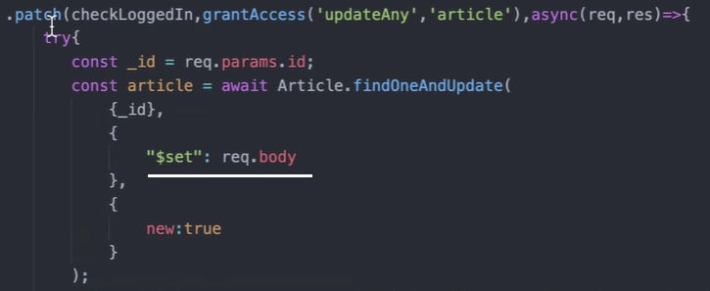

An HTTP **PUT** method is used to primarily update the resource information but it also can be used to create a new resource (Depends on API development) if the requested resource is not available. If a **PUT** request is made to update a resource, it should return 200 (OK) and 204 (No Content) status codes.

Find by more than one condition:

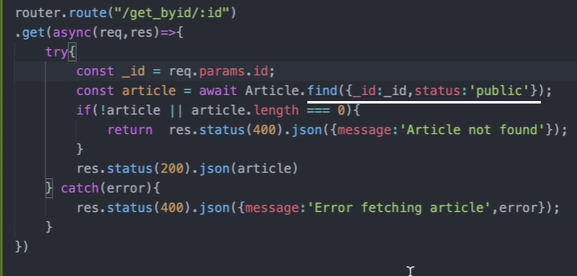

Sorting helper function:

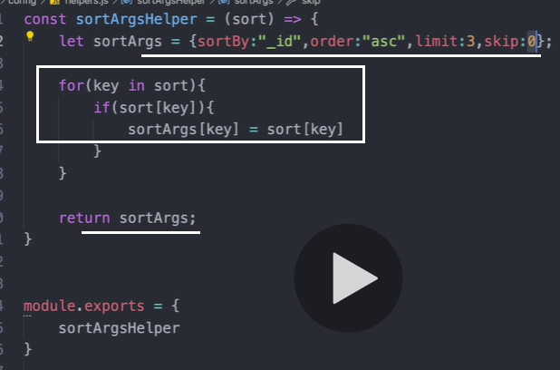

Sorting route:

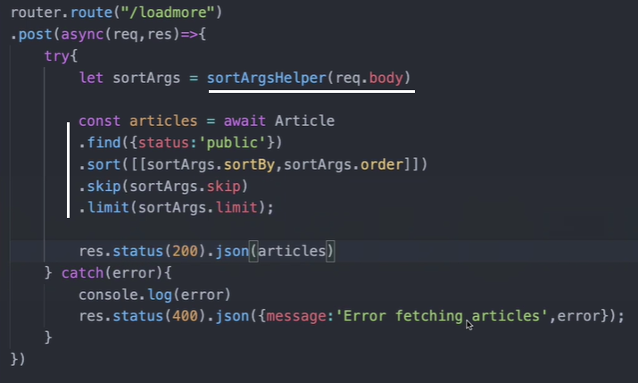

For pagination, install mongoose-aggregate-paginate-v2

|  |
| --- |
| const mongoose = require('mongoose'); |
|  | **const aggregatePaginate = require('mongoose-aggregate-paginate-v2');** |
|  | require('dotenv').config(); |
|  |  |
|  |  |
|  | const articleSchema = mongoose.Schema({ |
|  | title:{ |
|  | type:String, |
|  | maxLength:100, |
|  | required: [ true,'You need a title'] |
|  | }, |
|  | content:{ |
|  | type:String, |
|  | required: [ true,'You need some content'] |
|  | }, |
|  | excerpt:{ |
|  | type: String, |
|  | required: [true,'Please add an excerpt'], |
|  | maxLength: 500 |
|  | }, |
|  | score:{ |
|  | type:Number, |
|  | min:0, |
|  | max:100, |
|  | required:true |
|  | }, |
|  | director:{ |
|  | type: String, |
|  | required:true |
|  | }, |
|  | actors:{ |
|  | type:[String], |
|  | required:true, |
|  | validate:{ |
|  | validator: function(array){ |
|  | return array.length >= 2; |
|  | }, |
|  | message:"you must add at least three" |
|  | } |
|  | }, |
|  | status:{ |
|  | type: String, |
|  | required:true, |
|  | enum:['draft','public'], |
|  | default: 'draft', |
|  | index:true |
|  | }, |
|  | date:{ |
|  | type: Date, |
|  | default: Date.now |
|  | } |
|  | }); |
|  |  |
|  | **articleSchema.plugin(aggregatePaginate);** |
|  |  |
|  | const Article = mongoose.model('Article',articleSchema); |
|  | module.exports = { Article } |

|  |
| --- |
| router.route("/admin/paginate") |
|  | **.post(checkLoggedIn,grantAccess('readAny','articles'),async(req,res)=>{** |
|  | **try{** |
|  |  |
|  | **// let aggQuery = Article.aggregate([** |
|  | **// { $match: { status:"public" }},** |
|  | **// { $match: { title:{ $regex:/Lorem/ }}}** |
|  | **// ])** |
|  |  |
|  | **const limit = req.body.limit ? req.body.limit : 5;** |
|  | **const aggQuery = Article.aggregate();** |
|  | **const options = {** |
|  | **page: req.body.page,** |
|  | **limit,** |
|  | **sort:{_id:'asc'}** |
|  | **}** |
|  |  |
|  | **const articles = await Article.aggregatePaginate(aggQuery,options);** |
|  | **res.status(200).json(articles)** |
|  | **} catch(error){** |
|  | **res.status(400).json({message:'Error',error});** |
|  | **}** |
|  | **})** |

Material-ui is much harder than bootstrap. Npm install @material-ui/core

Npm insall react-google-font-loader

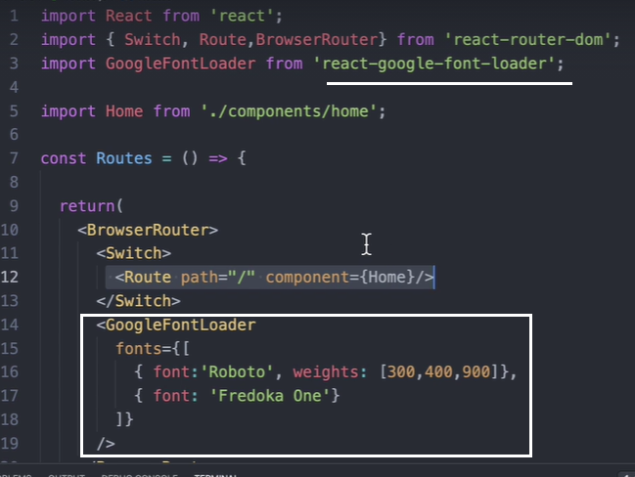

To apply, <div style={{fontFamily:’Fredoka One’}} />

Front-end middlewares: redux-thunk, redux-promise

Redux thunk has many other funcitons than redux-promise. It can be used to access the state, can dispatch multiple actions.

React-toastify for global notification in the application regarding some server error

Top application component:

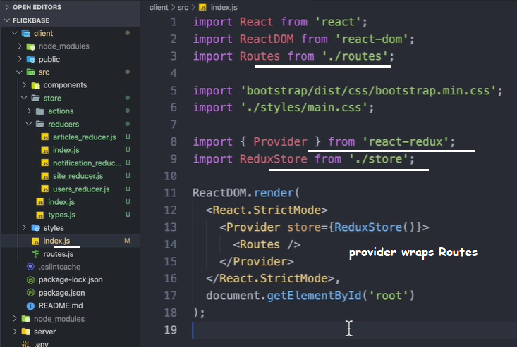

**What is** the **difference between NavLink** and **Link**? The **Link** component **is** used to navigate **the different** routes on the site. But **NavLink is** used to add the style attributes to the active routes

It has an activeClassName property.

withRouter(component) – will inject all the props to the component. When the component is placed outside of the switch BrowserRouter.

# What is React.lazy()

It is a new function in react that lets you load react components lazily through code splitting without help from any additional libraries. Lazy loading is the technique of rendering only-needed or critical user interface items first, then quietly unrolling the non-critical items later. It is now fully integrated into core react library itself. We formerly used react-loadable to achieve this but now we have react.lazy() in react core.

# Suspense

Suspense is a component required by the lazy function basically used to wrap lazy components. Multiple lazy components can be wrapped with the suspense component. It takes a fallback property that accepts the react elements you want to render as the lazy component is being loaded.

Import { Suspense, lazy } from ‘react’

const Artists = React.lazy(() => import('./Artists'));  
  
function MyComponent() {  
return (  
<div>  
<Suspense **fallback**={<div>Loading...</div>}>  
<Artists />  
</Suspense>  
</div>  
);  
}

service to store images: bucket

for images, <https://picsum.photos/200>

setState will merge the state with the old state. useState will overwrite the prevous state.

useReducer have access to both previous state and new state.

React’s useContext hook makes it easy to pass data throughout your app without manually passing props down the tree.

context = React.createContext({color:’blue’)

uContext = useContext(context)

getState:

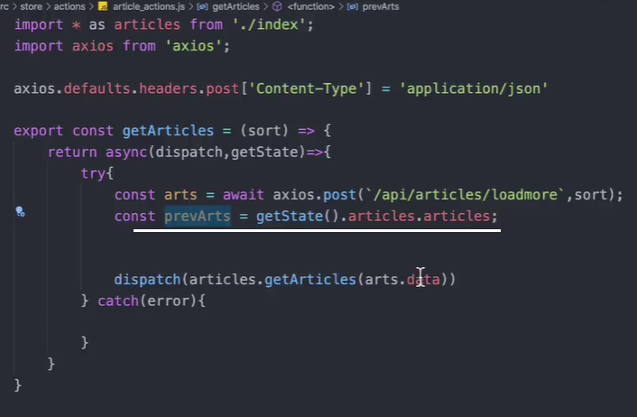

**Redux Thunk** is a middleware that lets you call action creators that return a function instead of an action object. That function receives the store's dispatch method, which is then used to dispatch regular synchronous actions inside the function's body once the asynchronous operations have been completed.

Flow:

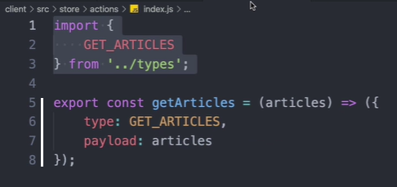

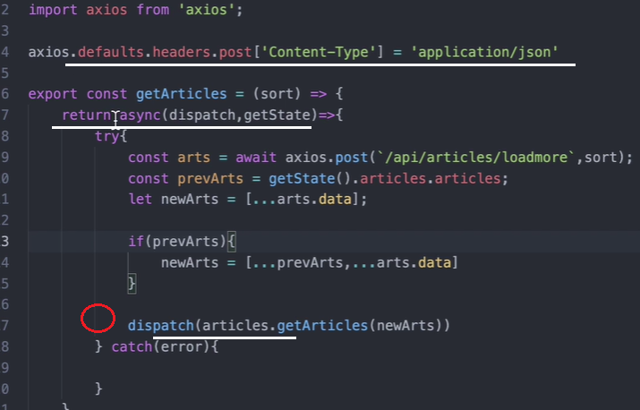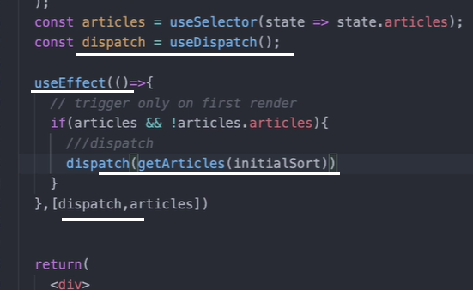

Toastify:

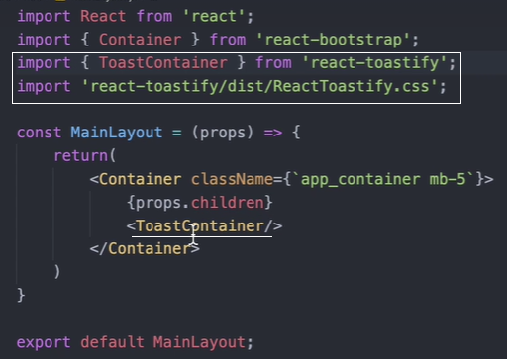

If useEffect uses a property inside its function body, it has to be specified in the dependency array.

Npm install react-cookies – to manage cookies in react. There is another one called react-cookie – much harder.

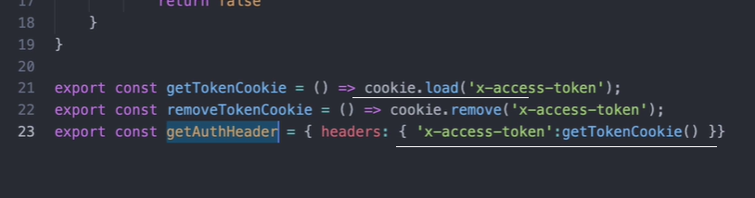

Call the getAuthHeader inside axios.get()

Auto signin – in video 157. The logic is, when the user refresh his browser, he is logged out. But using his token taken from the cookies, gets all the information about the user and reloads the user.

**React** Router **Guards** provides a middleware API for **React** Router, allowing you to perform complex logic between the call for navigation and the final render of a **route.**

For changing the layout dynamically, call the function with the classname as the argument based on the state value.

To guard a component, wrap it within another one in the router with the logic inside the wrapper component.

Formik:

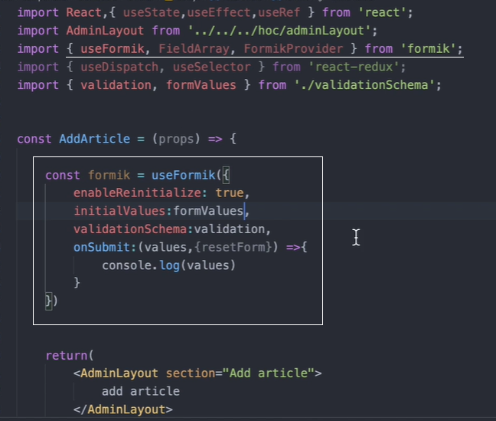

React-draft-wysiwyg, draft-js

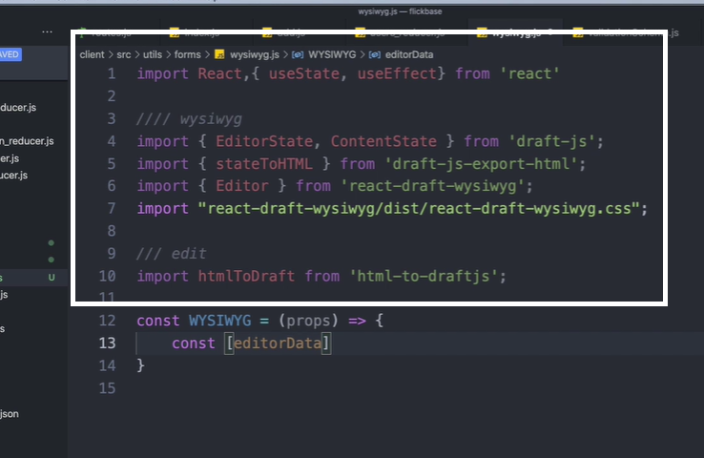

Pagination video 175,76

Formik errorHelper:

|  |
| --- |
| const errorHelper = (formik, values) => ({ |
|  | error: formik.errors[values] && formik.touched[values] ? true:false, |
|  | helperText: formik.errors[values] && formik.touched[values] ? formik.errors[values] : null |
|  | }); |

------------

In the <TextField {…errorHelper(formik, ‘email’} />

Es6 is ecma6

‘let’ has its own scope

For .. loops are not used in es6

String interpolation is also called template strings

String.raw(`sfsfs\nsfsd\nsfss`) – to print raw string including the special characters.

Javascript helpers:

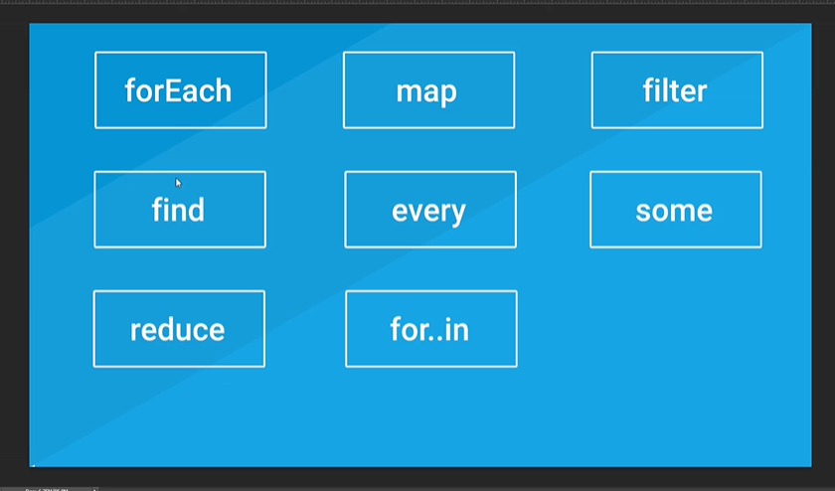

forEach:

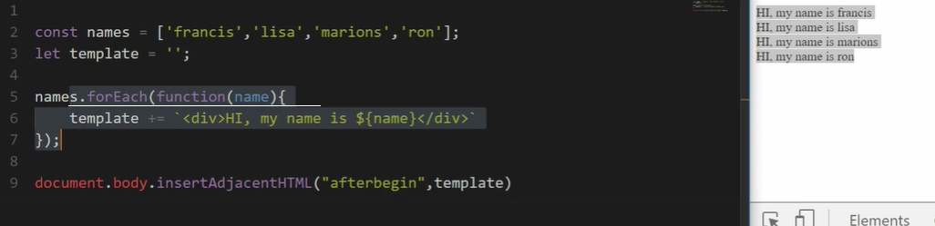

Function inside foreach:

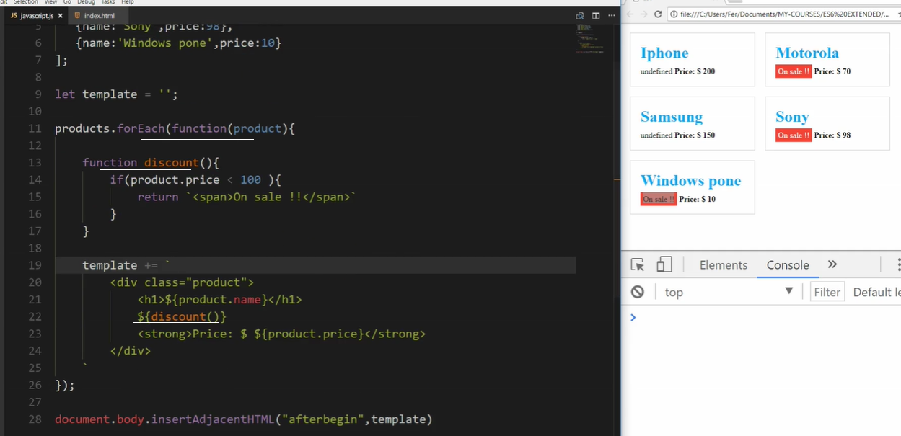

Array.map():

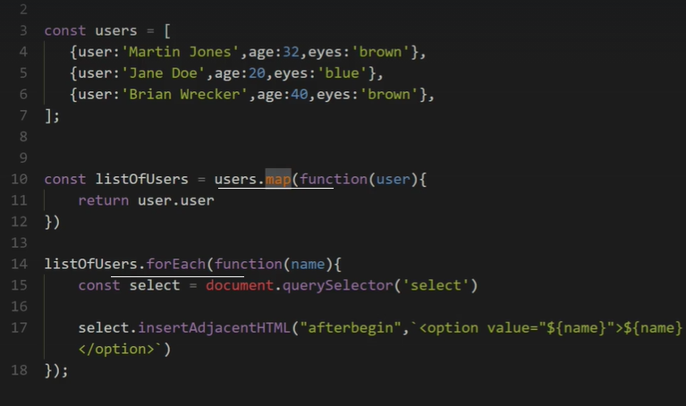

The querySelector() method returns the first element that matches a specified CSS selector(s) in the document.

**Note:** The querySelector() method only returns the first element that matches the specified selectors. To return all the matches, use the [querySelectorAll()](https://www.w3schools.com/jsref/met_document_queryselectorall.asp) method instead.

Map and foreach follow the same idea.

‘this’: with es5 function to reach the object scope within a function

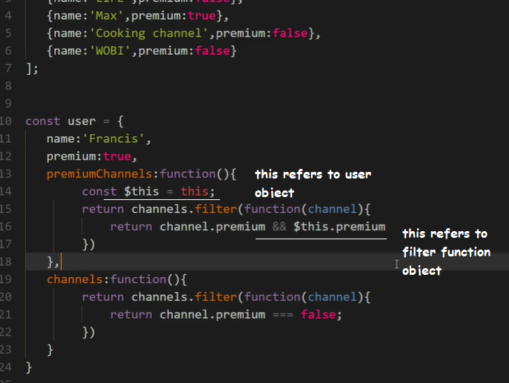

Find:

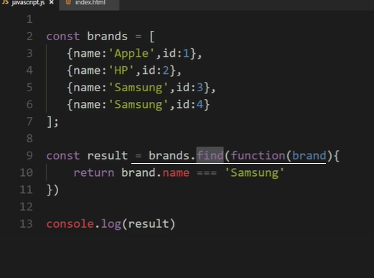

Find returns 1 where as filter returns all true.

Every: returns true if the conditon is true for all the elements of the array.

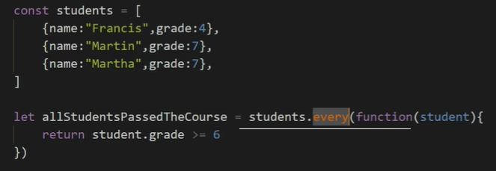

Some: if any of the condition is true, returns true

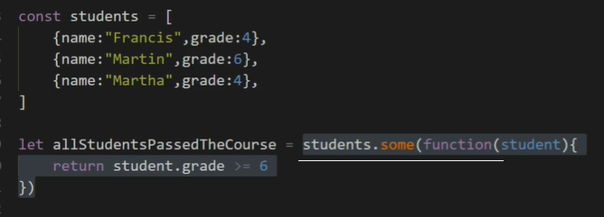

Reduce:

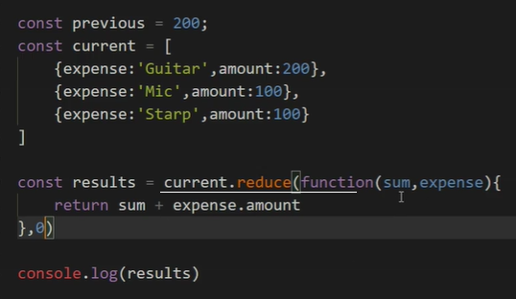

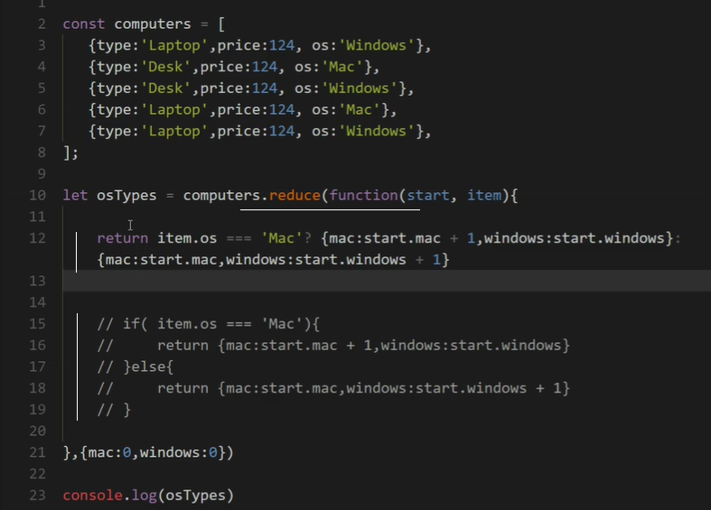

For…of

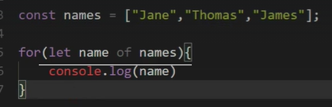

Generators use for… of

|  |
| --- |
| **Brackets** |
| |  |  |  |  | | --- | --- | --- | --- | | **( )** | **{ }** | **[ ]** | **⟨ ⟩** | | **Parentheses ()** or **round brackets** | **Braces {}** or **curly brackets** | **Brackets []** or **square brackets** | **Chevrons <>** or **angle brackets** | |

Object literals: properties don’t need keys if the value is the same.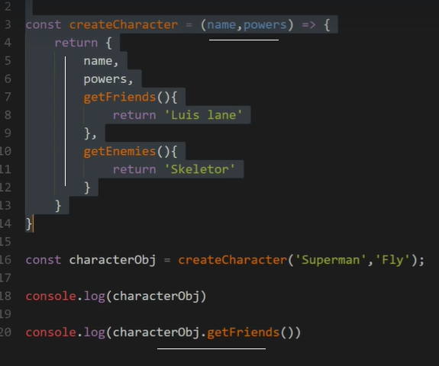

Default function arguments:

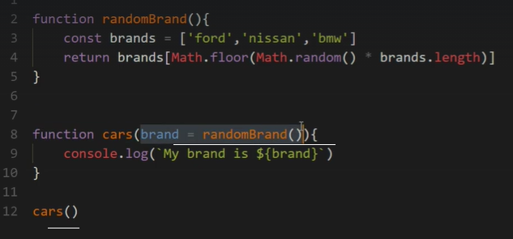

Rest operator:

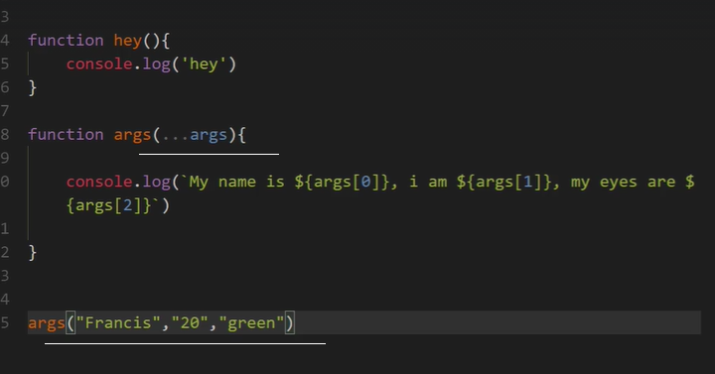

Spead operator:

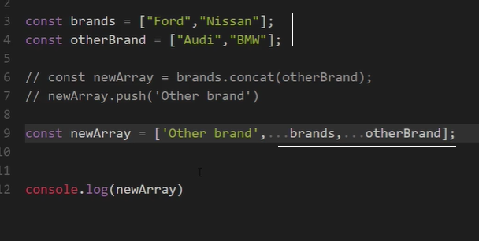

Function prototype:

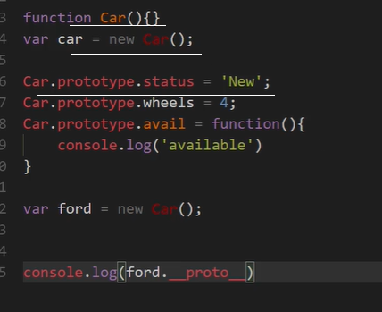

In object destructuring, reference is given to the object properties, where as in array destructuring, variables are accessing the array elements by position.

Accessing an array inside an object:

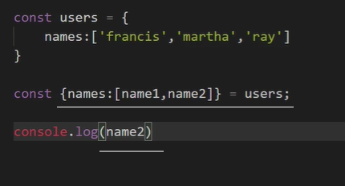

Defining a function with destructured parameters where the order of parameters doesn’t matter.

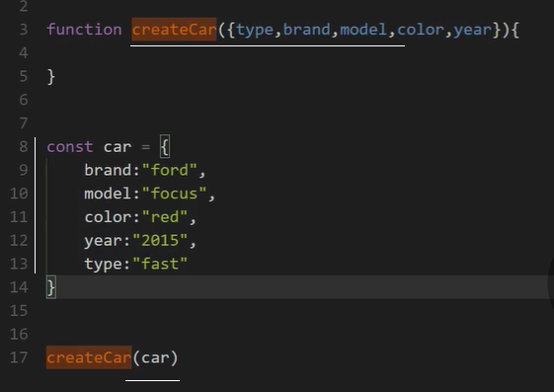

A promise flow:

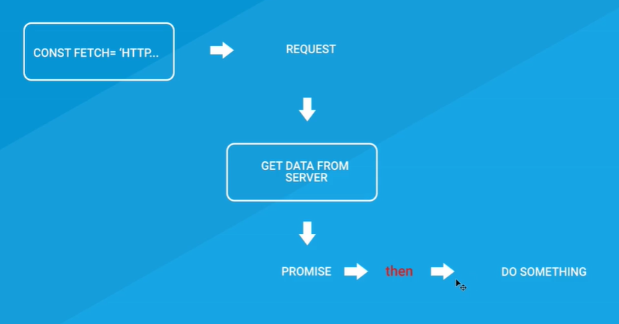

In promises, ‘then’ catches the resolved event and ‘catch’ the rejected event.

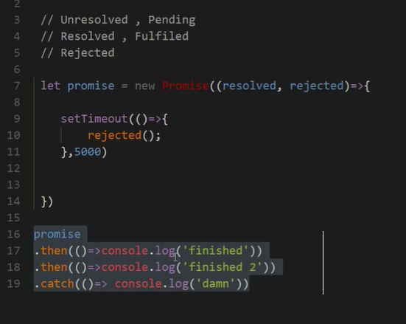

String methods: word.repeat(), includes, endsWith, startsWith, indexOf

Number methods starts from ‘Number’.isSafeInteger(1232), Number.isInteger(100)

A for loop can enter a generator and call next()

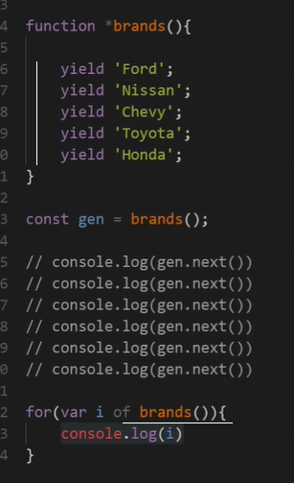

Generator using an object:

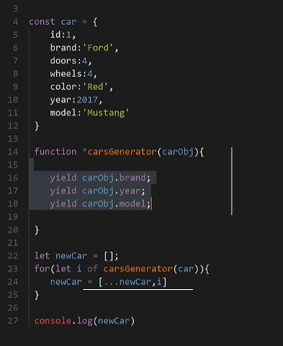

Delegating a generator inside another one.

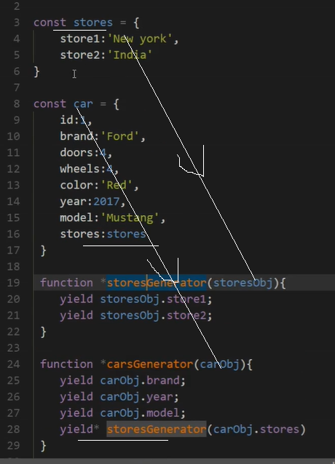

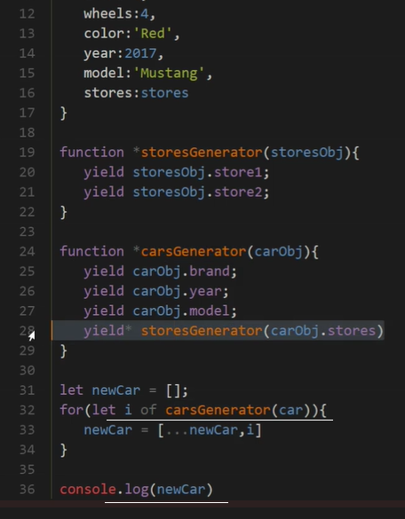

Set: will have no duplicates

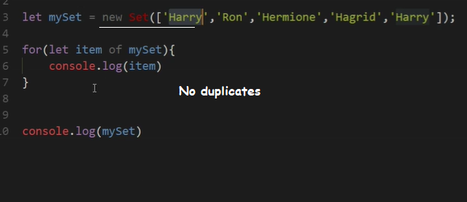

Converting a set to an array to use array helpers:

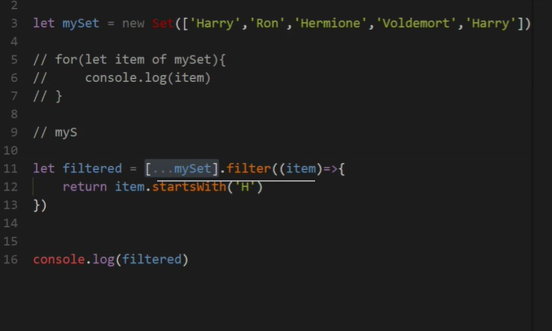

Map:

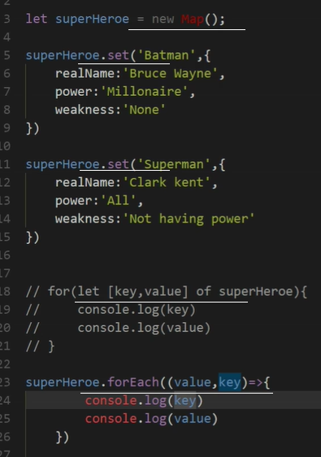

Array.from keys() values()

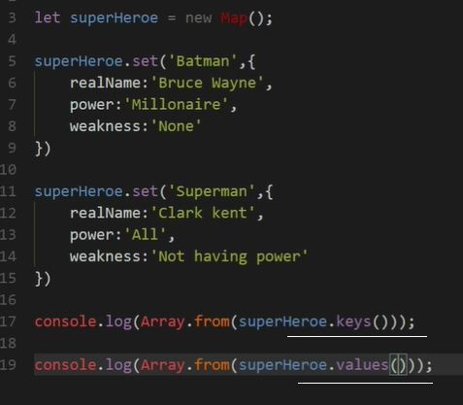

Using array.from to extract values from Map and to use array helpers

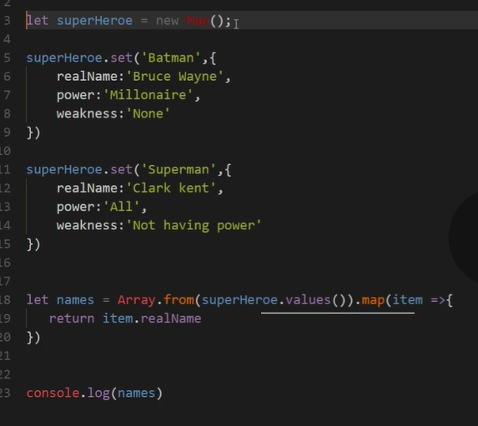

**ZERO TO MASTERY**

Basic html elements:

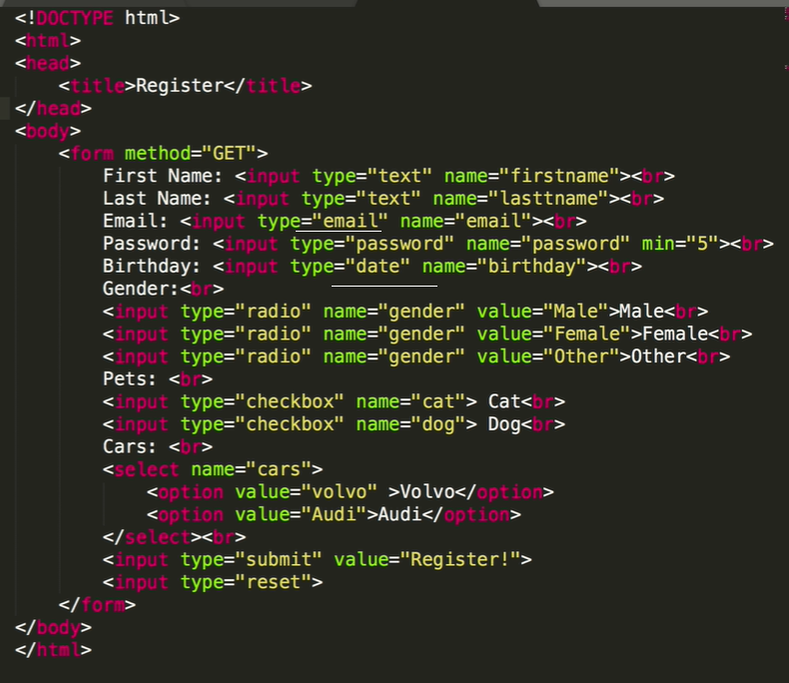

New HTML5 semantics:

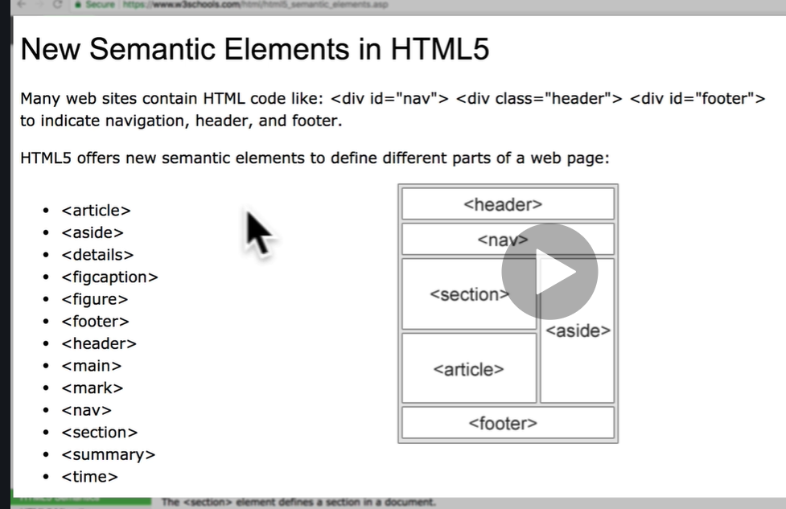

Input restrictions:

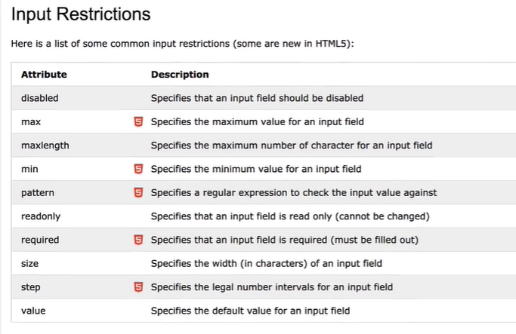

Css syntax: selector { property: value }

Separation of concerns: html, css, js …

Css-tricks.com for css // <https://paletton.com/> for color

Css selectors:

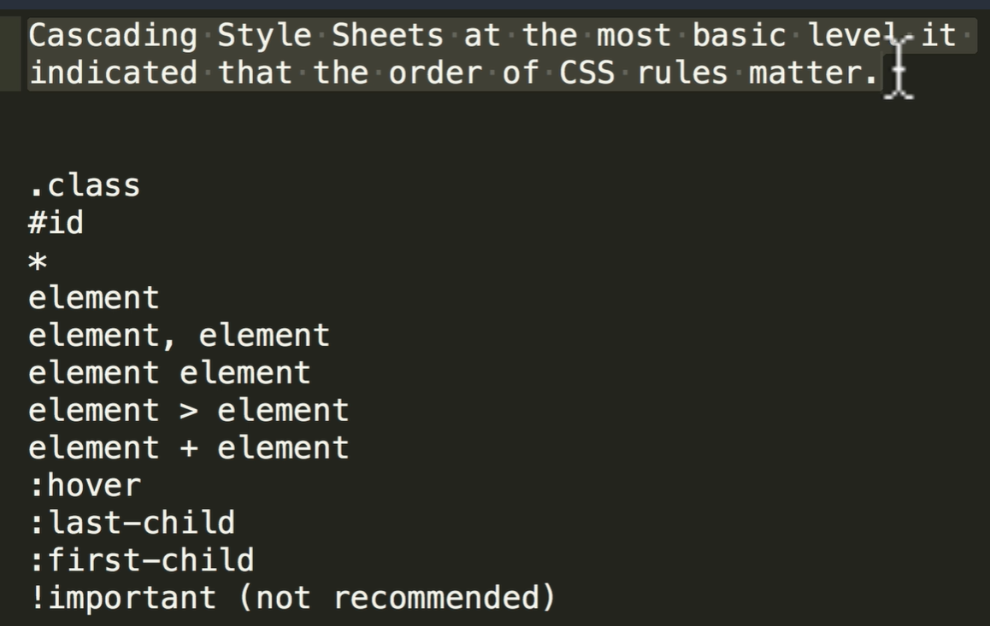

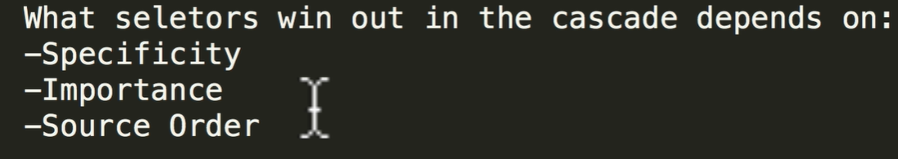

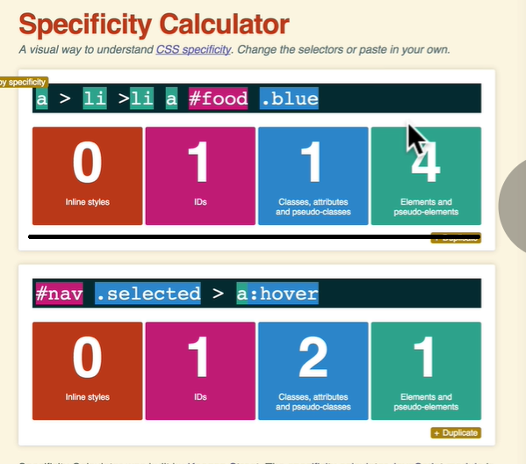

Inline, id, class, element

Font: 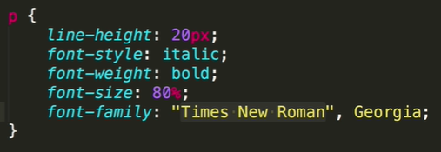

Font-size: em // rem

<http://flexboxfroggy.com/>

flexbox properties:

* **justify-content: flex-start, flex-end, center, space-between, space-around**
* **align-items: flex-start, flex-end, baseline, stretch, center**
* **flex-direction: row, row-reverse, column, column-reverse**
* **order: 0, 1, 2 ..**
* **align-self: flex-start, flex-end, baseline, stretch, center**
* **flex-wrap: wrap, nowrap, wrap-reverse**
* **flex-flow: shorthand for flex-direction and flex-wrap**
* **align-content****: flex-start, flex-end, center, space-between, space-around**

Grid has grid-template-columns and grid-template-rows. Grid-column, grid-row, grid-column-start, grid-column-end, span px,em,fr,%, gap, auto, justify-items: start/end, repeat(auto-fill, 20%) repeat(auto-fill, minmax(200px, 1fr)

in css, -1 signifies the end of viewport. Align-self: end

Transition, trnsform, translate are css3 features.

Responsive ui looks pefect in all devices.

Bootstrap Javascript source files are added to the html inorder to implement actions.

Bootstrap Grid:

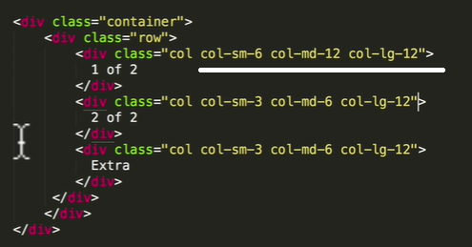

Mailchimp – for free mail service

Css grid, flexbox

<https://grid.malven.co/>

narmalizing css means changing the default css settings of the browser.

JavaScript supports different kinds of loops:

* [**for**](https://www.w3schools.com/jsref/jsref_for.asp)- loops through a block of code a number of times
* [**for/in**](https://www.w3schools.com/jsref/jsref_forin.asp)- loops through the properties of an object
* [**for/of**](https://www.w3schools.com/jsref/jsref_forof.asp) - loops through the values of an iterable object
* **while**- loops through a block of code while a specified condition is true
* [**do/while**](https://www.w3schools.com/jsref/jsref_dowhile.asp) - loops through a block of code once, and then repeats the loop while a specified condition is true

**Tip:** Use the [break](https://www.w3schools.com/jsref/jsref_break.asp) statement to break out of a loop, and the [continue](https://www.w3schools.com/jsref/jsref_continue.asp) statement to skip a value in the loop.

A funcion inside an object is called a method.

DOM selectors:

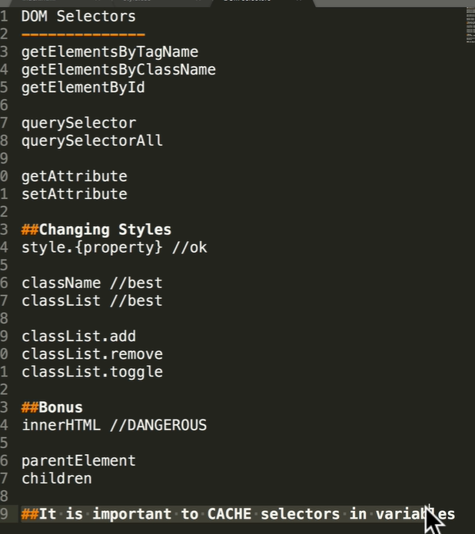

Type coercion is converting one type of the operand to another by the JS engine.

Array.flat(levelofflat) // arrayMap.flat()

Object.fromEntries(array) converts an array into an object – es10 feature

Object.entries(object) converts an object into an array

In es10, try {} catch don’t need to specify an ‘error’

Javascript is a single threaded language that is non-blocking.

Javascript engines convert to machine language, has memory heap and call stack.

KNEX.JS to connect with RDBMS databases

Npm install knex

Npm install pg

Node.JS is an opensource, cross platform runtime environment for executing javascript code outside of a browser. Its often used to build API services.

Specific features introduced by ECMAScript 2020 include:

* A “function-like” [import()](https://github.com/tc39/proposal-dynamic-import) module loading syntax to asynchronously import modules with a dynamic specifier. The proposal adds an import(specifier) syntactic form, acting in many ways like a function. It returns a promise for the module namespace object of the requested module, created after fetching, instantiating, and evaluating a module’s dependencies, along with the module itself. The specifier will be interpreted the same way as in an import declaration. While specifier is a string, it is not necessarily a string literal; thus, code like import(`./language-packs/${navigator.language}.js`) will work. This was not possible with the usual import declarations. With the plan, import() is proposed to work in both modules and scripts, giving script code an easy asynchronous entry point into the module world and allowing it to start running module code.
* [BigInt](https://github.com/tc39/proposal-bigint), a new number primitive for working with arbitrary precision integers. BigInt can represent numbers larger than two to the 53rd power, the largest number JavaScript can represent reliably with the Number primitive. A BigInt is created by appending n to the end of the integer or by calling the constructor.
* The [matchAll](https://github.com/tc39/proposal-string-matchall) method for strings, to produce an iterator for all matched objects generated by a global regular expression. The rationale behind this proposal is that if a developer has a string and either a sticky or a global regular expression with multiple capturing groups, the developer might want to iterate through all the matches, for which there are currently several options but with limitations. String#matchAll addresses issues by providing access to all capturing groups and not visibly mutating the regular expression object in question.
* [Promise.allSettled](https://github.com/tc39/proposal-promise-allSettled), a new Promise combinator that does not short-circuit. This returns a promise that is fulfilled with an array of promise state snapshots, but only after the original promises have settled, i.e. have been either fulfilled or rejected.
* [globalThis](https://github.com/tc39/proposal-global), providing a universal way to access the global this value.
* A dedicated [export * as ns from ‘module’](https://github.com/tc39/ecma262/pull/1174) syntax to use within modules.
* Increased standardization of [for-in enumeration order](https://github.com/tc39/proposal-for-in-order), partially specifying enumeration order in JavaScript.
* [import.meta](https://github.com/tc39/proposal-import-meta), a host-populated object in Modules that can contain contextual information. This serves as a JavaScript metaproperty, holding host-specific metadata about the current module.
* [Nullish coalescing](https://github.com/tc39/proposal-nullish-coalescing), a value selection operator for better handling of cases involving property accesses. It is a syntax feature to improve working with “nullish” values (null or undefined).
* [Optional chaining](https://github.com/tc39/proposal-optional-chaining), a property access and function invocation operator that will short-circuit if the value to access/invoke is nullish.

Node.js implements Chromes’ V8 JS engine. Node is not a framework.

Non-blocking nature of Node.js is asynchronous in nature.

Node should not be used for CPU intensive applications like image manipulation, video encoding.

Node monitors ‘event Q’ for responses from asynchronous code.

In Node, insteady of Window like in the browser, we have ‘global’ object.

Jshint is a tool to check for js errors

Module wrapper function autmatically used by Node:

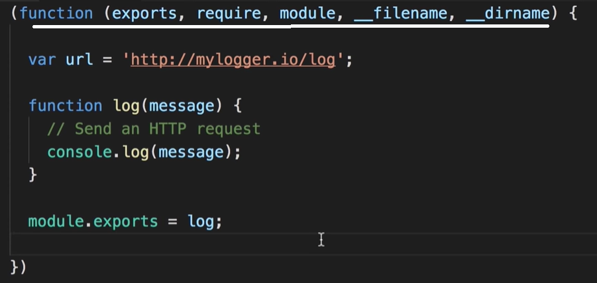

The **full form** of ECMA is European Computer Manufacturer's Association. **ECMAScript** is a Standard for scripting languages such as JavaScript, JScript, etc. It is a trademark scripting language specification. JavaScript is a language based on **ECMAScript**.

Here is a list of the built-in modules of Node.js version 6.10.3:

|  |  |
| --- | --- |
| **Module** | **Description** |
| [assert](https://www.w3schools.com/nodejs/ref_assert.asp) | Provides a set of assertion tests |
| [buffer](https://www.w3schools.com/nodejs/ref_buffer.asp) | To handle binary data |
| child_process | To run a child process |
| [cluster](https://www.w3schools.com/nodejs/ref_cluster.asp) | To split a single Node process into multiple processes |
| [crypto](https://www.w3schools.com/nodejs/ref_crypto.asp) | To handle OpenSSL cryptographic functions |
| [dgram](https://www.w3schools.com/nodejs/ref_dgram.asp) | Provides implementation of UDP datagram sockets |
| [dns](https://www.w3schools.com/nodejs/ref_dns.asp) | To do DNS lookups and name resolution functions |
| domain | Deprecated. To handle unhandled errors |
| [events](https://www.w3schools.com/nodejs/ref_events.asp) | To handle events |
| [fs](https://www.w3schools.com/nodejs/ref_fs.asp) | To handle the file system |
| [http](https://www.w3schools.com/nodejs/ref_http.asp) | To make Node.js act as an HTTP server |
| [https](https://www.w3schools.com/nodejs/ref_https.asp) | To make Node.js act as an HTTPS server. |
| [net](https://www.w3schools.com/nodejs/ref_net.asp) | To create servers and clients |
| [os](https://www.w3schools.com/nodejs/ref_os.asp) | Provides information about the operation system |
| [path](https://www.w3schools.com/nodejs/ref_path.asp) | To handle file paths |
| punycode | Deprecated. A character encoding scheme |
| [querystring](https://www.w3schools.com/nodejs/ref_querystring.asp) | To handle URL query strings |
| [readline](https://www.w3schools.com/nodejs/ref_readline.asp) | To handle readable streams one line at the time |
| [stream](https://www.w3schools.com/nodejs/ref_stream.asp) | To handle streaming data |
| [string_decoder](https://www.w3schools.com/nodejs/ref_string_decoder.asp) | To decode buffer objects into strings |
| [timers](https://www.w3schools.com/nodejs/ref_timers.asp) | To execute a function after a given number of milliseconds |
| [tls](https://www.w3schools.com/nodejs/ref_tls.asp) | To implement TLS and SSL protocols |
| tty | Provides classes used by a text terminal |
| [url](https://www.w3schools.com/nodejs/ref_url.asp) | To parse URL strings |
| [util](https://www.w3schools.com/nodejs/ref_util.asp) | To access utility functions |
| v8 | To access information about V8 (the JavaScript engine) |
| [vm](https://www.w3schools.com/nodejs/ref_vm.asp) | To compile JavaScript code in a virtual machine |
| [zlib](https://www.w3schools.com/nodejs/ref_zlib.asp) | To compress or decompress files |

All asynchronous function takes a function as its last argument. Node will invoke this callback function when then asynchronous function returns.

Event emitter:

const EventEmitter = require('events')

const emitter = new EventEmitter()

function doEmit(){

  emitter.emit("onevent", {name:"Jaison"})

}

emitter.on('onevent', (name)=> console.log('onevent raised',name))

setTimeout(() => {

  doEmit()

}, 1000);

Output: onevent raised { name: 'Jaison' }

Express framework is built on top of http module in Node to handle routes efficiently.

NODE JS – EDUREKA

NodeJs used to develop server side web applications in JS. It compiles JS code into machine code.

In a multithreaded model, a shared resource is locked with one thread.

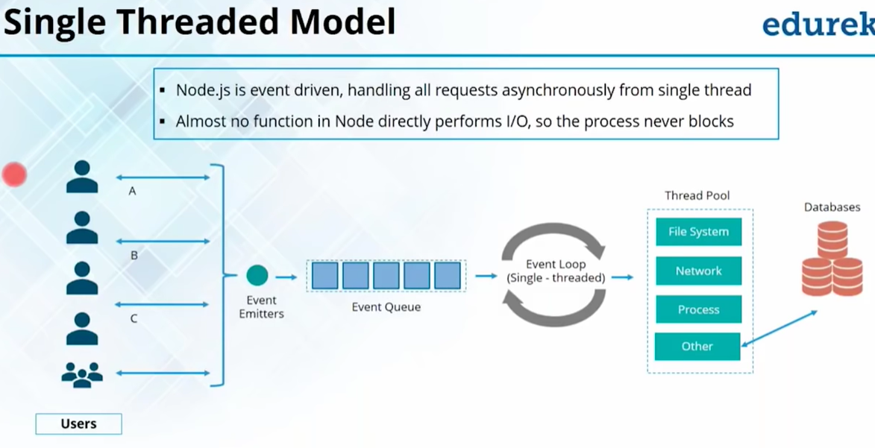

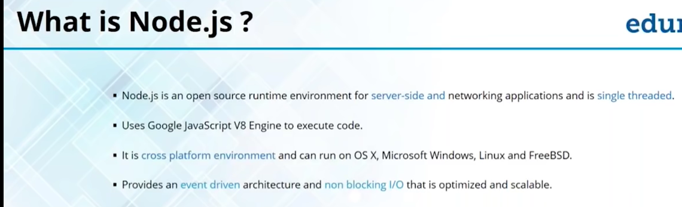

No buffering in nodejs. It sends data in chunks

Notification mechanishm of asynchronous function is callback

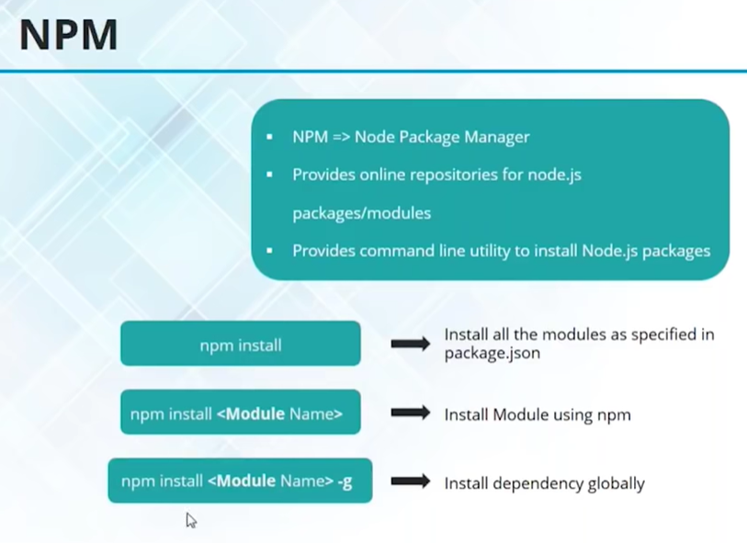

setTimeout, setInterval, setImmediate // clearTimeout, clearInterval, clearImmediate

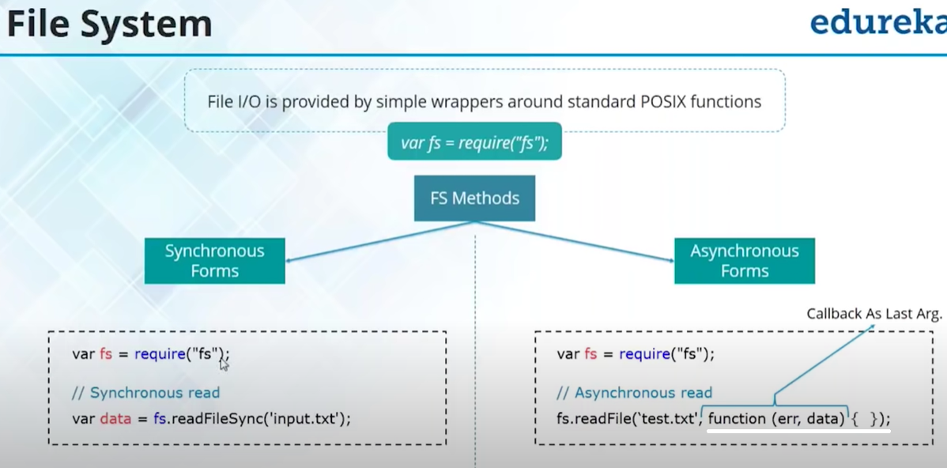

Callback:

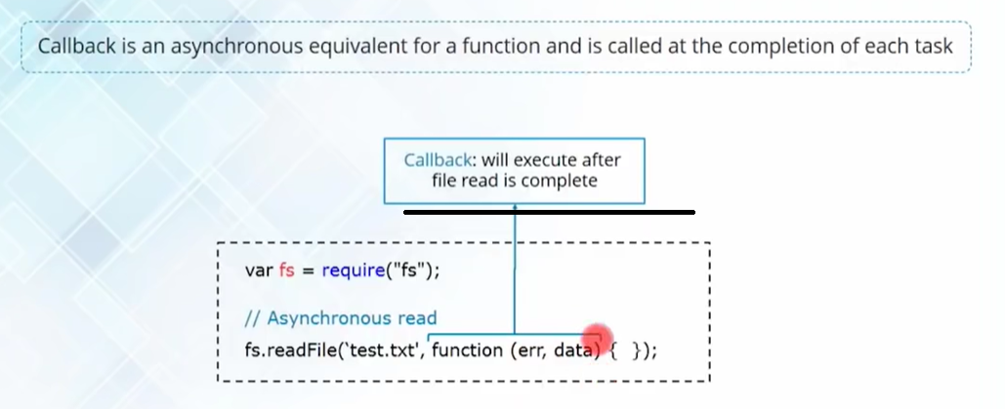

Event emitter:

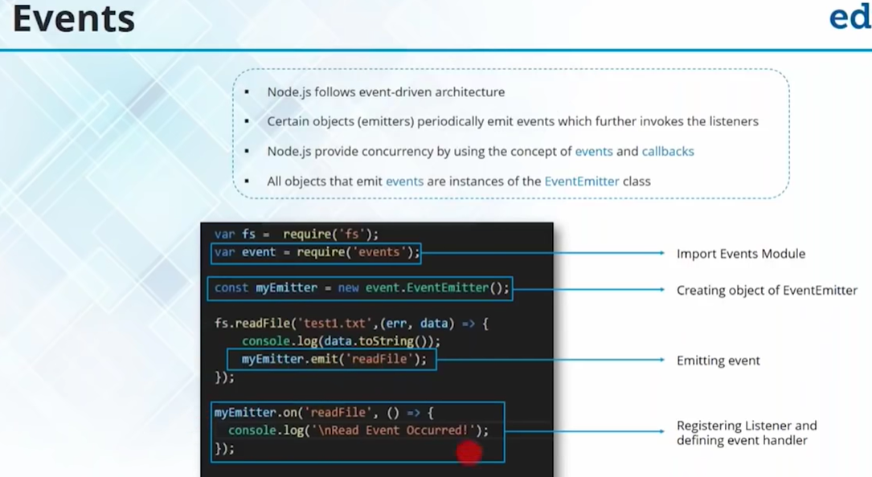

http:

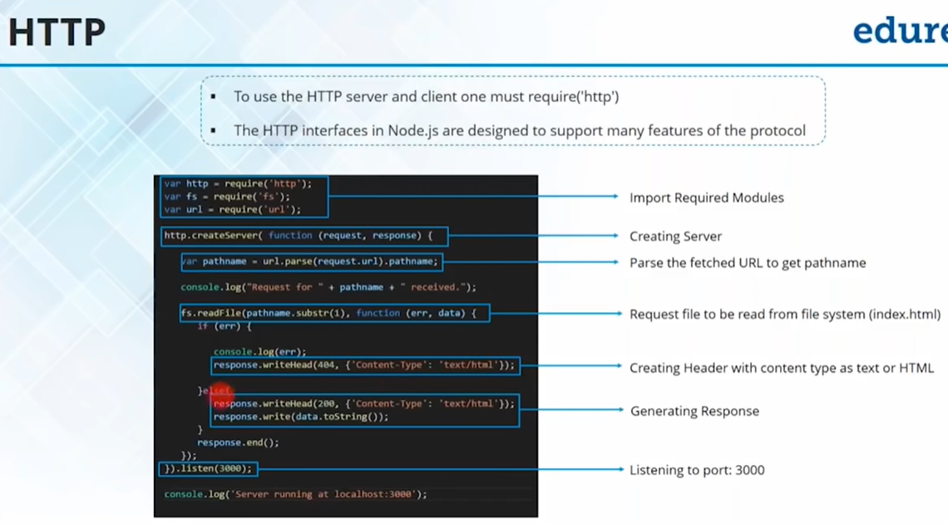

couchDB jade nano errorhandler url serve-favicon logger json express-session method-override

npm install express-generator // express

principles of REST:

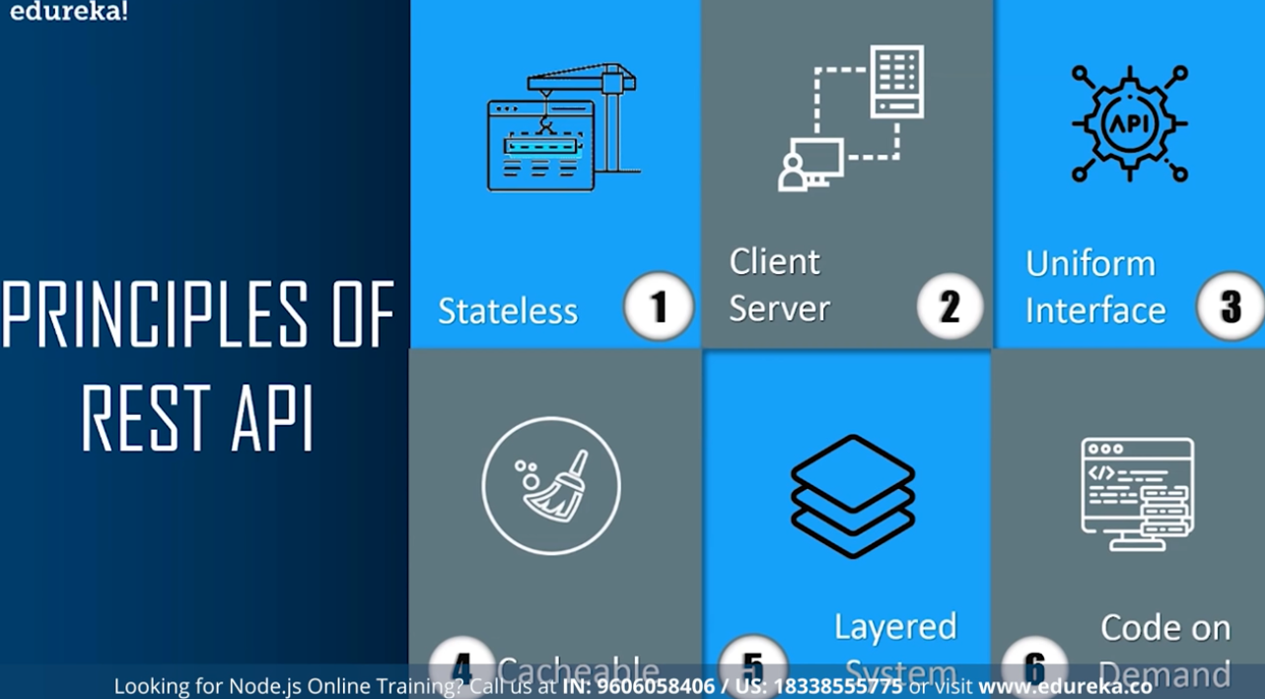

Socket.io is used for realtime data transfer.

On client, install create-react-app, socket.io-client, react-scroll-to-bottom, react-router-dom, react-emoji, query-string

On server, install nodemon, express, cors, socket.io

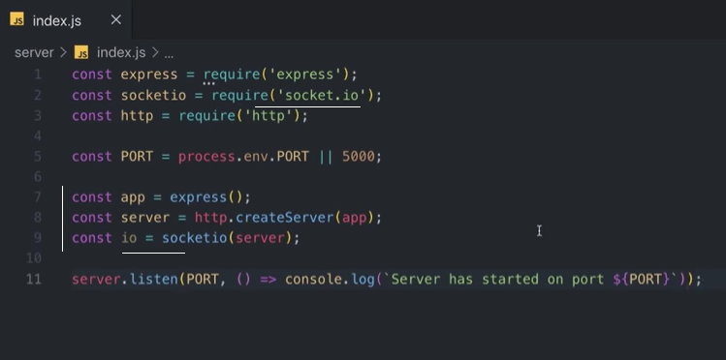

Deploy backend to heroku, frontend to netlify

Javascript cheatsheet:

// STRINGS

// string[index] - get a certain character of a string

// string.length - return the number of characters in a string

// string.split(' ') - returns an array of words of a string

// string.split('') - returns an array of characters of a string

// string.toLowerCase() - returns a lowercased string

// string.toUpperCase() - returns an uppercased string

// string.includes('subtring') - checks whether a substring exists inside of a string [check the character case]

// ARRAYS

// array[index] - returns a certain value from an array

// array.indexOf('value') - returns the index of the first occurance of that value

// array.length - returns the number of elements in the array

// array.join('') - returns a string of array values

// array.push(value) - adds the value to the end of the array

// array.pop() - removes the value from the end of the array

// array.unshift(value) - adds the value to the start of the array

// array.shift() - removes the value from the start of the array

// array.splice(fromIndex, number_of_elements) - removes the number_of_elements, starting from fromIndex from the array

// array.slice(fromIndex, toIndex) - copies a certain part of the array

// for - looping

const emojis = [ 'ðŸ˜€', 'ðŸ˜†', 'ðŸ™ƒ', 'ðŸ˜' ];

const wavingEmojis = [];

for (let i = 0; i < emojis.length; i++) { wavingEmojis.push(`ðŸ‘‹${emojis[i]}ðŸ‘‹`); }

// forEach - array method for looping

emojis.forEach((emoji) => console.log(emoji));

// map - array method for looping BUT IT HAS RETURNS

const wavingEmojis = emojis.map((emoji) => `ðŸ‘‹${emoji}ðŸ‘‹`);

// filter const numbers = [ 1, 2, 3, 4, 5, 6, 7, 8, 9 ];

const numbersBiggerThanFive = numbers.filter((number) => number > 5);

// sort const numbers = [ 3, 4, 1, 5, 4, 7, 2, 23, 12 ];

const sortFromSmalles = numbers.sort((a, b) => a - b);

const sortFromLargest = numbers.sort((a, b) => b - a);

// VALUE VS REFERENCE (part 1: intro)

// arrays

const numbers = [ 1, 2, 3, 4 ]; // #123asd

const anotherNumbers = numbers; // #123asd

anotherNumbers.push(5);

// objects

const person = { firstName: 'John', lastName: 'Doe' };

const anotherPerson = person;

anotherPerson.lastName = 'DOEEEE';

console.log(numbers === anotherNumbers); // true

console.log(person === anotherPerson) // true

// VALUE VS REFERENCE (part 2: CLONING ARRAYS AND OBJECTS)

// SHALLOW CLONING - ONE LEVEL DEEP

const original = [ 1, 2, 3 ];

const newOriginal = [...original];

// DEEP CLONING - TWO LEVELS DEEP

const users = [ { name: 'John', age: 25 }, { name: 'Victor', age: 25 } ];

const newUsers = JSON.parse(JSON.stringify(users));

Heroku apps include a **Procfile** that specifies the commands that are executed by the app on startup. You can use a Procfile to declare a variety of **process types**, including:

* Your app’s web server
* Multiple types of worker processes
* A singleton process, such as a [clock](https://devcenter.heroku.com/articles/scheduled-jobs-custom-clock-processes)
* Tasks to run [before a new release is deployed](https://devcenter.heroku.com/articles/release-phase)

All Heroku applications run in a collection of lightweight Linux containers called **dynos**.

Npm list // npm list –depth=0 // npm list minimist // npm list –g all for the install packages

Npm install netlify-cli –g // netlify login // netlify deploy

For production ready deploy, use: netlify deploy –prod

The bookshelf

The config directory and its config.js file is used to store the secret keys and other things.

Config.js

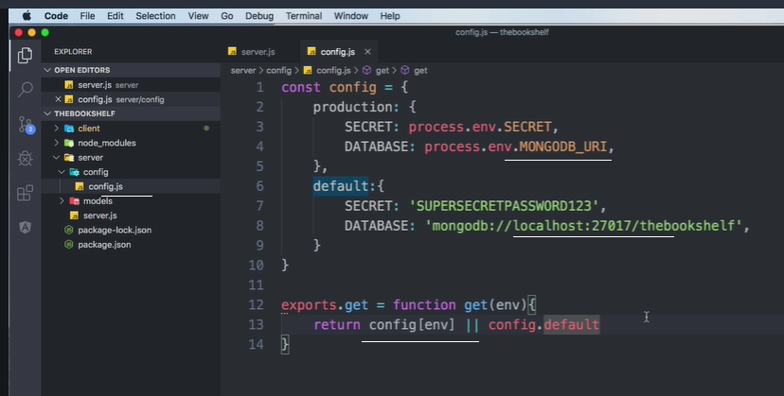

Server.js

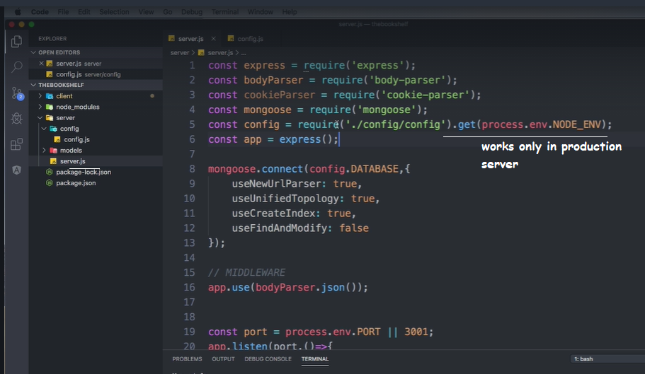

Server / package.json

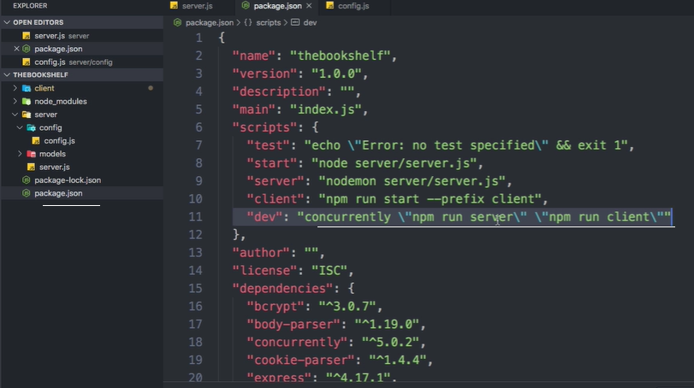

To run, type: npm run dev from the server directory

Proxy setting on client/package.json

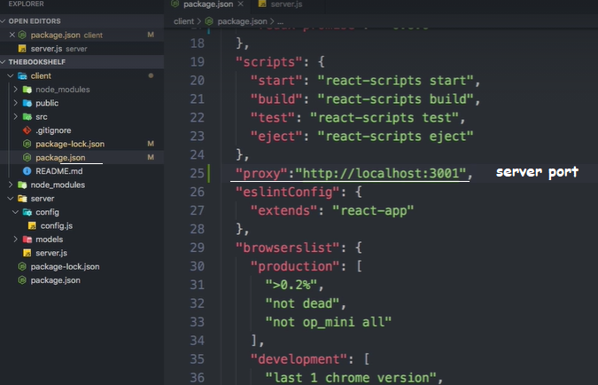

Npm install react-fontawesome // is for using css icons. It can be used as a wrapper component.

Also embed the link in index.html

React.render(<FA name=”rocket” />, document.body)

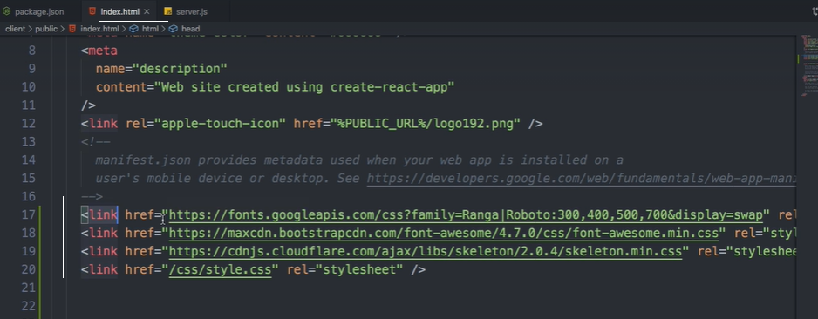

A callback function in a middleware is called in the middleware, but defined in the calling function. If the 2nd parameter is being used in the middleware in the callback, 1st parameter should be passed as ‘null’

JavaScript objects are containers for named values, called properties and methods.

There are different ways to create new objects:

* Define and create a single object, using an object literal.
* Define and create a single object, with the keyword new.
* Define an object constructor, and then create objects of the constructed type.

In ECMAScript 5, an object can also be created with the function Object.create().

Objects are mutable: They are addressed by reference, not by value.

Properties are the values associated with a JavaScript object.

## **Accessing JavaScript Properties**

The syntax for accessing the property of an object is:

*objectName.property*// person.age

or

*objectName*["*property*"]      // person["age"]

or

*objectName*[*expression*]      // x = "age"; person[x]

this keword: In a function definition, this refers to the "owner" of the function.

## **The this Keyword**

In JavaScript, the thing called this is the object that "owns" the code.

The value of this, when used in an object, is the object itself.

In a constructor function this does not have a value. It is a substitute for the new object. The value of this will become the new object when a new object is created.

Note that this is not a variable. It is a keyword. You cannot change the value of this.

A JavaScript **method** is a property containing a **function definition**.

Some common solutions to display JavaScript objects are:

* Displaying the Object Properties by name
* Displaying the Object Properties in a Loop
* Displaying the Object using Object.values()
* Displaying the Object using JSON.stringify()

Getters and setters allow you to define Object Accessors (Computed Properties).

Built-in JS constructors:

var x1 = new Object();    // A new Object object  
var x2 = new String();    // A new String object  
var x3 = new Number();    // A new Number object  
var x4 = new Boolean();   // A new Boolean object  
var x5 = new Array();     // A new Array object  
var x6 = new RegExp();    // A new RegExp object  
var x7 = new Function();  // A new Function object  
var x8 = new Date();      // A new Date object

The Math() object is not in the list. Math is a global object. The new keyword cannot be used on Math.

Use object literals {} instead of new Object().

Use string literals "" instead of new String().

Use number literals 12345 instead of new Number().

Use boolean literals true / false instead of new Boolean().

Use array literals [] instead of new Array().

Use pattern literals /()/ instead of new RegExp().

Use function expressions () {} instead of new Function().

In **MongoDB**, the $**unset** operator is used to delete a particular field. The value specified in the $**unset** expression does not make any impact on the operation. The $**unset** has no effect when the field does not exist in the document.

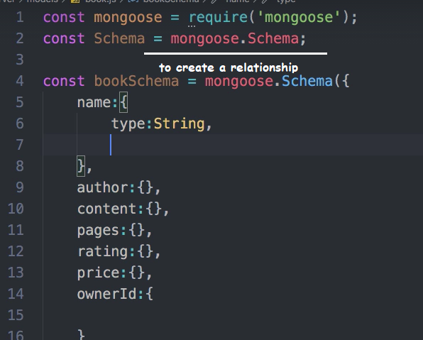

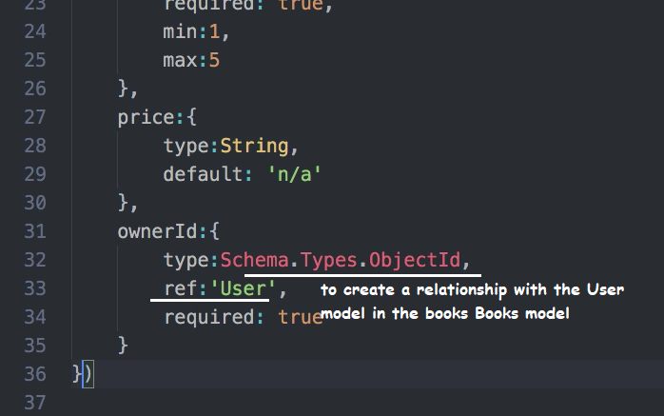

Route:

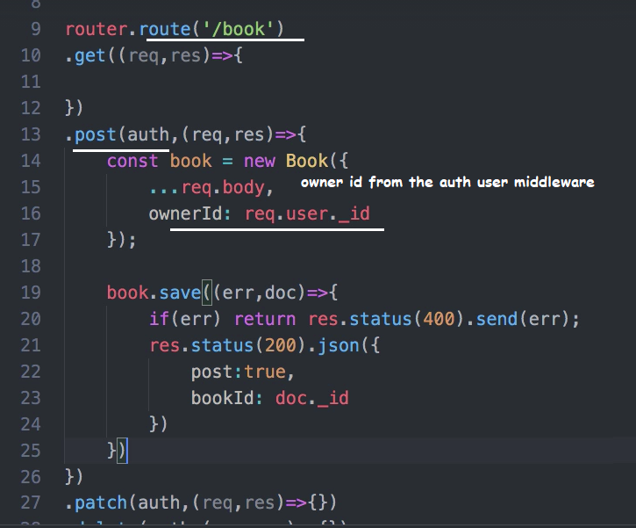

Populate in mongoose means go to a different database and find the reference.

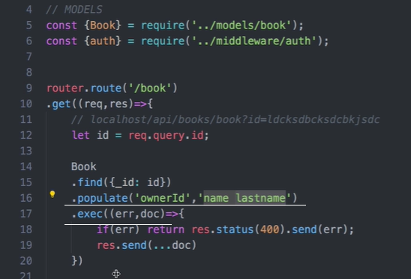

Get all books with conditions:

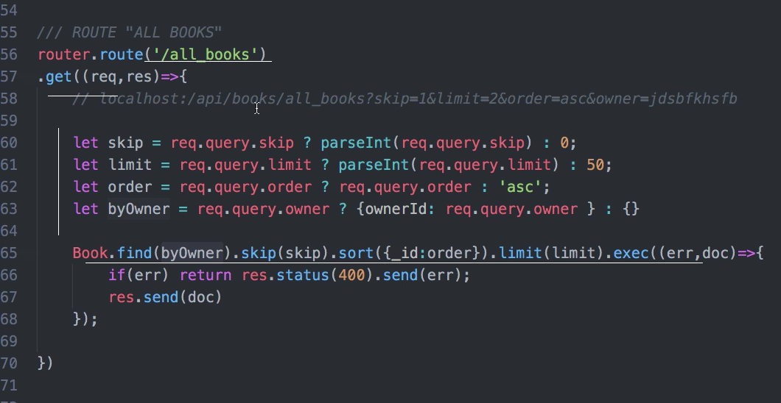

Since mongodb installed on a computer will work from the Terminal, install Robomongo or Robo 3T for a graphical interface. Robomongo.org

The default mongodb port on the localhost is 27017

Connecting to local installed mongodb:

In the terminal, "C:\Program Files\MongoDB\Server\4.4\bin\mongod.exe" --dbpath="c:\data\db"

"C:\Program Files\MongoDB\Server\4.4\bin\mongo.exe"

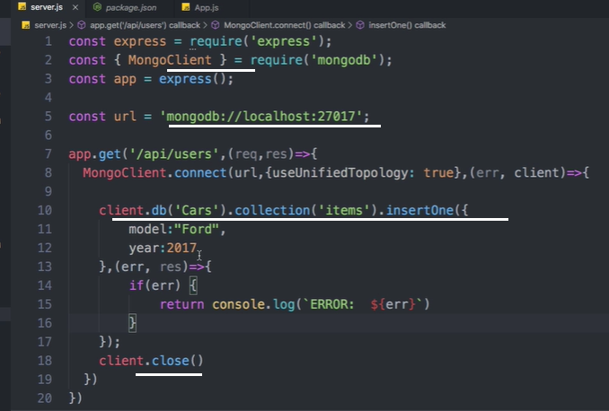

Find returns a cursor for the collections in the database: with a promise

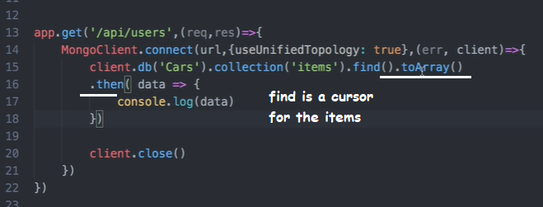

Find with Callback:

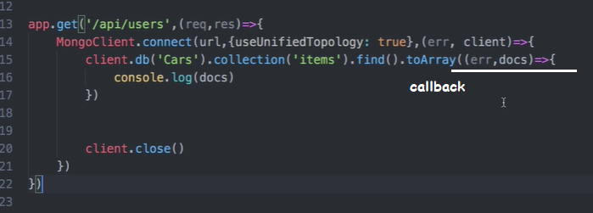

Find, limit

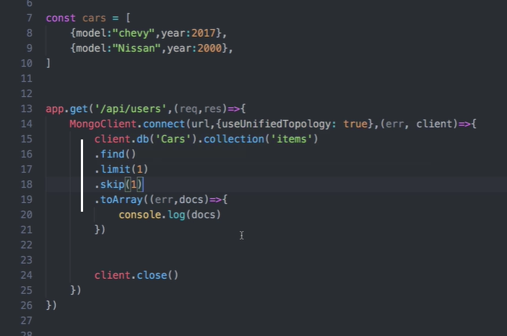

Mori and immutable.js for persistant datastructure in JS

Update the database:

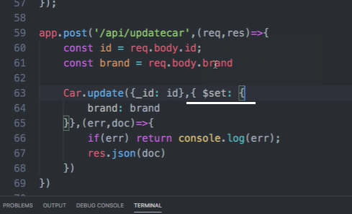

A typescript:  An **interface** is a syntactical contract that an entity should conform to. In other words, an **interface** defines the syntax that any entity must adhere to. **Interfaces** define properties, methods, and events, which are the members of the **interface**.

http is a stateless protocol. Remembers nothing. Each request requires to give full information.

Session token is a reference token where as jwt is a value token.

React Error boundaries:

These are the wrapper components that wraps a component inside. Upon error on the wrapped compoenent, it catches. The error component should implement either of the following methods.

* Static getDerivedStateFromError // A fallback component is one which renders when this error happens
* componentDidCatch // in this method we can log the error that is happening

<ErrorComponent>

<MyComponent>

<ErrorComponent>

React patterns:

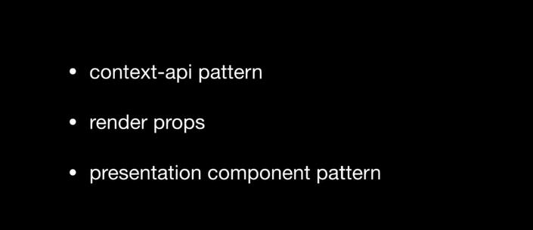

The scope of css is global. Css-in-js pattern

‘let’ inside a for loop has its own scope. a variable / property has lexical scope.

Express.static is used to provide the address of static pages: middleware runs before any other code in the module

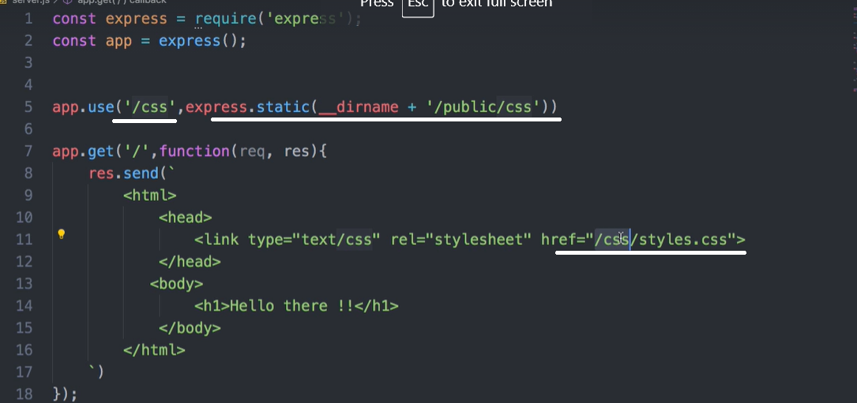

<https://www.youtube.com/watch?v=wHFflWvii3M> // html / css dropdown

awesome font cdn – link the url provided into the page head link of the html page

font awesome icons – choose the font and its link copy into the li.

Html page:

<html>

<head><a href="#">

<title>My Page</title>

<link rel="stylesheet" href="mystyle.css"/>

<link rel="stylesheet" href="https://stackpath.bootstrapcdn.com/font-awesome/4.7.0/css/font-awesome.min.css" />

</head>

<body>

<div class="menu-bar" >

<ul>

<li><i class="fa fa-home" aria-hidden="true"></i><a href="#"> Home </a></li>

<li><i class="fa fa-university" aria-hidden="true"></i><a href="#"> Training </a>

<div class="sub-menu-1">

<ul>

<li class="hover-me"><a href="#">Web Design</a><i class="fa fa-angle-right" aria-hidden="true"></i>

<div class="sub-menu-2">

<ul>

<li><a href="#">HTML</a></li>

<li><a href="#">CSS</a></li>

<li><a href="#">SCSS</a></li>

</ul>

</div>

</li>

<li class="hover-me"><a href="#">System Design</a><i class="fa fa-angle-right" aria-hidden="true"></i>

<div class="sub-menu-2">

<ul>

<li><a href="#">WINDOWS</a></li>

<li><a href="#">UNIX</a></li>

<li><a href="#">MAC</a></li>

</ul>

</div>

</li>

<li><a href="#">Protocol Design</a><i class="fa fa-angle-right" aria-hidden="true"></i></li>

</ul>

</div>

</li>

<li><a href="#"> Production</a></li>

<li><a href="#"> Pricing</a></li>

<li><a href="#"> Quoting</a></li>

<li><i class="fa fa-phone" aria-hidden="true"></i><a href="#"> Contact</a>

<div class="sub-menu-1">

<ul>

<li><a href="#">Mission</a></li>

<li><a href="#">Strength</a></li>

<li><a href="#">Vision</a></li>

</ul>

</div>

</li>

</ul>

</div>

</body>

</html>

Css page:

* {

padding: 0;

margin: 0;

box-sizing:border-box;

}

body {

background-image:url(avtar.jpg);

background-size:cover;

background-position:center;

font-family: sans-serif

}

.menu-bar {

background: rgba(100,100,200,.9);

text-align: center;

}

.menu-bar ul {

display: inline-flex;

color: white;

list-style: none;

text-align: center;

}

.menu-bar ul li {

width: 150px;

margin: 15px;

padding: 15px;

}

.menu-bar ul li a {

color: white;

text-decoration: none;

}

.active, .menu-bar ul li:hover {

background: #2aab3e;

border-radius: 10px;

}

.menu-bar .fa {

margin-right: 8px;

}

.sub-menu-1 {

display: none;

}

.menu-bar ul li:hover .sub-menu-1{

display: block;

position: absolute;

background: rgb(0,100,0);

margin-top: 15px;

margin-left: -15px;

}

.menu-bar ul li:hover .sub-menu-1 ul {

display: block;

margin: 10px;

}

.menu-bar ul li:hover .sub-menu-1 ul li {

width: 200px;

padding: 10px;

border-bottom: 1px dotted #fff;

background: transparent;

text-align: left;

border-radius: 0

}

.menu-bar ul li:hover .sub-menu-1 ul li:last-child {

border-bottom: none;

}

.menu-bar ul li:hover .sub-menu-1 ul li a:hover {

color: aquamarine

}

.fa-angle-right {

float: right;

}

.sub-menu-2{

display: none

}

.hover-me:hover .sub-menu-2 {

display: block;

position: absolute;

margin-top: -15px;

margin-left: 85px;

background-color:aqua;

}

Flexbox:

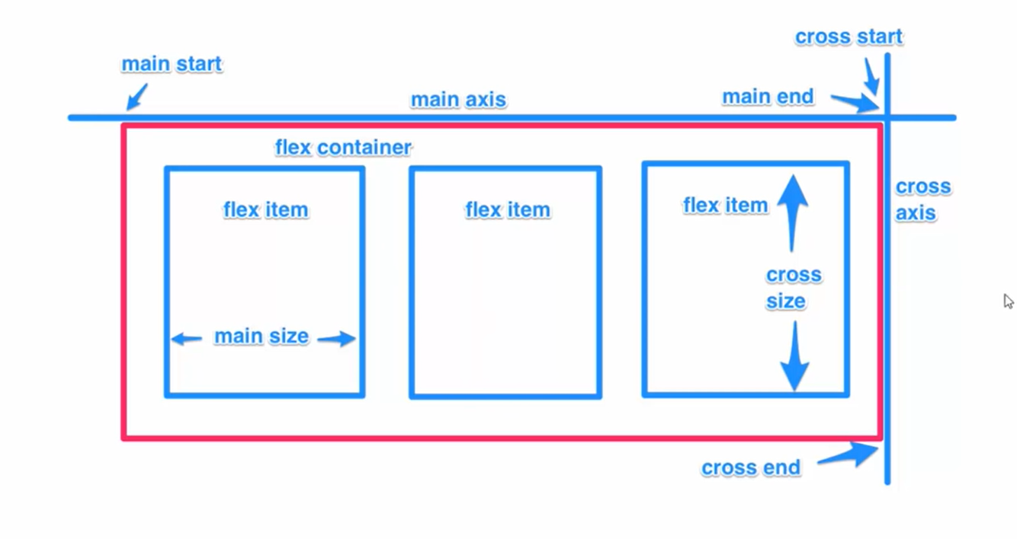

Flex properties:

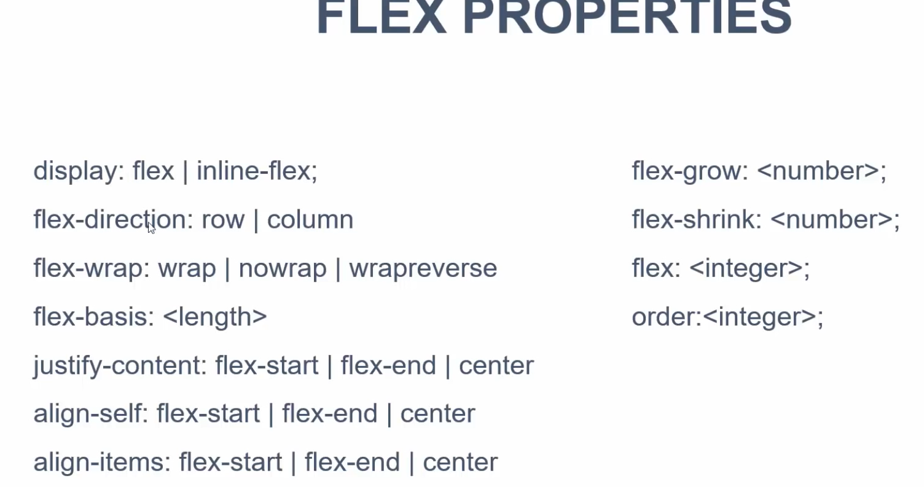

<https://www.quackit.com/html/html_editors/scratchpad/> for editing online

flexbox for one dimensional layout, grid is for 2 dimensional layout:



Css grid:

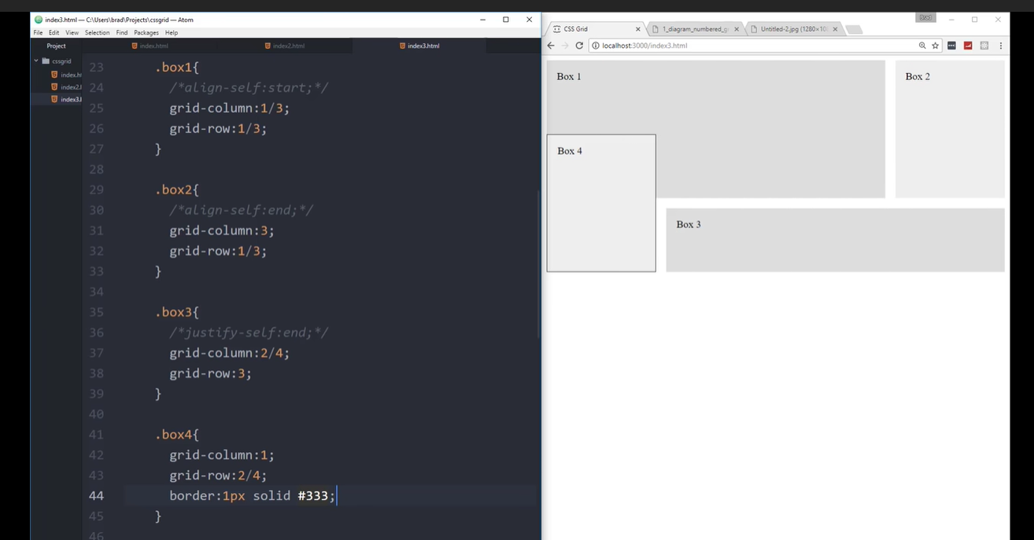

Unsplash, pexels for images.

! <tab> -- in vscode .html file for html boilerplate.

Type Lorem<number of words required> press tab.

Elementname.classname and enter – to create an element with a class

<!—will complete the comment.

Css variables are defines as -- :root{ --variable1: <value>; -- variable2:<value>}

To use the variable, color: var(--<variablename>)

To put a comment in vscode for css, ctrl + /

Formik:

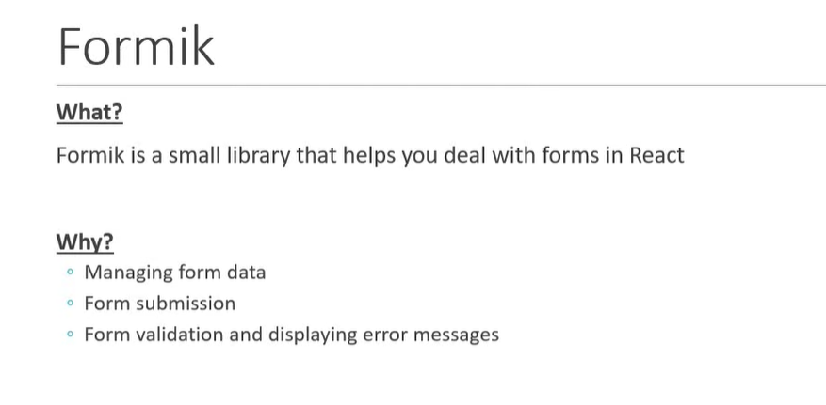

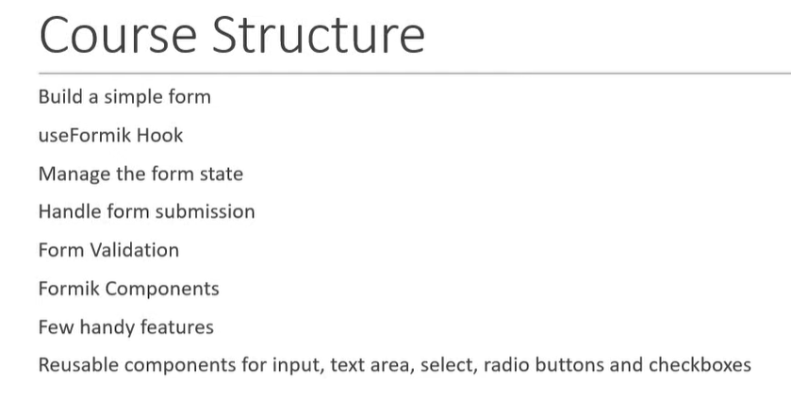

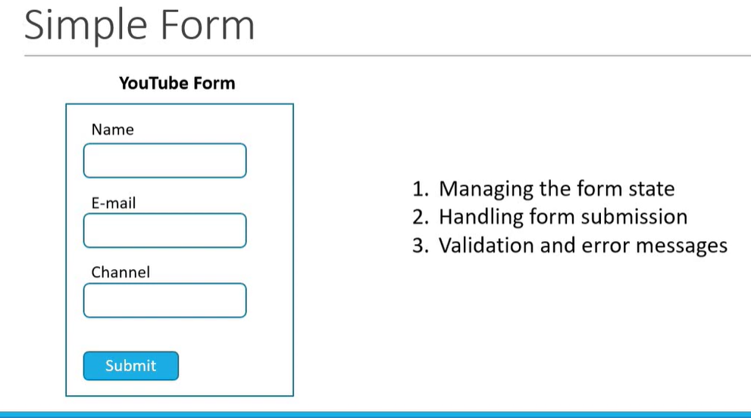

Form state is an object that maintain the values of different form fields.

Const {userFormik} import from (‘formik’)

userFormik returns an object. It contains the properties and methods to manage the ‘form state’.

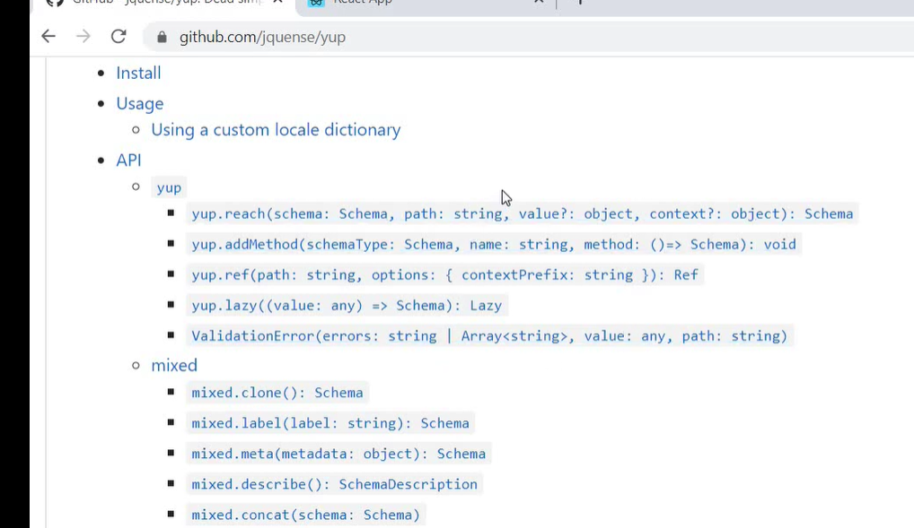

Formik.getFieldProps will replace the common field properties from the field. {…formik.getFieldProps(‘<fieldname>’}

Formik components:

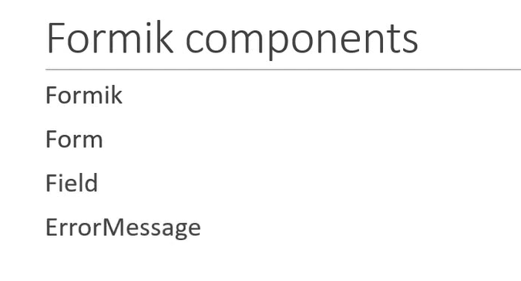

Formik component is a replacement for useFormik hook.

The Formik will serve as a context provider for the other 3 components.

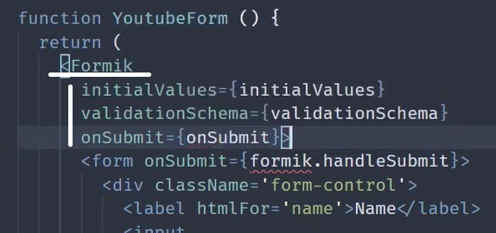

Wen the Form component replaces the html form component, the onSubmit property is not required. ‘Form’ component will handle it.

Form component refactor the useFormik.

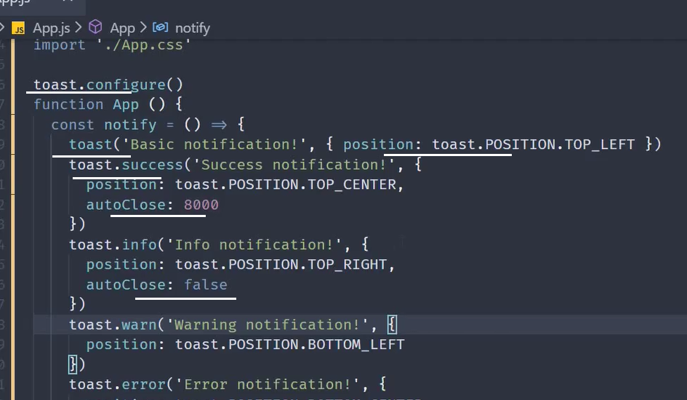

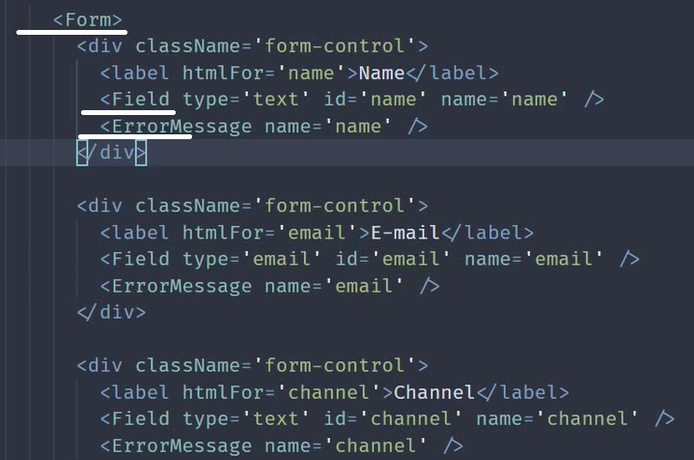

Toastify:

Install react-toastify

Import {toast} from ‘react-toastify’

Import ‘react-toastify/dist/ReactToastify.css’

toast.configure()

create a function inside the component, upon click returns the function.

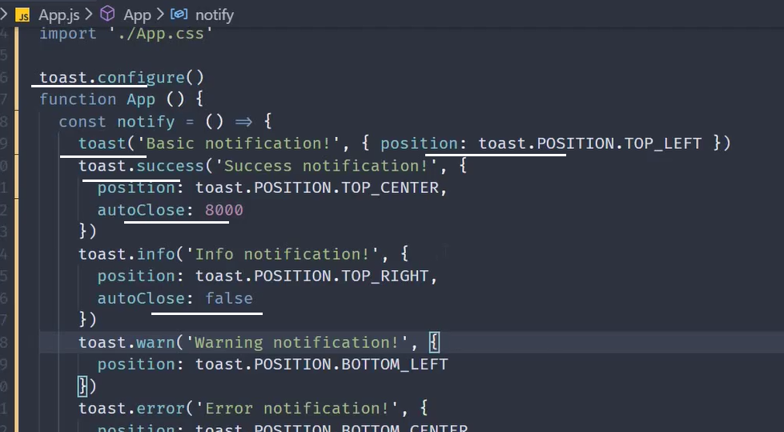

react-material-ui--form-validator

Formik Field as textarea:

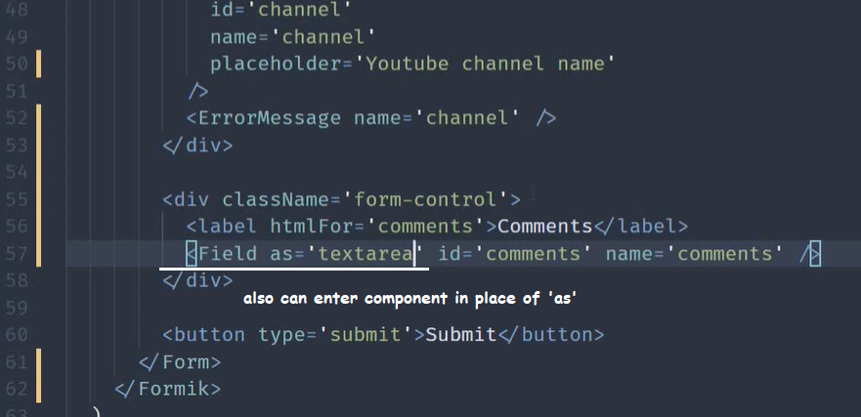

Custom components with Formik: render form pattern

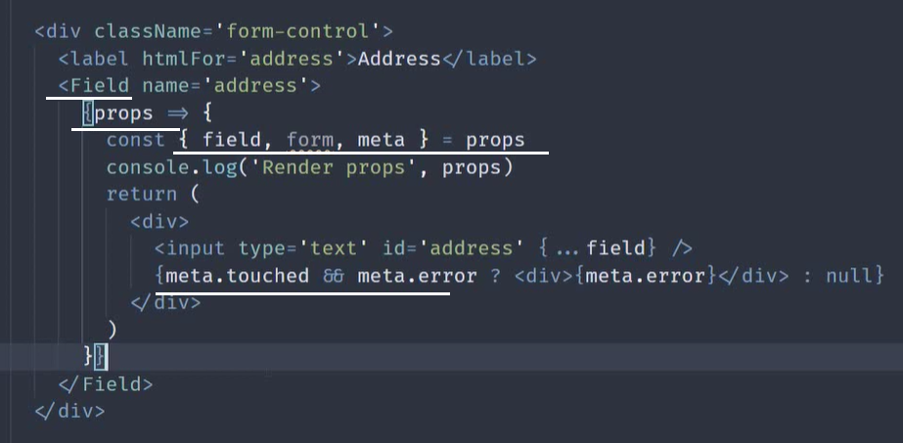

To show the error message in a custom style, wrap it with a hoc as an attribute inside: 2 ways to do it 1) hoc, 2) render

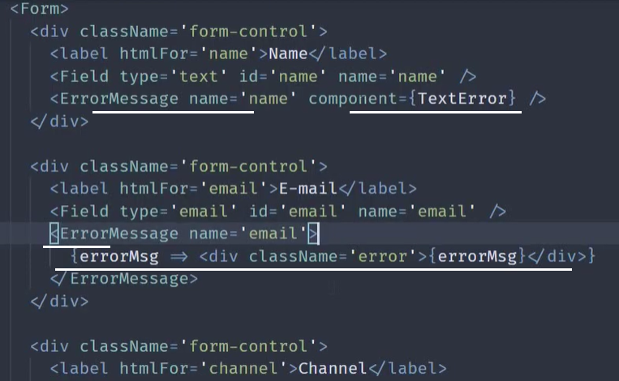

Formik nested object: here the initialValue has to be defined as

initialValues = { name:”Jaison”, email:[jaison@gmail.com](mailto:jaison@gmail.com), social:{facebook:””, twitter:””}, passowrd:””}

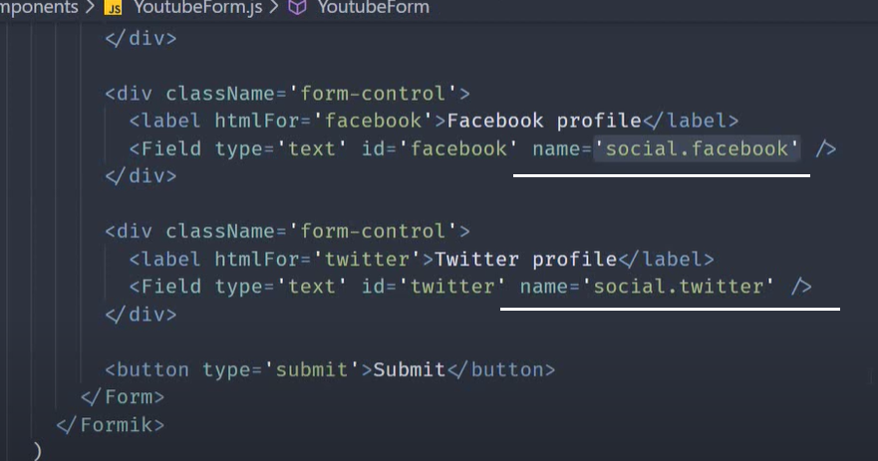

As array

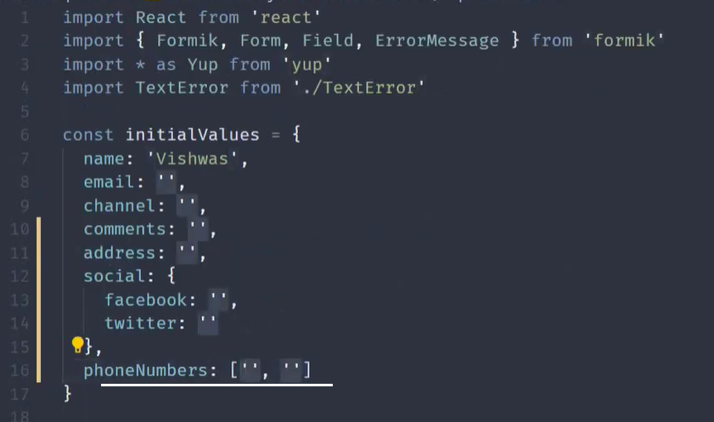

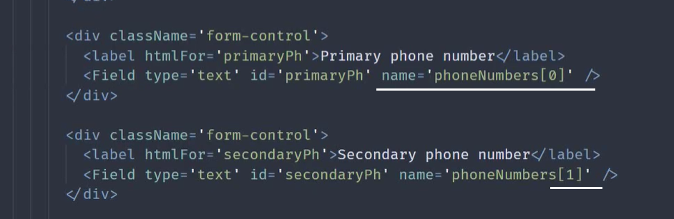

The ‘render props’ pattern is just a function accepting props and return jsx. This behaves like ‘props.children’.

‘FieldArray’ helps array properties for list manipulation.

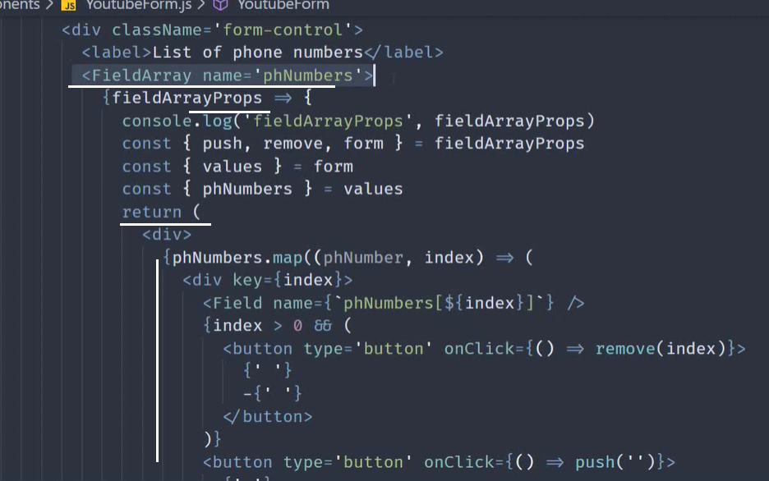

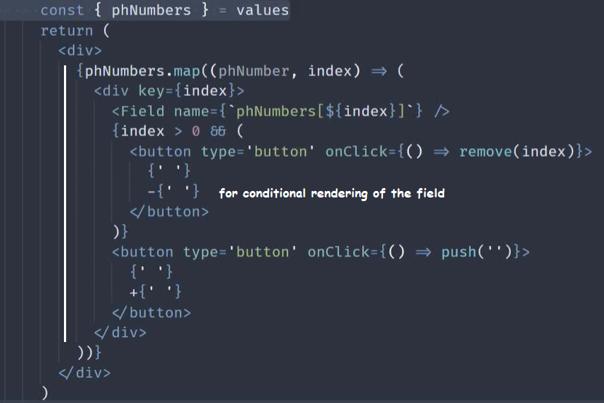

FastField component – for performance optimization. Used when more fields and complex validation is required.

If a particular field is independent of all other fields in the form, use FastField. It iternally implements ‘shouldComponentUpdate’ rerender method, to block additional re-renders unless there are direct updates to the FastField component itself.

Formik components:

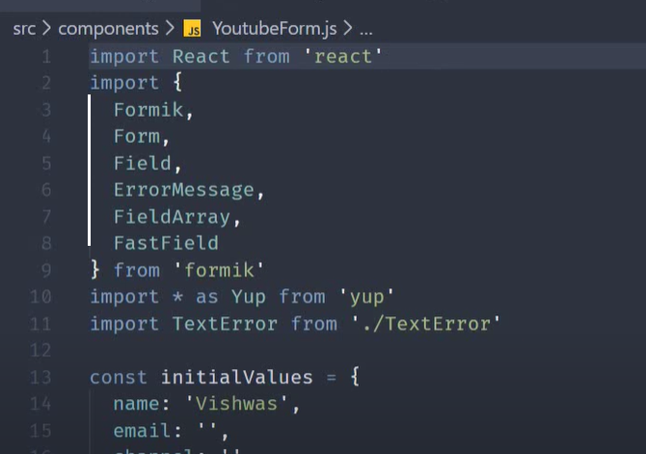

Form validation happens 1) during onChange, 2) onBlur, 3) onSubmit – whenever there is a validation error, onSubmit handle will not run.

Form level validation can be disabled by following 2 scenarios:

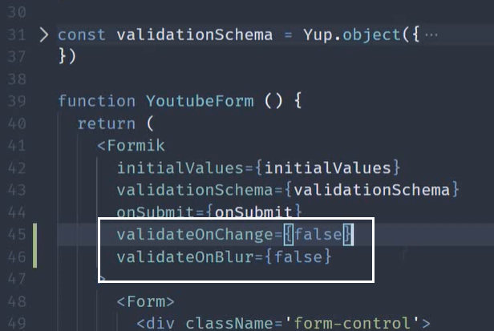

you can also use the setFieldError() and setErrors() found in actions object to show the server side errors

Field level validation:

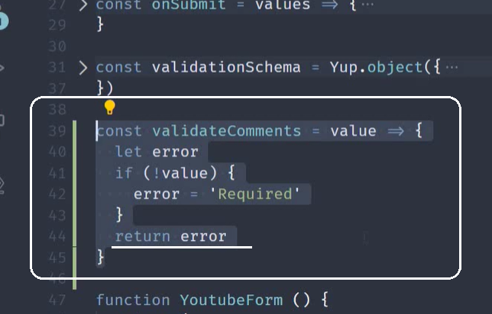

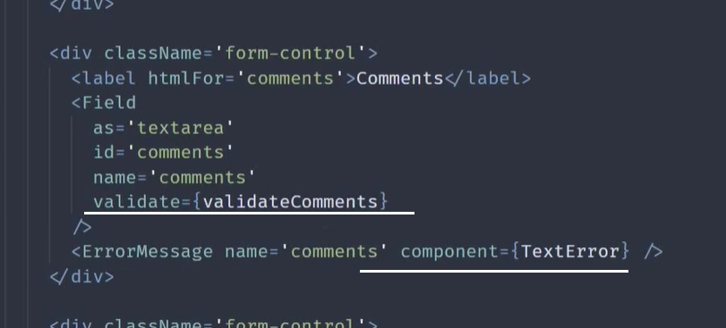

This ‘validate’ prop is also available on FastFileld component.

Formik props can be accessed via renderprops pattern: put the entire code under the ‘return’ statement.

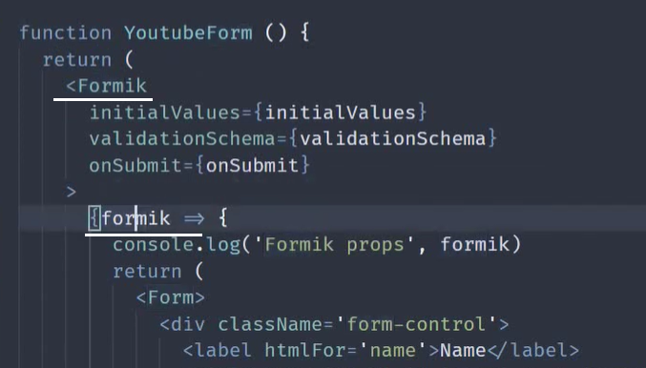

Manually validate Form and field:

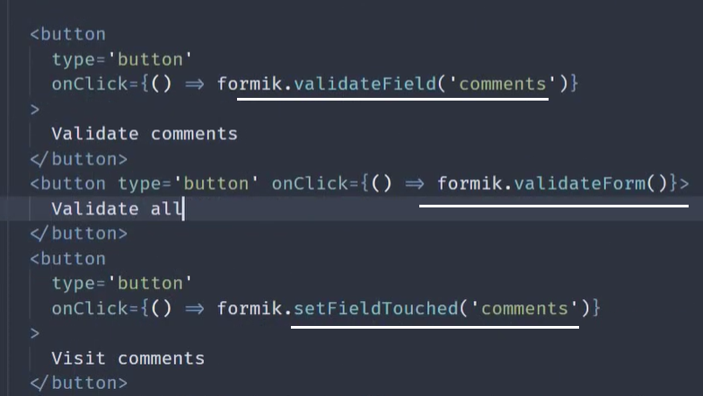

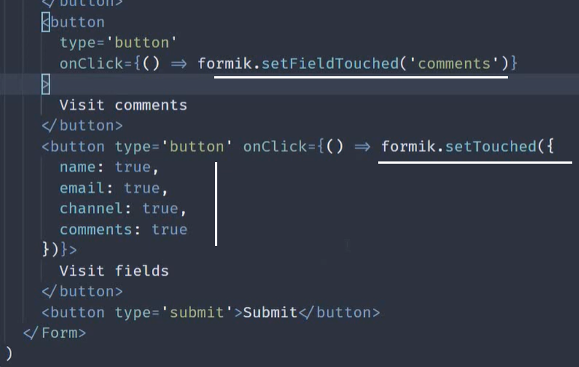

Use ‘validateOnMount’ in the Formik property to true will disable the submit button disabled.

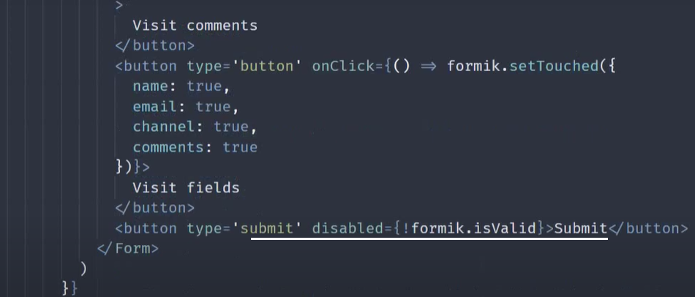

‘dirty’ property become true when an initialized value changes.

Formik property ‘isSubmitting’ is used when the submit button is pressed to disable the submit button.

onSubmitProps has a setSubmitting property. Set this to false inorder to enable the submit button.

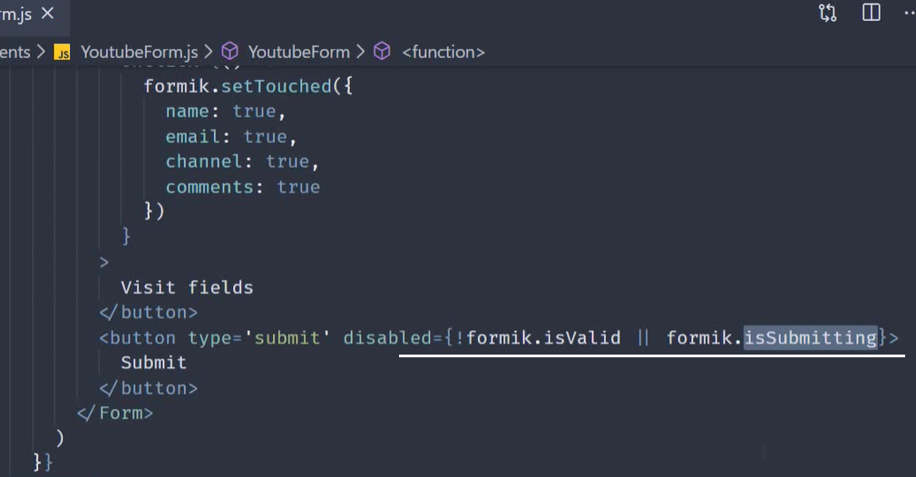

Use saved data into the form.

Use ‘useState’ to populate the saved data into the useState variable.

Then assign the initialValues to useState variable. Set enableReinitialize property of the Formit library to true.

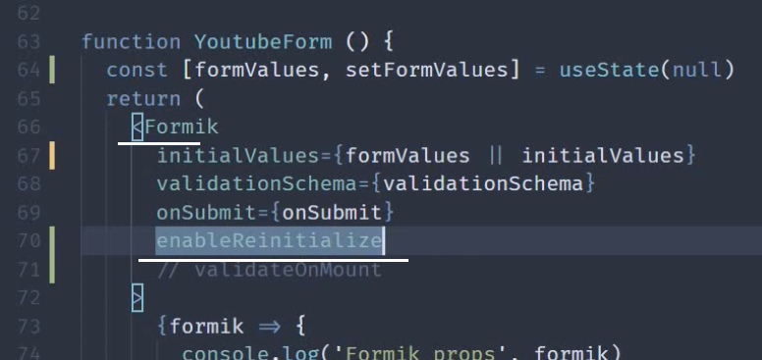

onSubmitProps.resetForm

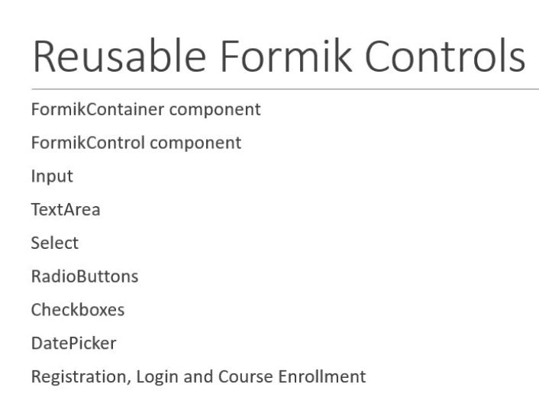

Create custom components in Formik:

Step1:

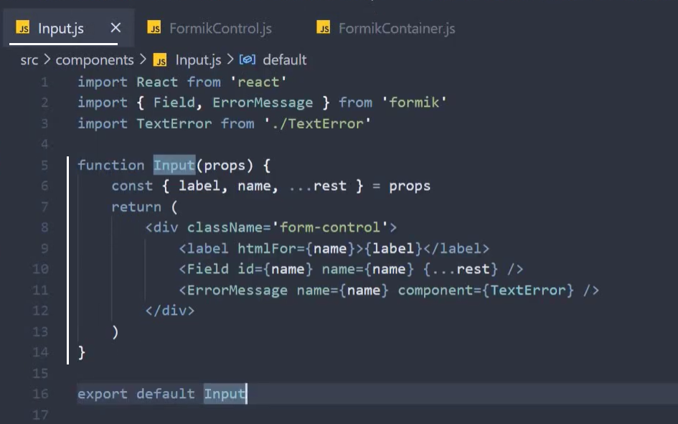

Step2:

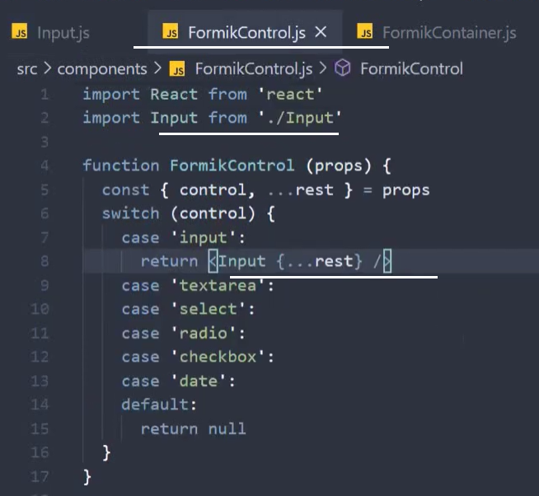

Step3:

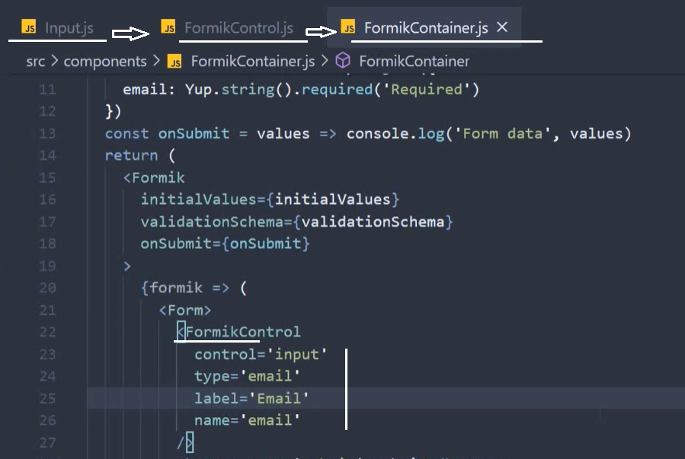

Select input:

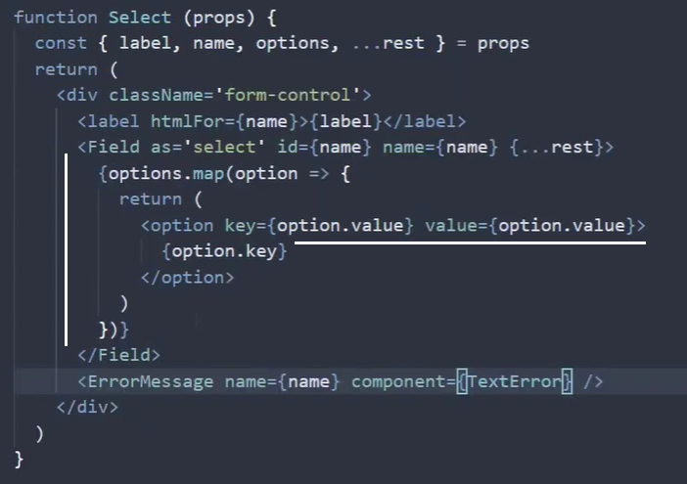

React Datepicker – to do with dates.

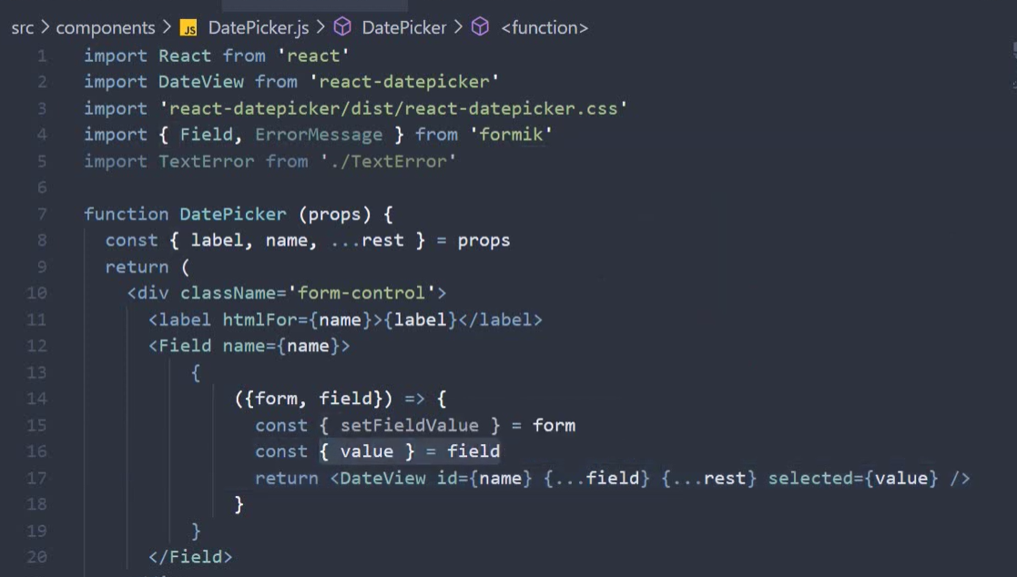

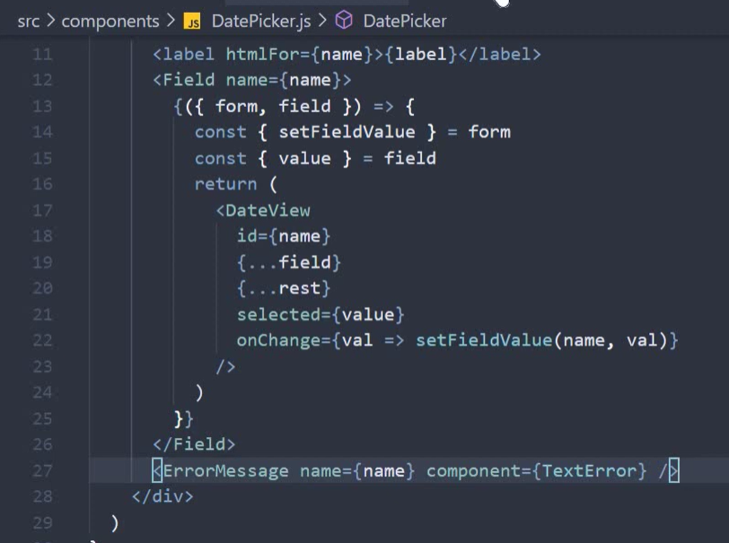

Validating formik confirm password:

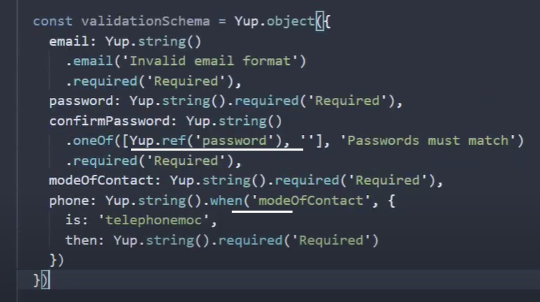

Formik youtube: <https://www.youtube.com/watch?v=l73kPdY1juk&list=PLC3y8-rFHvwiPmFbtzEWjESkqBVDbdgGu&index=41>

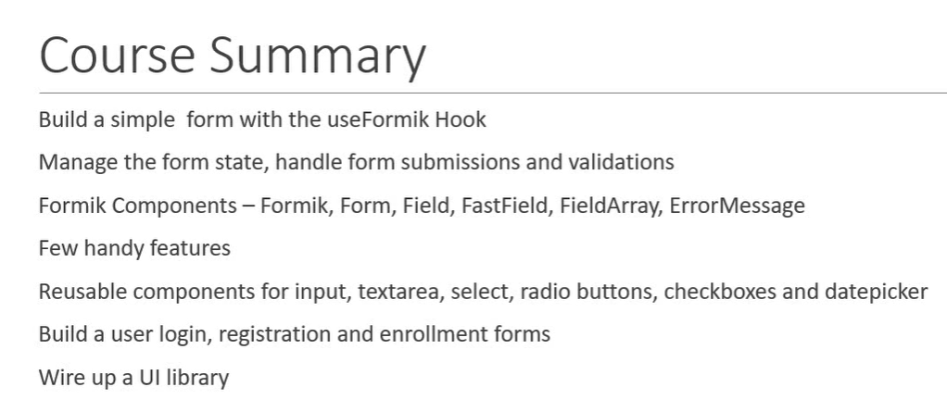

Popperjs for tooltip libarary

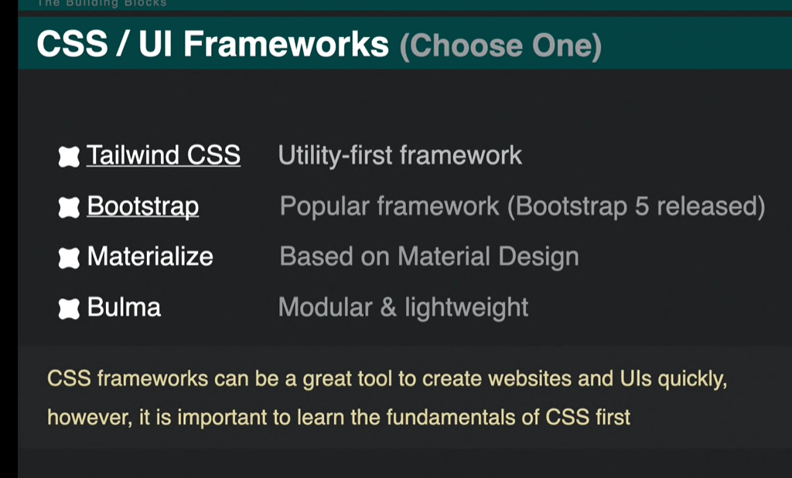

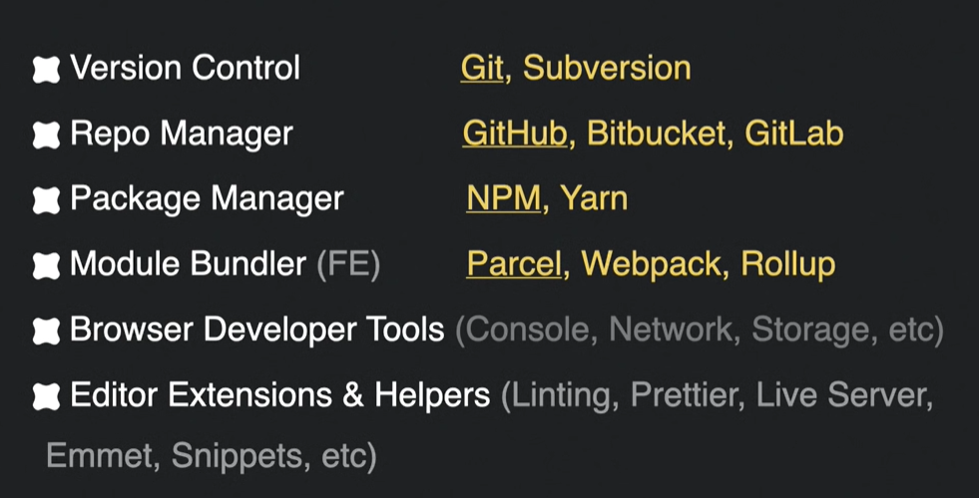

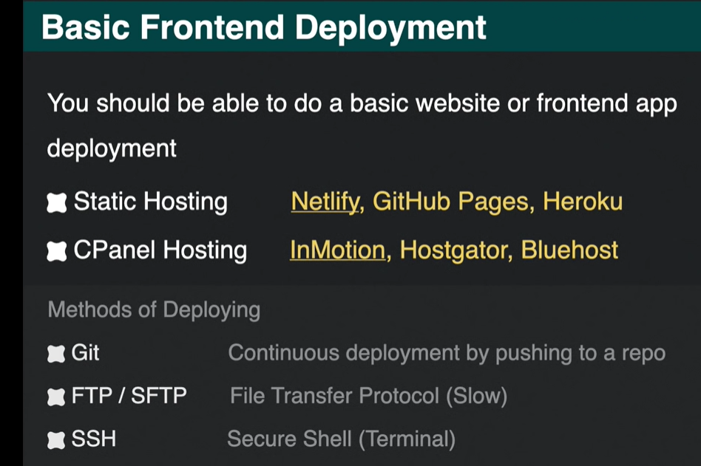

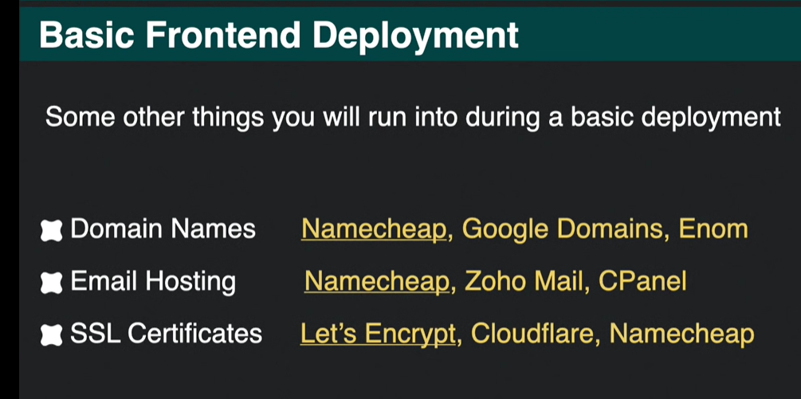

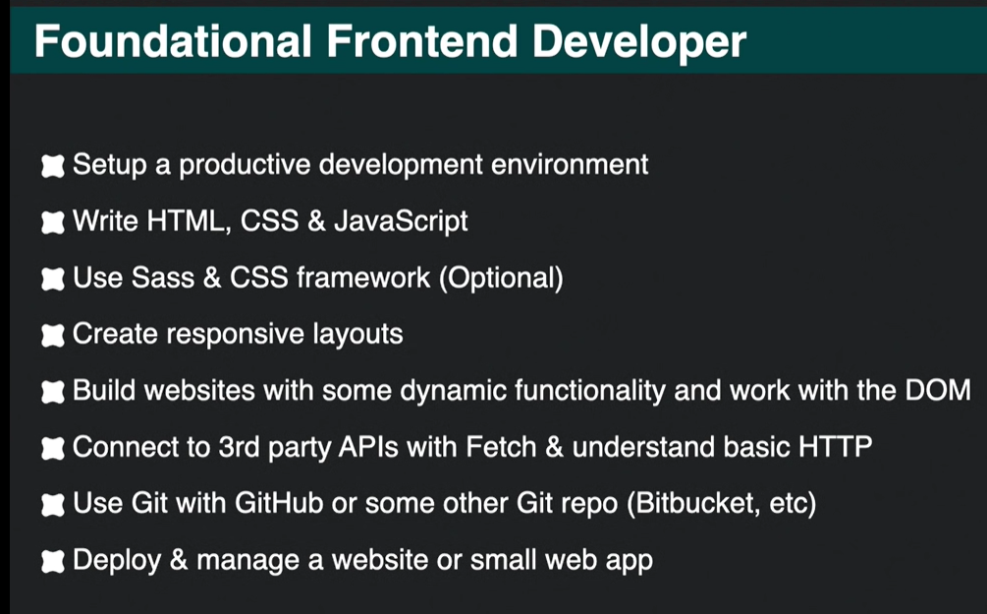

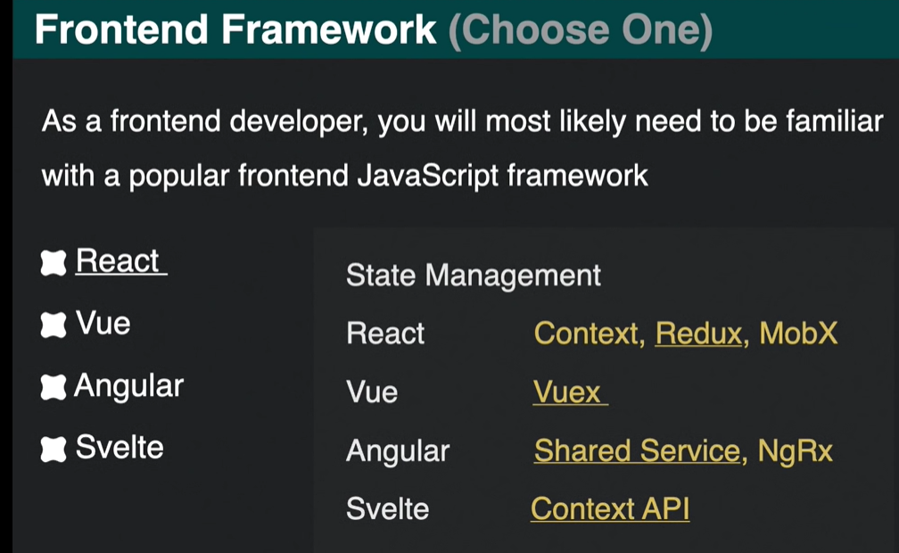

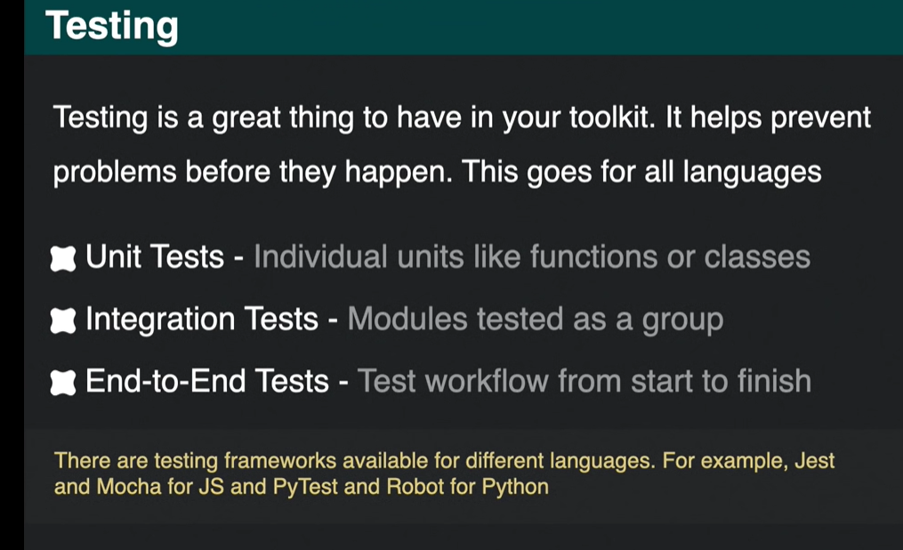

**Server**-**side rendering** (SSR) is the process of **rendering** web pages on a **server** and passing them to the browser (**client**-**side**), instead of **rendering** them in the browser. SSR sends a fully **rendered** page to the **client**; the **client's** JavaScript bundle takes over and enables the SPA framework to operate. Use NextJs for React

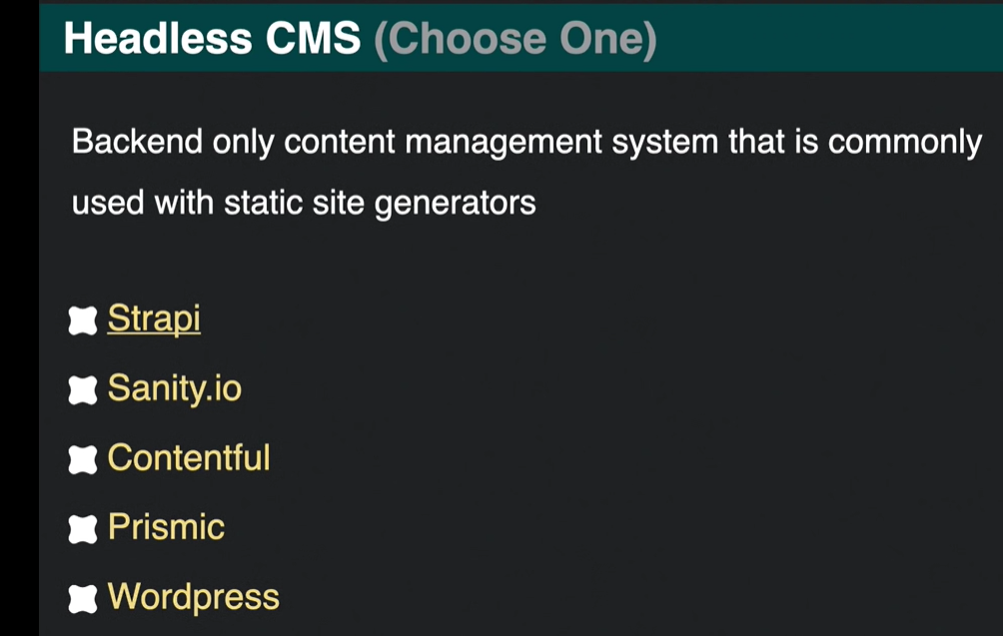

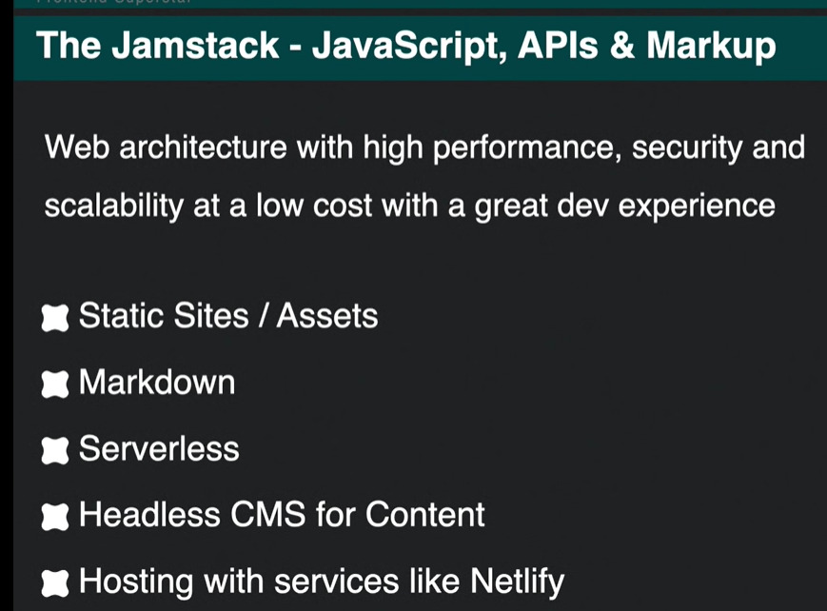

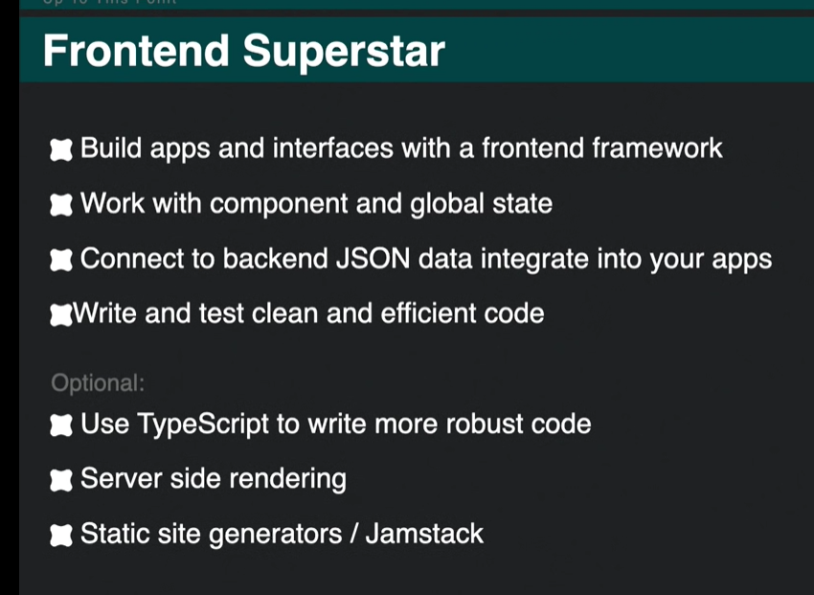

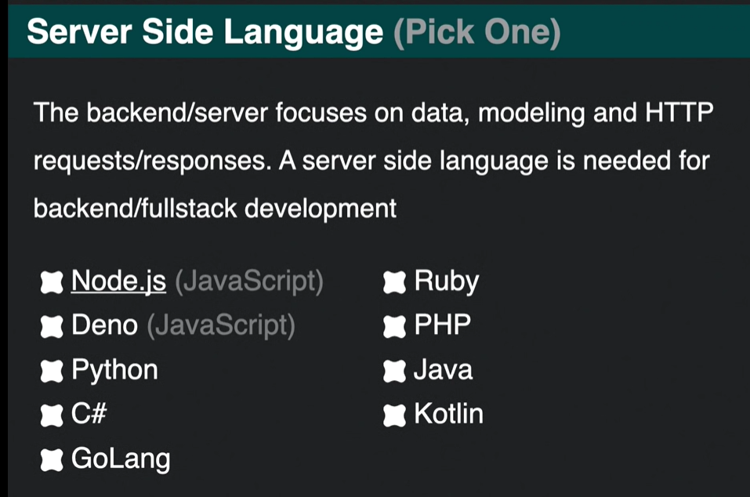

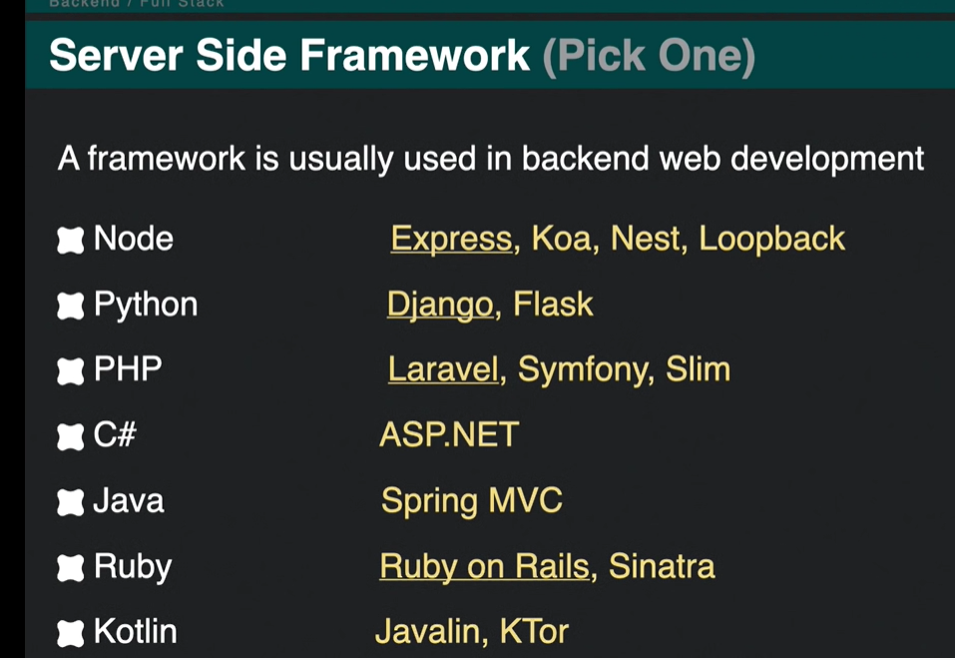

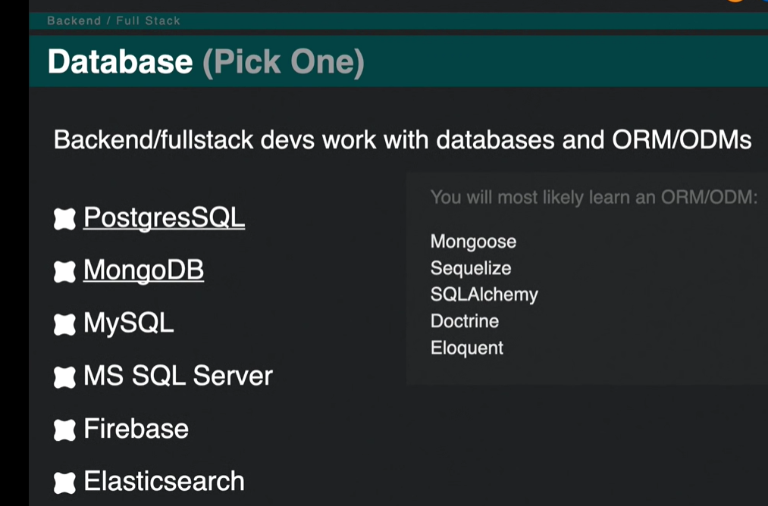

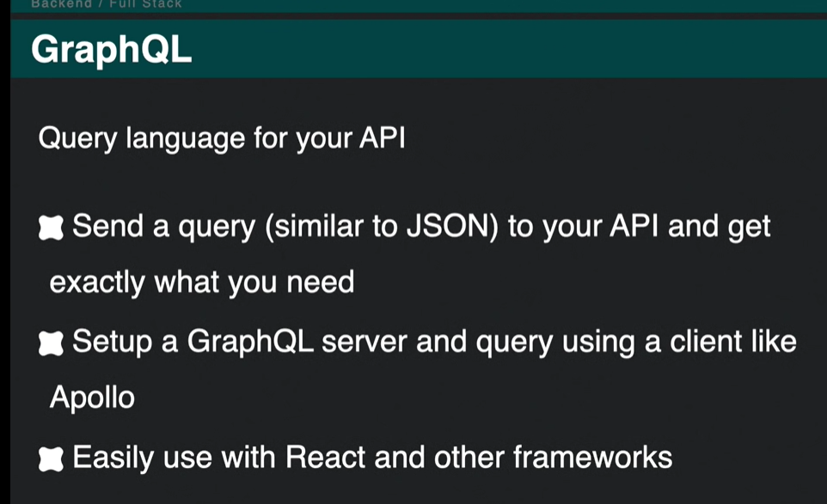

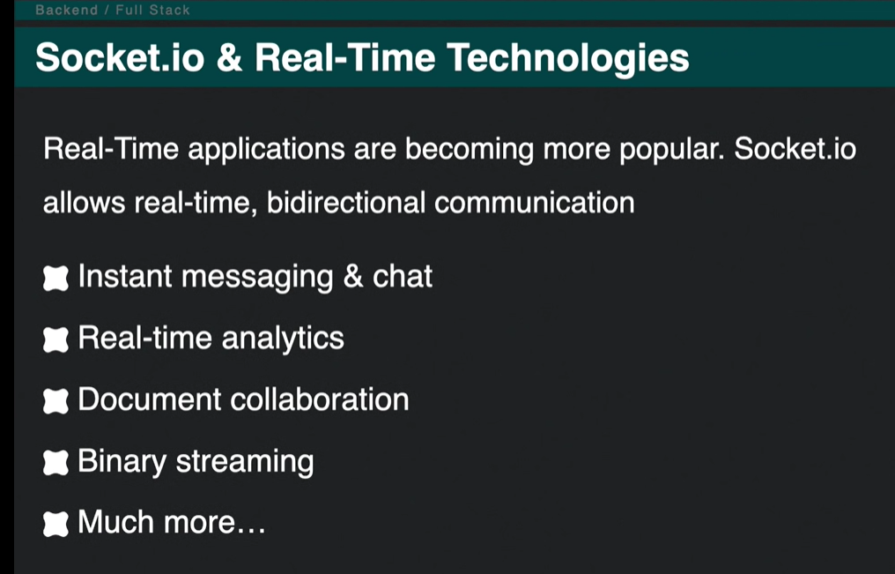

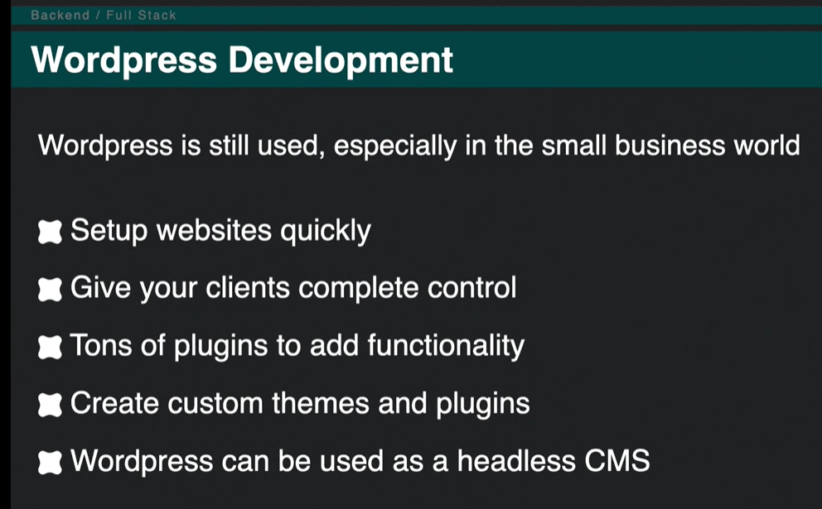

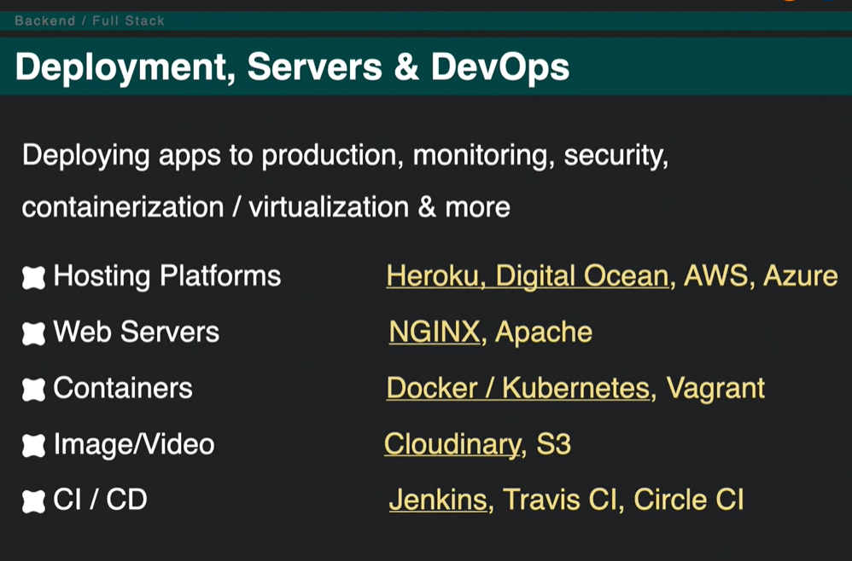

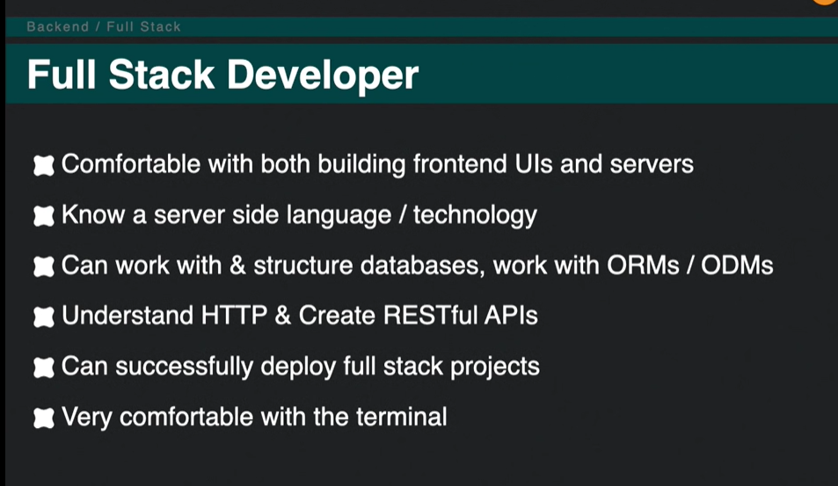

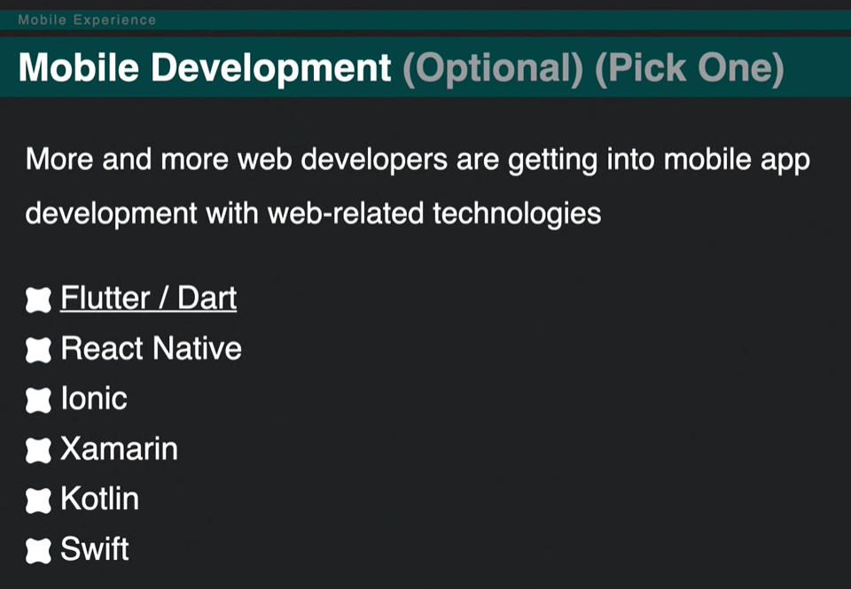

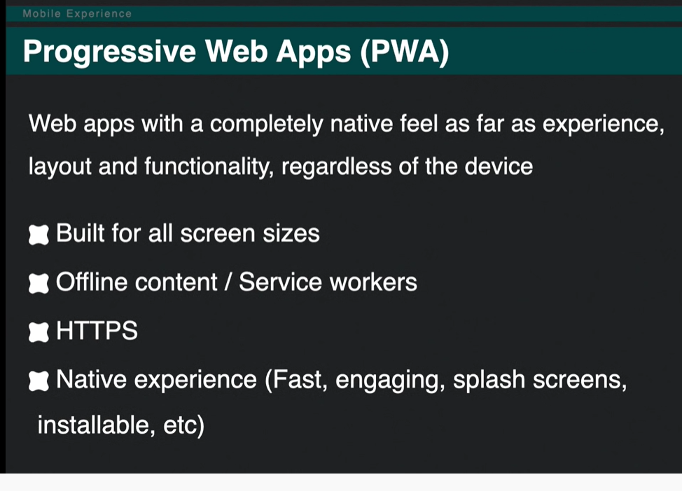

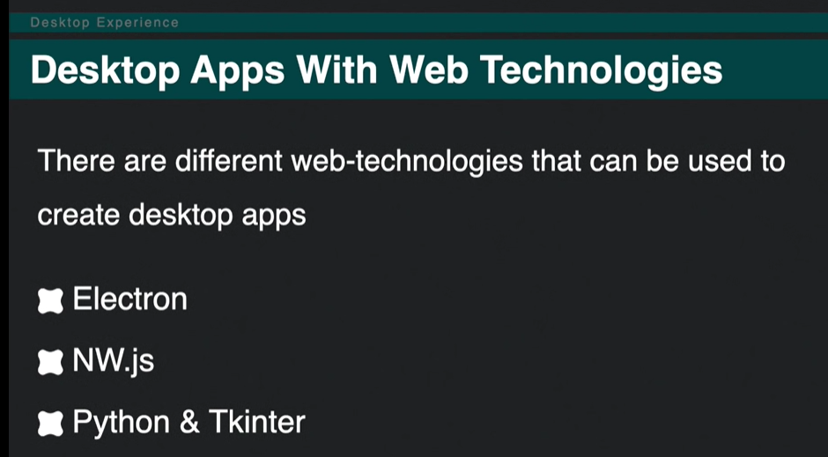

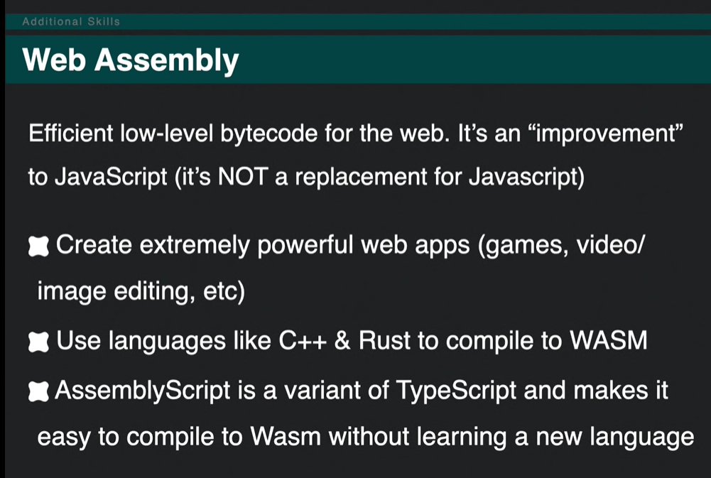

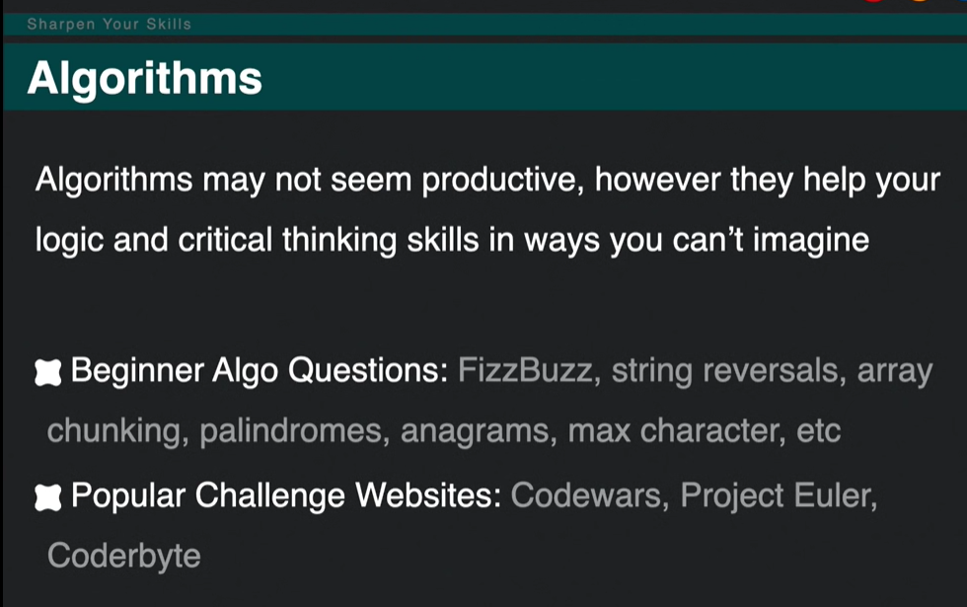

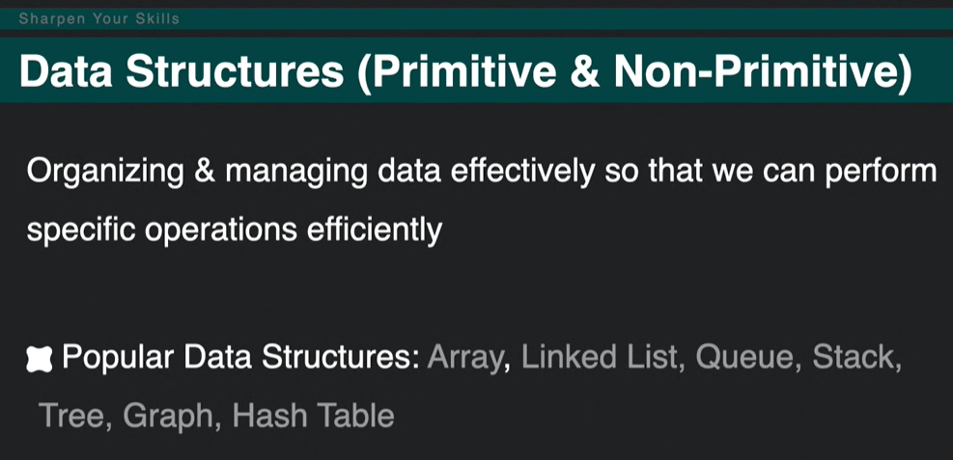

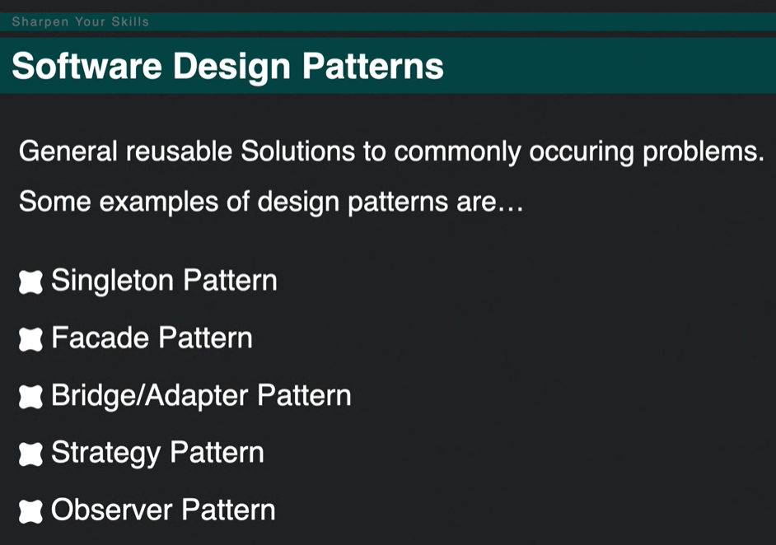

When chaining promises in javascript, we put the 2nd promise function as the parameter inside the first then(<promisefunction>)

The await keyword is used in an async function to ensure that all promises returned in the async function are synchronized, ie. they wait for each other. Await eliminates the use of callbacks in .then() and .catch(). In using async and await, async is prepended when returning a promise, await is prepended when calling a promise. try and catch are also used to get the rejection value of an async function.

**Npm** is a tool that use to install packages. **Npx** is a tool that use to execute packages. Packages used by **npm** are installed globally you have to care about pollution for the long term. Packages used by **npx** are not installed globally so you have to carefree for the pollution for the long term.

Uncontrolled components:

In most cases, we recommend using [controlled components](https://reactjs.org/docs/forms.html#controlled-components) to implement forms. In a controlled component, form data is handled by a React component. The alternative is uncontrolled components, where form data is handled by the DOM itself.

To write an uncontrolled component, instead of writing an event handler for every state update, you can [use a ref](https://reactjs.org/docs/refs-and-the-dom.html) to get form values from the DOM.

For example, this code accepts a single name in an uncontrolled component:

class NameForm extends React.Component {

constructor(props) {

super(props);

this.handleSubmit = this.handleSubmit.bind(this);

this.input = React.createRef(); }

handleSubmit(event) {

alert('A name was submitted: ' + this.input.current.value); event.preventDefault();

}

render() {

return (

<form onSubmit={this.handleSubmit}>

<label>

Name:

<input type="text" ref={this.input} /> </label>

<input type="submit" value="Submit" />

</form>

);

}

}

CSS – Brad-Traversy – Youtube - <https://www.youtube.com/watch?v=yfoY53QXEnI>

Style declaration inline, head, css file

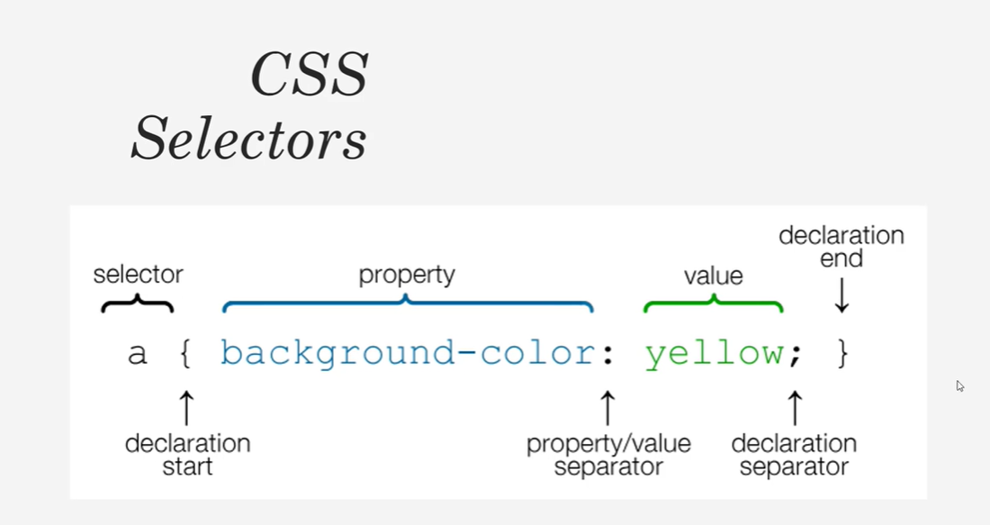

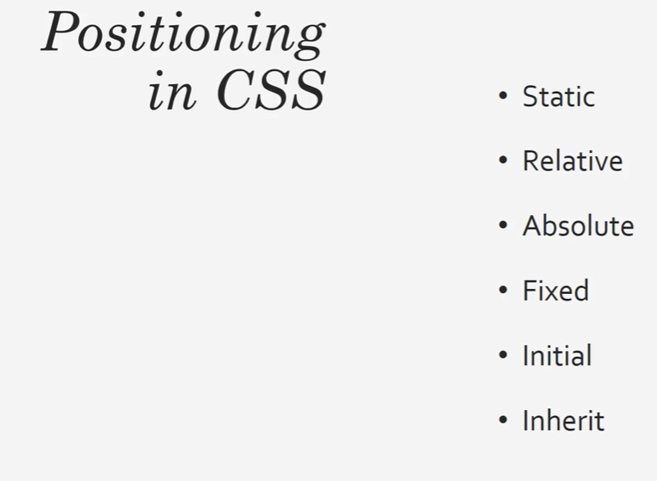

Relative position is almost like the static positioning except that it has top, right, botto and left positioning. If its aligned with this, then it is taken out of flow from the document.

Postion absoulue is taken out completely from the document flow. it has top, right, botto and left positioning. It is aligned with the parent element. Parent elelment can have relative, fixed, sticky positions.

Absolute will be relative to the relatively positioned element.

Fixed position is fixed irrespective of any other positioning.

Sticky is like relative positioning, but when it goes out of the page, becomes fixed.

Default is static positioning.

The height and widht of an inline element can be changed.

Gird – justify-content, align-content, justify-items, align-items

Align-self, justify-self for the individual items

To **center** our box we use the **align**-items property to **align** our item on the cross axis, which in this case **is** the block axis running vertically. We use **justify**-content to **align** the item on the main axis, which in this case the inline axis running horizontally.

Animation with @keyframes:

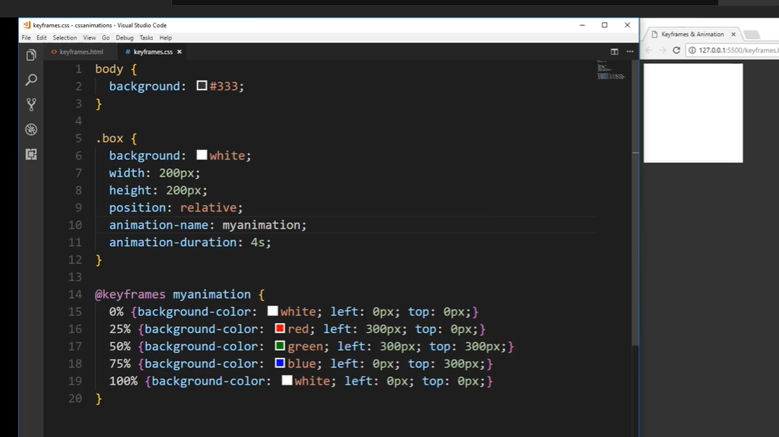

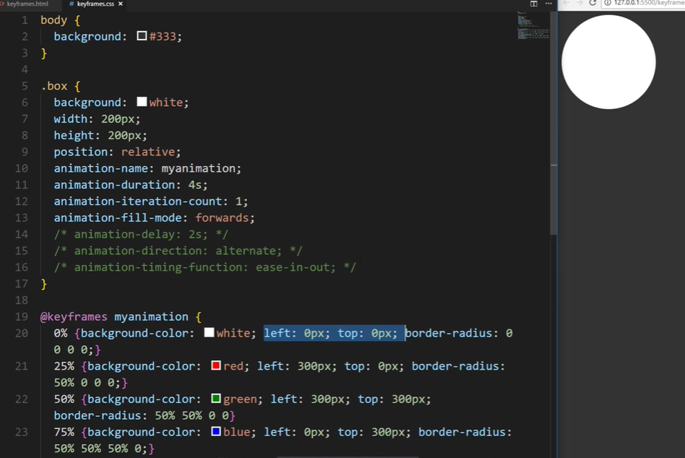

Transition:

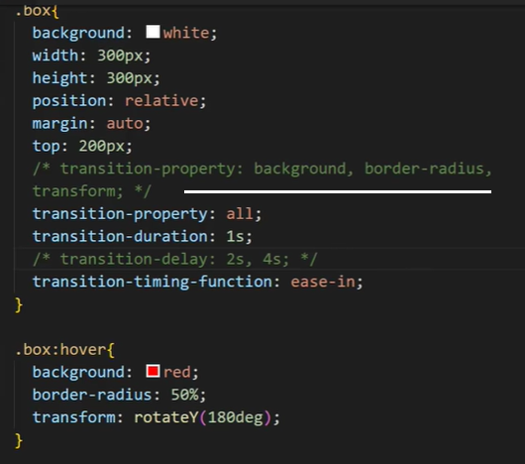

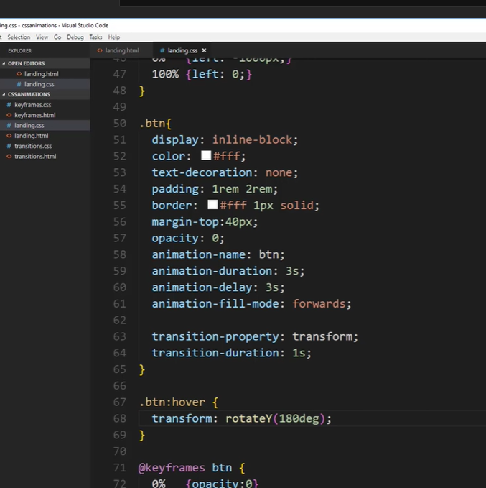

*end

Flexbox align-content is used when multiline objects are there.

Flexbox justify-content is used to place contents on a row/column

Flexbox align-items are used place items on the cross-axis

<https://css-tricks.com/snippets/css/complete-guide-grid/>

npm install bootstrap@next // include the css at the top of the head and javascript at the bottom of the body in the index.html

import 'bootstrap/dist/css/bootstrap.min.css';

bootstrap components

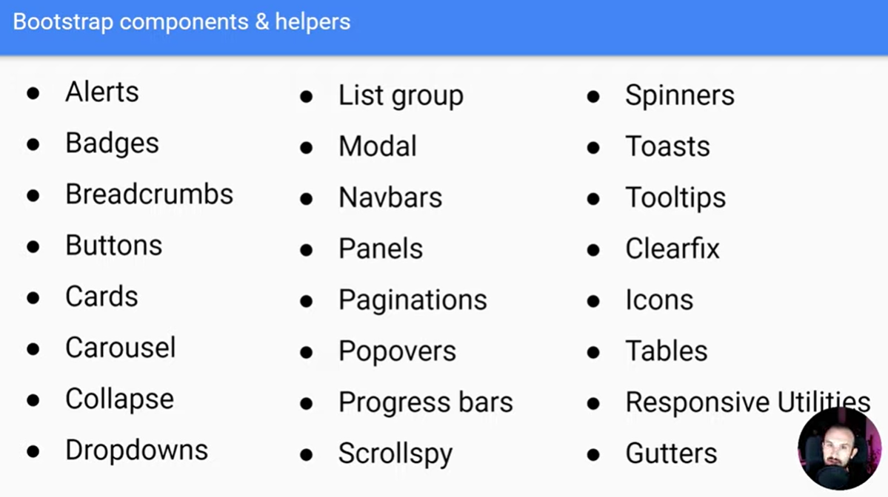

Bootstrap breakpoints

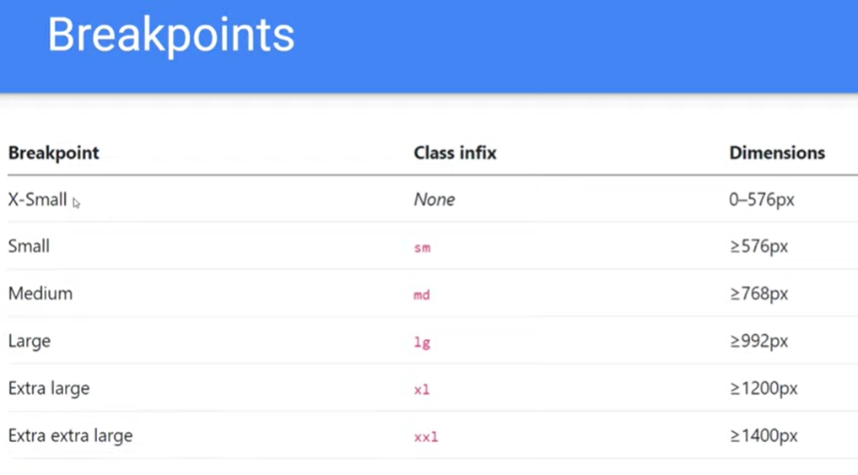

Bootstrap button

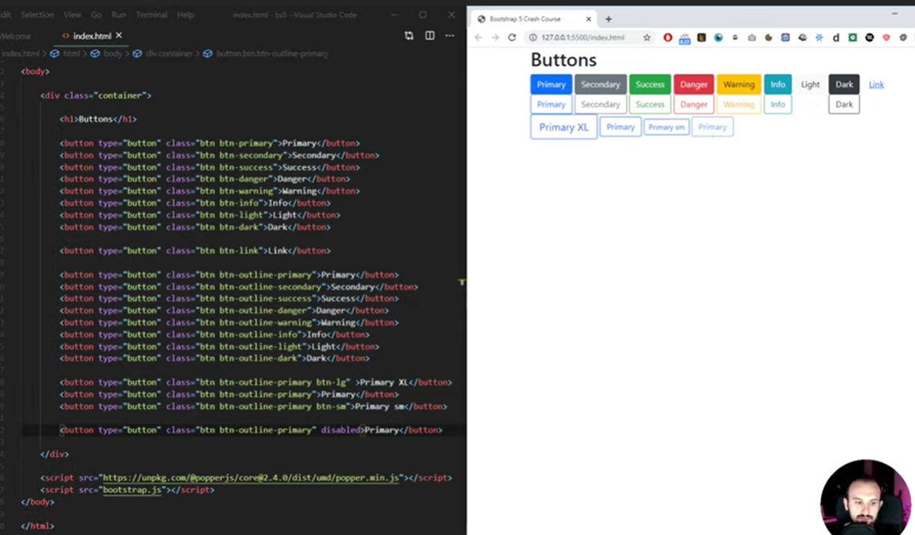

React Bootstrap:

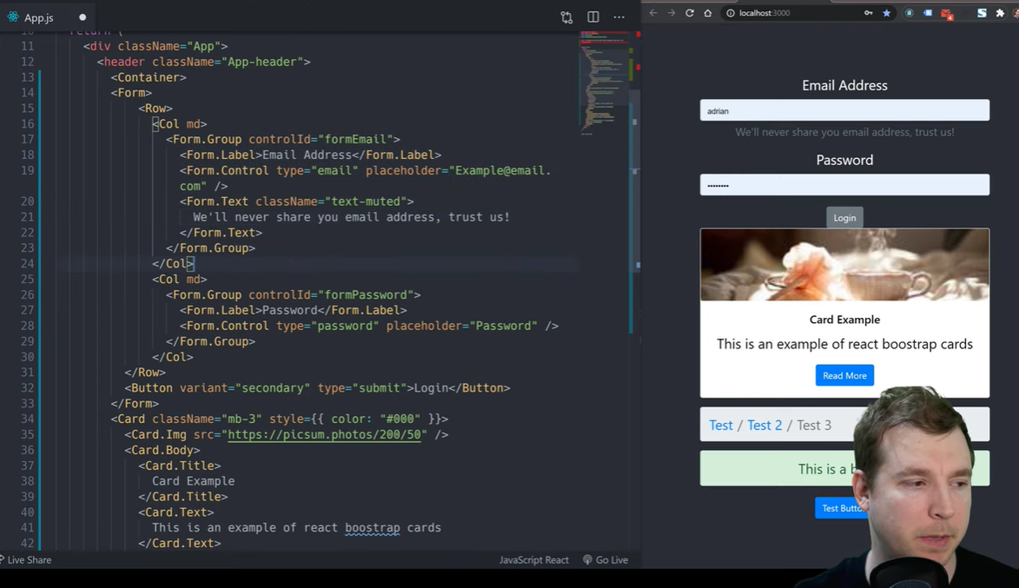

Npm install react-bootstrap bootrstrap

Import ‘bootstrap/dist/css/bootstrap.min.css

Import { Card, Form, Button } from ‘react-bootstrap’

Npm install @material-ui/core

Import Button from ‘@material-ui/core’

Create styles and theme

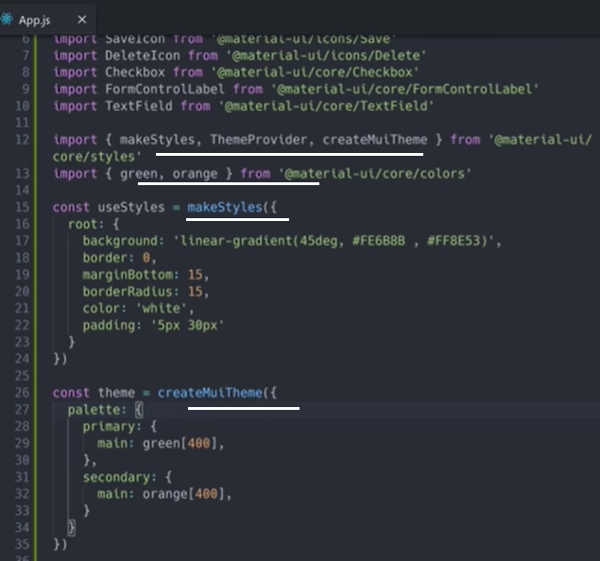

Using theme:

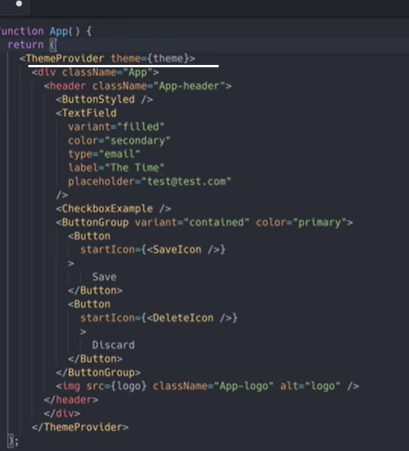

Using style:

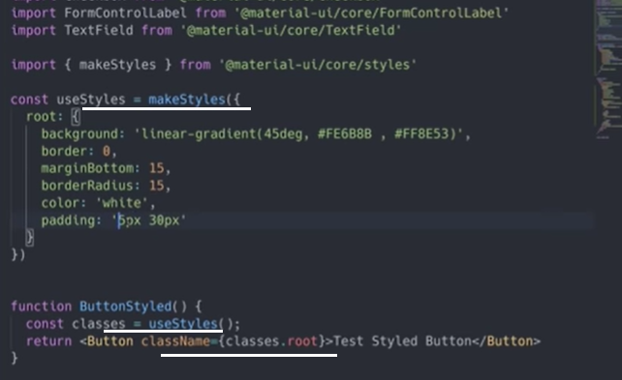

Yarn add fontsource-roboto

Import fontsource-roboto

Grid:

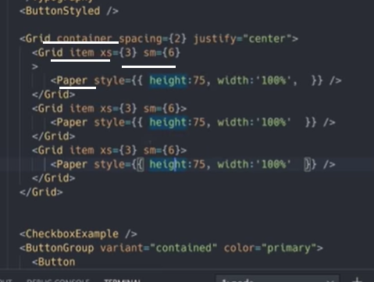

Flutter and Kotlin, web development framework from Google.

<https://cssinjs.org/>

CSS rules with jss

makeStyles

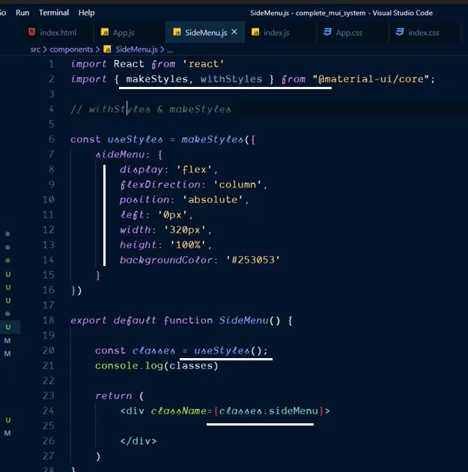

withStyles:

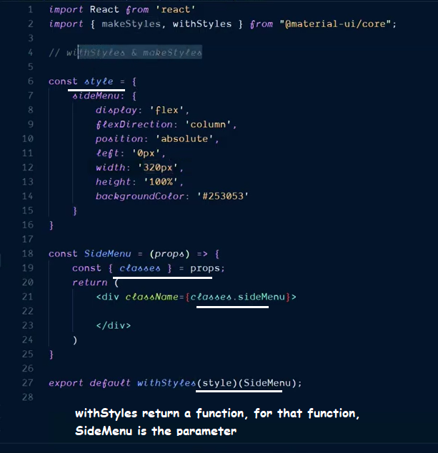

Grid has 12 columns in Material-ui

When passing numerical values to attributes in jsx, use curly braces. sm={4}

To apply css cmmon rules for the website, use <CssBaseline /> in the main app

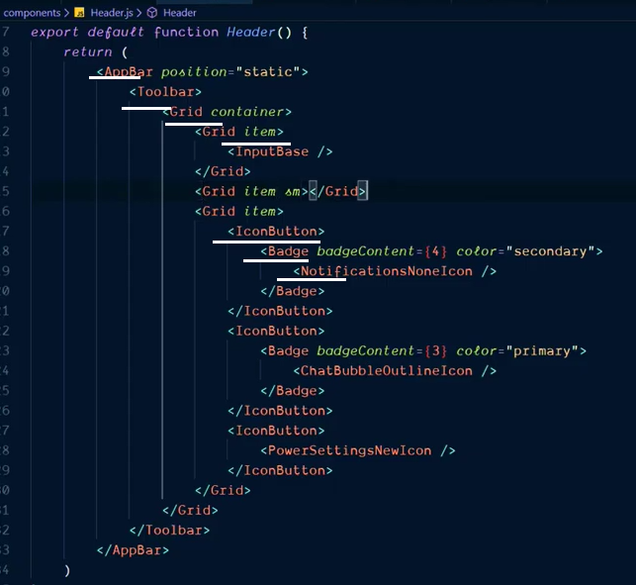

craeateMuiTheme:

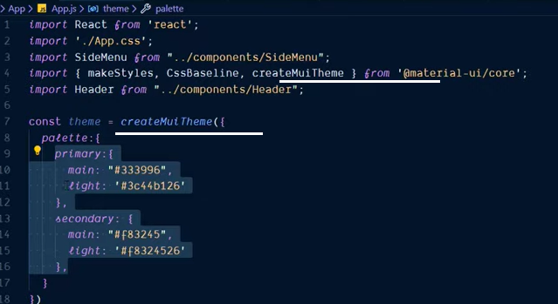

The **translateZ**() **CSS** function repositions an element along the z-axis in 3D space, i.e., closer to or farther away from the viewer. Its result is a <**transform**-function> data type.

Theme with multiple properties:

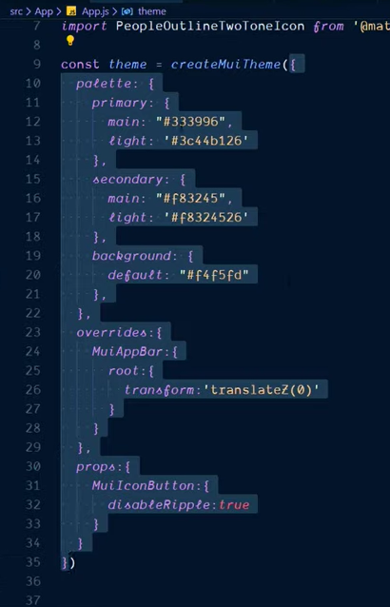

useEffect is a side effect function for those variales, whose values are passed as 2nd parameter. The call back function is executed whenever the value is changed.

npm install formik-material-ui –save

passing state in 3 ways in Formik:

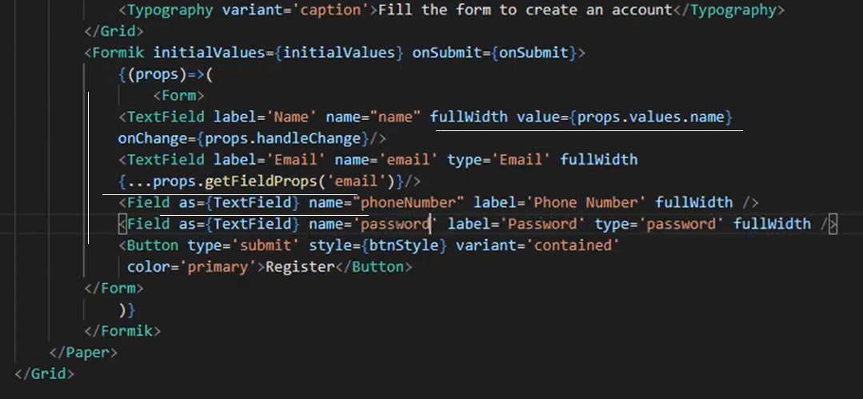

validationSchema:

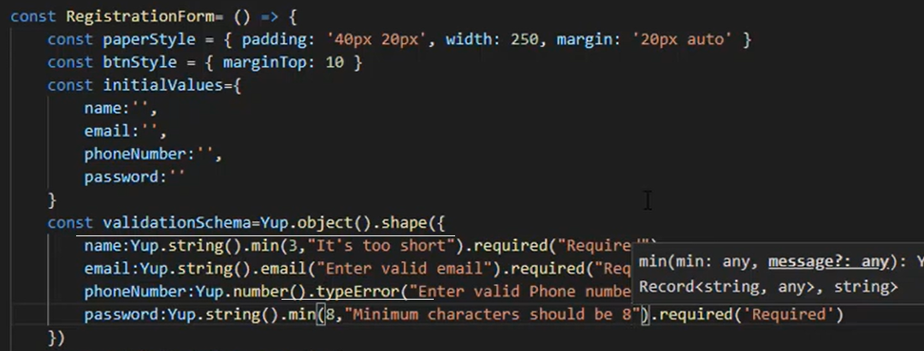

Field error property:

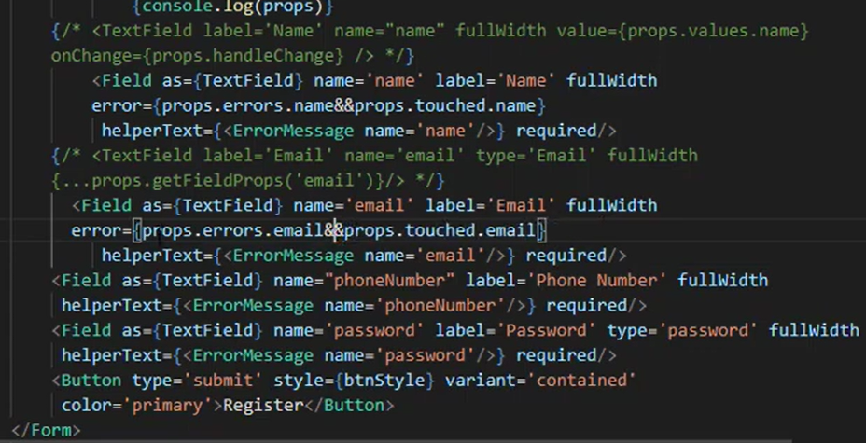

Rest Form:

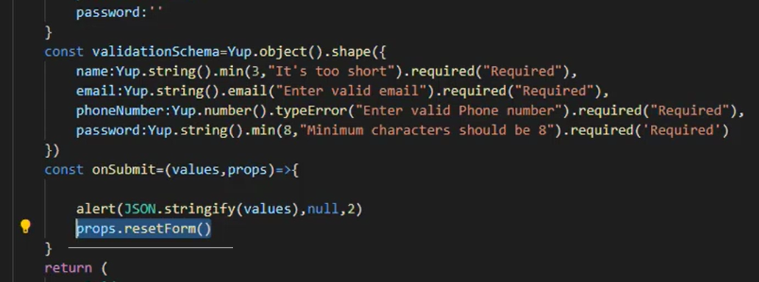

Only when the string is alowed:

Yup.InputName.string().matches(/^([^0-9]*)$/,"number not allowed")

<https://www.youtube.com/watch?v=IwbgS2LZugw>

*starend